

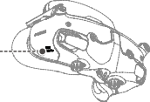

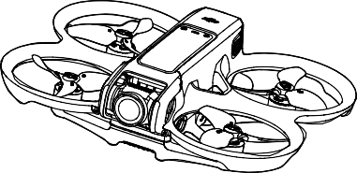Quick Start Guide

#### 快速入门指南

v1.0

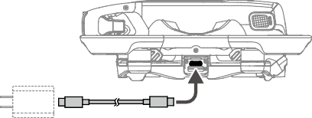

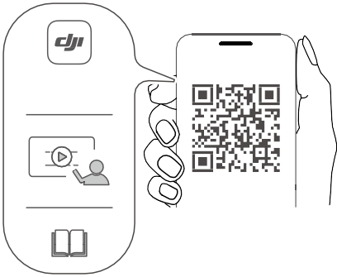

**DJI Fly App**

**https://s.dji.com/guide71**



Charge to Activate the Battery

充电激活电池

**≥30W USB PD**

EN Charge to activate the Intelligent Flight Battery before using for the first time.

智能飞行电池首次使用需充电激活。

CHS

首次使用智慧飛行電池之前須充電及啟用。

CHT

ID

Isi daya untuk mengaktifkan Baterai Penerbangan Cerdas sebelum menggunakannya untuk pertama kali.

初めて使用する前に、インテリジェント フライトバッテリーは、充電してアクティベーションしてください。

JP

처음 사용하기 전에, 인텔리전트 플라이트 배터리를 **충전해 활성화해야 합니다**. Caskan untuk mengaktifkan Bateri Penerbangan Pintar sebelum menggunakannya untuk kali pertama.

KR

MS

ชาร์จเพื่อเปิดใช้งานแบตเตอรโดรนอจฉรยะกอนใชงานครงแรก

TH

BG

Заредете, за да активирате интелигентната полетна батерия, преди да я използвате за първи път.

Před prvním použitím inteligentní letovou baterii nabijte, aby se aktivovala.

CS

Oplad for at aktivere Intelligent Flight-batteriet, før det bruges første gang.

DA

DE

Lade die Intelligent Flight Battery auf, um sie vor dem ersten Gebrauch zu aktivieren.

Antes de usar la batería de vuelo inteligente por primera vez, cárguela para activarla.

ES

Φορτίστε για να ενεργοποιήσετε την έξυπνη μπαταρία πτήσης πριν την

EL

χρησιμοποιήσετε για πρώτη φορά.

Lataa älykäs lentoakku aktivoidaksesi sen ennen ensimmäistä käyttökertaa. Rechargez la Batterie de Vol Intelligente pour l’activer avant la première utilisation.

FI

FR

Napunite pametnu Flight bateriju kako bi je aktivirali prije prve uporabe.

HR

HU

Az első használat előtt töltse fel az intelligens repülési akkumulátort az aktiváláshoz.

Ricarica per attivare la Batteria di volo intelligente prima di utilizzarla per la

IT

prima volta.

Laad de Intelligent Flight Battery op om te activeren vóór het eerste gebruik. Lad opp for å aktivere det intelligente flybatteriet før du bruker det for første gang.

NL

NO

Aby dokonać aktywacji, przed pierwszym użyciem należy naładować

PL

inteligentny akumulator lotniczy.

Carregue a bateria de voo inteligente para a ativar antes da primeira utilização.

PT

Carregue para ativar a Bateria de Voo Inteligente antes de usá-la pela primeira

PT-BR

vez.

RO Încărcați pentru a activa bateria inteligentă de zbor înainte de prima utilizare.

Перед первым использованием аккумулятор Intelligent Flight Battery необходимо зарядить для его активации.

RU

Ladda för att aktivera Intelligent Flight-batteriet innan det används för första

SV

gången.

Akıllı Uçuş Bataryasını ilk kez kullanmadan önce etkinleştirmek için şarj edin.

TR

AR

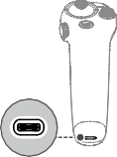ا شس� ف� ل ت� ف� ش� ي�ط ب�طار ي�ة الط ي�ران الذك ي�ة ت� ب�ل اس ت� ف�دامها للمرة ا ألولى.



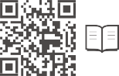[https://www.dji.com/avata-2/downloads](http://www.dji.com/avata-2/downloads)

WE ARE HERE FOR YOU

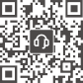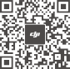在线技术支持

Contact

DJI SUPPORT

微信扫一扫获取技术支持

SUBSCRIBE FOR MORE INFO

关注 DJI 大疆创新及时获取最新资讯



This content is subject to change without prior notice. DJI and DJI AVATA are trademarks of DJI.

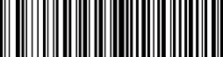Copyright © 2024 DJI All Rights Reserved. YCBZSS00275202

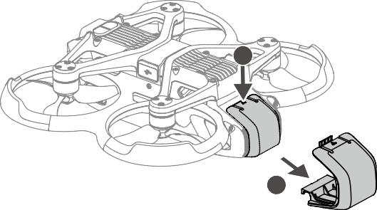

**1**

**2**



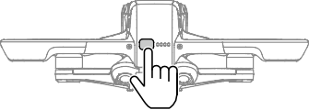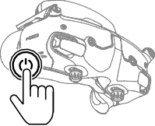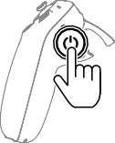

Check battery level: press once. Power on/off: press, then press and hold.

EN

检查电量：短按一次。

CHS

开机 / 关机：短按一次，再长按 2

秒以上。

檢查電量：短按一次。

CHT

開機 / 關機：短按一次，再長按 2

秒以上。

Memeriksa tingkat baterai: tekan sekali.

ID

Menghidupkan/mematikan:

tekan, lalu tekan dan tahan.

バッテリー残量確認：1 回押す。電源をオン／オフ：1 回押して、長押し。

JP

**배터리 잔량 확인**: 한 번 누르기. **전원 켜기**/**끄기**: 한번 누르고 다시 길 게 누르기.

KR

Periksa tahap bateri: tekan sekali. Hidupkan/matikan kuasa: tekan, kemudian tekan dan tahan.

MS

ตรวจสอบระดับแบตเตอรี่: กดหนงครง ปุ่มพาวเวอร์เปิด/ปิด: กดหนงครง แลวกดอกครงคางไว

TH

Проверка на заряда на батерията: натиснете веднъж. Включване/Изключване: натиснете, след това натиснете и задръжте.

BG

Kontrola stavu baterie: stiskněte jednou.

CS

Zapnutí/vypnutí: stiskněte a poté stiskněte a podržte.

Kontroller batteriniveau: Tryk én gang.

DA

Tænd/sluk: Tryk, og tryk derefter igen og hold nede.

Einmal drücken: Akkustand überprüfen.

DE

Ein-/ausschalten: Kurz drücken, dann nochmals drücken und gedrückt halten.

Comprobar nivel de batería:

ES

presione una vez. Encender/apagar: pulse, vuelva a pulsar y mantenga pulsado.

Έλεγχος στάθμης μπαταρίας:

EL

πατήστε μία φορά. Ενεργοποίηση/απενεργοποίηση: πατήστε και έπειτα πατήστε παρατεταμένα.

Tarkista akun varaus: paina kerran.

FI

Virta päälle / pois päältä: paina, ja paina sitten pitkään.

Vérification du niveau de batterie: appuyer une fois. Allumer/Éteindre: appuyez une fois, puis appuyez et maintenez le bouton enfoncé pour allumer/ éteindre.

FR

Provjera razine baterije: pritisnite jednom.

Uključivanje/isključivanje:

HR

pritisnite, a zatim pritisnite i držite.

Akkumulátor töltöttségi szintjének ellenőrzése: nyomja meg egyszer.

HU

Be- és kikapcsolás: nyomja meg, majd nyomja meg és tartsa lenyomva.

Verificare il livello della batteria:

IT

premere una volta. Accendere/spegnere: premere, quindi premere e tenere premuto.

Controle batterijniveau: één keer drukken.

NL

Aan- en uitzetten: Indrukken en vasthouden.

Sjekk batteriet: trykk én gang. Slå på/av: trykk, deretter trykk og hold.

NO

Sprawdzenie poziomu naładowania akumulatora: naciśnij raz.

PL

Włączenie/wyłączenie zasilania: naciśnij, a następnie naciśnij i przytrzymaj.

Verificar o nível da bateria:

PT

prima uma vez.

Ligar/desligar: prima, e em seguida prima de forma contínua.

Verificar o nível da bateria:

PT-BR

pressione uma vez. Ligar/desligar: pressione uma vez, então pressione novamente e segure.

Pentru a verifica nivelul bateriei:

RO

apăsați o singură dată.

Pentru a porni/opri: apăsați lung.

Проверить заряд аккумулятора: нажмите один раз.

RU

Включение/выключение: нажмите, затем нажмите еще раз и удерживайте кнопку.

Kontrollera batterinivån: tryck en gång.

SV

Slå på/av: tryck och håll intryckt.

Pil seviyesi kontrolü: Bir kez basın.

TR

Açma/kapama: Açma kapama tuşuna basın ve basılı tutun.

لل ت�� ت�ق م ف� م� ت�وى ال ب�طار ي�ة: ا نص ن�ط مرة واحدة. لل ت� ش� فع ي�ل/ إا ي� ت�اف ال ت� ش� فع ي�ل: ا نص ن�ط، �ثم ا نص ن�ط مرة أ نحرى مع ال� ت�مرار.

AR



###### A

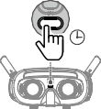

5s

1. Linking / 对频

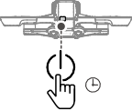

5s





 

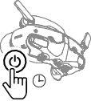

5s

**DJI Goggles 3**

**DJI Goggles 2**



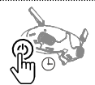

5s

**DJI Goggles Integra**

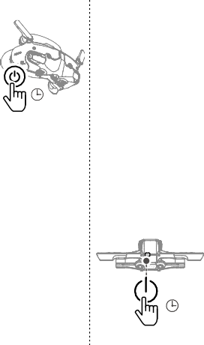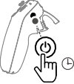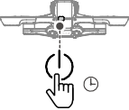

5s

**DJI Goggles 3**

5s

5s

**DJI RC Motion 3**

5s



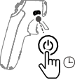

5s

**DJI RC Motion 2**

1. Activation / 激活 B

数据线需自备

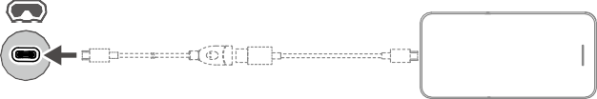

**DJI Fly App**

**USB-C**

Not Included in the Box

Linking and Activation

Make sure that the devices used with the aircraft have been updated to the latest firmware version via the DJI ASSISTANTTM 2 (Consumer Drone Series) software [(https://www.dji.com/](http://www.dji.com/) avata-2/downloads ) before linking and powering on all the devices.



EN

Press the power button on the devices to stop the process if the linking fails. Connect the goggles to a mobile device, run the DJI Fly app, select Connection Guide, and then follow the on-screen instructions to link.

对频及激活

确保对频前配合飞行器使用的 DJI 设备已通过 DJI ASSISTANTTM 2（消费机系列) 调参软件 (https:// [www.dji.com/avata-2/downloads)](http://www.dji.com/avata-2/downloads)) 升级至最新固件，且所有设备均已开机。



CHS

若长时间无法对频成功，可短按电源按键停止对频，然后连接飞行眼镜至手机并运行 DJI Fly App, 点击连接引导，按照屏幕提示进行对频操作。

配對與啟用

配對前，請確保搭配飛行器使用的 DJI 裝置已透過 DJI ASSISTANTTM 2（消費級無人機系列）調參軟體 [(https://www.dji.com/avata-2/downloads)](http://www.dji.com/avata-2/downloads)) 升級至最新韌體，且所有裝置均已開機。



CHT

若長時間無法配對成功，可短按電源按鍵停止配對，再將飛行眼鏡連接至手機並執行 DJI Fly App，點選「連接引導」，按照螢幕提示進行配對操作。

**Penautan dan Aktivasi**

Pastikan perangkat yang digunakan bersama pesawat telah diperbarui ke versi firmware terbaru melalui perangkat lunak DJI ASSISTANTTM 2 (Seri Drone Konsumen) (https://www.dji. com/avata-2/downloads) sebelum menautkan dan menyalakan semua perangkat.



ID

Tekan tombol daya pada perangkat untuk menghentikan prosesnya jika penautan gagal Hubungkan kacamata ke perangkat seluler, jalankan aplikasi DJI Fly, pilih Panduan Koneksi, lalu ikuti instruksi di layar untuk menautkan.

**リンクとアクティベーション**

すべての機器をリンクさせて電源を入れる前に、機体で使用する機器が、DJI ASSISTANTTM 2（コンシューマードローンシリーズ）ソフトウェア [(https://www.dji.com/avata-2/downloads)](http://www.dji.com/avata-2/downloads)) を介して、最新のファームウェアバージョンにアップデートされていることを確認してください。



JP

リンクに失敗した場合は、デバイスの電源ボタンを押してプロセスを中止してください。ゴーグルをモバイルデバイスに接続し、DJI Fly アプリを起動し、[ 接続ガイド ] を選択し、画面上の指示に従ってリンク作業を行います。

**연동 및 활성화**

모든 기기를 연동하고 전원을 켜기 전에 기체와 함께 사용하는 기기가 DJI ASSISTANTTM 2(소비자 드론 시리즈용) 소프 트웨어[(https://www.dji.com/avata-2/downloads)를](http://www.dji.com/avata-2/downloads)를) 통해 최신 펌웨어 버전으로 업데이트되었는지 확인하십시오.



KR

연동되지 않으면 기기의 전원 버튼을 눌러 프로세스를 중지합니다. 고글을 모바일 기기에 연결하고 DJI Fly 앱을 실행해 연결 가이드를 선택한 다음 화면의 지시에 따라 연동합니다.

Pemautan dan Pengaktifan

Pastikan peranti yang digunakan dengan pesawat telah dikemaskinikan kepada versi perisian tegar yang terkini melalui perisian DJI ASSISTANTTM 2 (Siri Dron Pengguna) [(https://www.dji.com/](http://www.dji.com/) avata-2/downloads) sebelum dipautkan kepada dan dihidupkan pada semua peranti.



MS

Tekan butang kuasa pada peranti untuk menghentikan proses jika pemautan gagal. Sambungkan gogal kepada peranti mudah alih, jalankan apl DJI Fly, pilih Panduan Sambungan dan ikut arahan pada skrin untuk membuat pemautan.

การเชื่อมโยงและการเปิดการทำางาน ตรวจดูให้แน่ใจว่าอุปกรณ์ที่ใช้กับโดรนได้รับการอัปเดตเป็นเวอร์ชันเฟิร์มแวร์ล่าสุดผ่านทางซอฟต์แวร์ DJI ASSISTANTTM 2 (Consumer Drone Series) [(https://www.dji.com/avata-2/downloads)](http://www.dji.com/avata-2/downloads)) ก่อนที่จะทำาการเชื่อมโยงและเปิดเครื่องอุปกรณ์ทั้งหมด



TH

 หากไม่สามารถเชื่อมโยงได้ ให้กดปุ่มเปิดปิดบนอุปกรณ์เพื่อหยุดกระบวนการ เชื่อมต่อแว่นตากับอุปกรณ์มือถือ แล้วเรียกใช้แอป DJI Fly เลือกคู่มือการเชื่อมต่อ จากนั้นทำาตามคำาแนะนำาบนหน้าจอเพื่อเชื่อมโยง

Свързване и активиране

Уверете се, че фърмуерът на устройствата, използвани с дрона, е актуализиран до последната версия чрез софтуера DJI ASSISTANTTM 2 (серия потребителски дронове) (https:// [www.dji.com/avata-2/downloads),](http://www.dji.com/avata-2/downloads)) преди да свържете и включите всички устройства.



BG

Натиснете бутона за захранване на устройствата, за да спрете процеса, ако свързването не се осъществи. Свържете очилата с мобилно устройство, стартирайте приложението DJI Fly, изберете Указания за свързване и следвайте инструкциите на екрана.



CS

Párování a aktivace

Než začnete párovat a zapínat všechna zařízení používaná spolu s dronem, ujistěte se, že jsou aktualizována na nejnovější verzi firmwaru pomocí softwaru DJI ASSISTANTTM 2 (řada spotřebitelských dronů) [(https://www.dji.com/avata-2/downloads).](http://www.dji.com/avata-2/downloads))

 Pokud se připojení nezdaří, stiskem tlačítka napájení na zařízeních proces přerušte. Připojte brýle k mobilnímu zařízení a spusťte aplikaci DJI Fly, klepněte na Průvodce připojením a poté pro spárování postupujte podle pokynů na obrazovce.

Sammenkobling og aktivering

Sørg for, at de enheder, der bruges med dronen, er blevet opdateret til den nyeste firmwareversion via programmet DJI ASSISTANTTM 2 (forbrugerdroneserien) (https://www.dji. com/avata-2/downloads), før du forbinder og tænder for alle enhederne.



DA

Tryk på tænd-knappen på enhederne for at stoppe processen, hvis oprettelse af forbindelse mislykkes. Tilslut brillerne til en mobilenhed og kør DJI Fly-appen, vælg Forbindelsesvejledning og følg derefter instruktionerne på skærmen for at oprette forbindelse.



DE

Koppeln und Aktivieren

Sorge vor dem Koppeln und Einschalten dafür, dass die mit dem Fluggerät benutzten Geräte anhand des DJI ASSISTANTTM 2 (für Hobby-Drohnen) auf die neueste Firmware-Version aktualisiert wurden [(www.dji.com/avata-2/downloads).](http://www.dji.com/avata-2/downloads))

Drücke die Netztaste an den Geräten, um den Kopplungsvorgang zu unterbrechen, falls dieser fehlschlägt. Verbinde die Goggles mit einem Mobilgerät, starte die DJI Fly App, wähle das „Verbindungstutorial“ und folge den Anweisungen auf dem Bildschirm, um die Kopplung durchzuführen.



ES

Vinculación y activación

Asegúrese de que el firmware de los dispositivos que se utilicen con la aeronave se haya actualizado a la última versión con el software DJI ASSISTANTTM 2 (serie de drones de consumo) [(https://www.dji.com/avata-2/downloads)](http://www.dji.com/avata-2/downloads)) antes de realizar la vinculación y encender todos los dispositivos.

Presione el botón de encendido de los dispositivos para detener el proceso si las gafas no se vinculan a la aeronave. Conecte las gafas a un dispositivo móvil, abra la aplicación DJI Fly y seleccione Guía de conexión. A continuación, siga las instrucciones que aparecen en la pantalla para completar la vinculación.

Σύνδεση και ενεργοποίηση

EL

Βεβαιωθείτε ότι οι συσκευές που χρησιμοποιούνται με το αεροσκάφος έχουν αναβαθμιστεί στην τελευταία έκδοση υλικολογισμικού μέσω του λογισμικού DJI ASSISTANTTM 2 (Consumer Drone Series) [(https://www.dji.com/avata-2/downloads)](http://www.dji.com/avata-2/downloads)) πριν συνδέσετε και ενεργοποιήσετε όλες τις συσκευές.

Πατήστε το κουμπί λειτουργίας στις συσκευές για να σταματήσετε τη διαδικασία εάν η σύνδεση αποτύχει. Συνδέστε τα γυαλιά με κινητή συσκευή, ανοίξτε την εφαρμογή DJI Fly, επιλέξτε Οδηγός σύνδεσης και έπειτα ακολουθήστε τις οδηγίες στην οθόνη για σύνδεση.

FI

Linkitys ja aktivointi

Varmista, että kopterin kanssa käytetyt laitteet on päivitetty uusimpaan laiteohjelmiston versioon DJI ASSISTANTTM 2 (Consumer Drone Series) -ohjelmistolla (https:/[/www.dji.com/](http://www.dji.com/) avata-2/downloads) ennen laitteiden kytkemistä ja laittamista päällä.

Jos linkittäminen epäonnistuu, pysäytä prosessi painamalla laitteiden virtapainiketta. Yhdistä lasit mobiililaitteeseen ja käynnistä DJI Fly -sovellus, valtise Connection Guide (liitäntäopas) ja noudata näytöllä esitettäviä linkitysohjeita.

FR

Appairage et activation

Assurez-vous que les appareils utilisés avec l’appareil ont été mis à jour vers la dernière version du firmware via le logiciel DJI ASSISTANTTM 2 (Gamme Drones de loisirs) (http[s://www.dji.com/](http://www.dji.com/) avata-2/downloads) avant d’appairer et de mettre sous tension tous les appareils.

Appuyez sur le bouton d’alimentation des appareils pour interrompre le processus si la liaison échoue. Connectez les lunettes à un appareil mobile, lancez l’application DJI Fly, sélectionnez Guide de connexion, et suivez les instructions à l’écran pour vous connecter.

HR

Povezivanje i aktivacija

Prije povezivanja i uključivanja svih uređaja, pobrinite se da su uređaji koji se upotrebljavaju s letjelicom ažurirani na najnoviju verziju firmvera putem softvera DJI ASSISTANTTM 2 (serija potrošačkih dronova) [(https://www.dji.com/avata-2/downloads).](http://www.dji.com/avata-2/downloads))

Ako povezivanje ne uspije, pritisnite gumb za uključivanje/isključivanje na uređajima kako biste zaustavili proces. Povežite naočale na mobilni uređaj i pokrenite aplikaciju DJI Fly, odaberite Vodič za povezivanje i slijedite upute na zaslonu za povezivanje.

HU

Csatlakoztatás és aktiválás

Mielőtt az összes eszközt csatlakoztatná és bekapcsolná, győződjön meg arról, hogy a drónnal használt eszközök frissítve lettek a legújabb firmware-verzióra a DJI ASSISTANTTM 2 (hobbidrón- sorozat) szoftverrel [(https://www.dji.com/avata-2/downloads](http://www.dji.com/avata-2/downloads) ).

Nyomja meg a készülékek bekapcsológombját a folyamat leállításához, ha az összekapcsolás nem sikerül. Csatlakoztassa a szemüveget mobileszközéhez, futtassa a DJI Fly alkalmazást, válassza a Csatlakozási útmutató lehetőséget, majd kövesse a képernyőn megjelenő utasításokat az összekapcsoláshoz.

IT

Collegamento e attivazione

Accertarsi che nei dispositivi utilizzati con l’aeromobile sia stato eseguito l’aggiornamento alla versione più recente del firmware tramite il software DJI ASSISTANTTM 2 (Serie Consumer Drone) [(https://www.dji.com/avata-2/downloads)](http://www.dji.com/avata-2/downloads)) prima del collegamento e della loro accensione.

In caso di mancato collegamento, premere il pulsante di accensione sui dispositivi per interrompere il processo. Collegare il visore a un dispositivo mobile, avviare l’app DJI Fly, toccare Guida alla connessione, quindi seguire le istruzioni visualizzate sullo schermo per effettuare il collegamento.

NL

Koppeling en activering

Zorg ervoor dat de apparaten die met de drone worden gebruikt zijn bijgewerkt naar de nieuwste firmwareversie via de DJI ASSISTANTTM 2 (Consumer Drone Series)-software (https:// [www.dji.com/avata-2/downloads)](http://www.dji.com/avata-2/downloads)) voordat u alle apparaten koppelt en inschakelt.

Druk op de aan/uit-knop op de apparaten om het proces te stoppen als de koppeling mislukt. Sluit de bril aan op een mobiel apparaat, open de DJI Fly-app, selecteer Verbindingshandleiding en volg vervolgens de instructies op het scherm om te koppelen.

NO

Sammenkobling og aktivering

Sørg for at enhetene som brukes med flyet har blitt oppdatert til den siste firmware-versjonen via DJI ASSISTANTTM 2 (forbrukerdrone serien) programvaren (http[s://www.dji.com/avata-2/](http://www.dji.com/avata-2/) downloads) før du kobler til og slår på alle enhetene.

Trykk på startknappen på enhetene for å avslutte prosessen hvis koblingen mislykkes. Koble brillene til en mobilenhet og kjør DJI Fly-appen, velg tilkoblingsveiledning, og følg deretter instruksjonene på skjermen for å koble til.

PL

Łączenie i aktywacja

Upewnij się, że urządzenia używane z dronem zostały zaktualizowane do najnowszej wersji za pomocą oprogramowania DJI ASSISTANTTM 2 (seria dronów konsumenckich) (https://www.dji. com/avata-2/downloads) przed połączeniem i włączeniem zasilania wszystkich urządzeń.

Jeśli nie nastąpi połączenie, zatrzymaj proces, naciskając przycisk zasilania na urządzeniach. Podłącz gogle do urządzenia mobilnego, w aplikacji DJI Fly wybierz Instrukcja łączenia i postępuj zgodnie z instrukcjami.

PT

Ligação e ativação

Certifique-se de que os dispositivos utilizados com a aeronave foram atualizados para a versão mais recente do firmware através do software DJI ASSISTANTTM 2 (Série de drones de consumo) [(https://www.dji.com/avata-2/downloads)](http://www.dji.com/avata-2/downloads)) antes de ligar todos os dispositivos.

Prima o botão de alimentação nos dispositivos para parar o processo se a ligação falhar. Ligue os goggles ao seu dispositivo móvel e execute a aplicação DJI Fly; selecione o Guia de Ligação e siga as instruções apresentadas no ecrã para efetuar a ligação.

PT-BR

Vinculação e ativação

Certifique-se de que os dispositivos utilizados com a aeronave tenham sido atualizados para a versão mais recente por meio do software DJI ASSISTANTTM 2 (Série de drones de consumo) [(https://www.dji.com/avata-2/downloads)](http://www.dji.com/avata-2/downloads)) antes de vincular e de ligar todos os dispositivos.

Pressione o botão Liga/Desliga nos dispositivos para interromper o processo se houver falha na vinculação. Conecte os Goggles a um dispositivo móvel, abra o aplicativo DJI Fly, selecione o Guia de conexão e depois siga as instruções na tela para fazer a vinculação.

RO

Asocierea și activarea

Asigurați-vă că dispozitivele utilizate cu drona au fost actualizate la cea mai recentă versiune de firmware prin intermediul software-ului DJI ASSISTANTTM 2 (Consumer Drone Series) (https:// [www.dji.com/avata-2/downloads)](http://www.dji.com/avata-2/downloads)) înainte de a asocia și de a porni toate dispozitivele.

Apăsați butonul de alimentare de pe dispozitive pentru a opri procesul în cazul în care conectarea eșuează. Conectați ochelarii la un dispozitiv mobil, porniți aplicația DJI Fly, selectaţi Ghidul de conectare și apoi urmați instrucțiunile de pe ecran pentru a vă conecta.

RU

Сопряжение и активация

Убедитесь в том, что программное обеспечение устройств, используемых с дроном, обновлено до последней версии, воспользовавшись программным обеспечением DJI ASSISTANTTM 2 (серии дронов потребительского сегмента) [(https://www.dji.com/avata-2/](http://www.dji.com/avata-2/) downloads), прежде чем выполнять сопряжение и включение устройств.

Если не удалось выполнить сопряжение, нажмите кнопку питания на устройствах, чтобы остановить процесс. Подключите очки к мобильному устройству, запустите приложение DJI Fly, выберите «Подключить дрон», а затем следуйте инструкциям на экране для сопряжения.

SV

Koppla och aktivera

Se till att enheterna som används med drönaren har uppdaterats med den senaste versionen av inbyggd programvara via programvaran DJI ASSISTANTTM 2 (drönarserien för konsumenter) [(https://www.dji.com/avata-2/downloads)](http://www.dji.com/avata-2/downloads)) innan alla enheterna kopplas och slås på.

Tryck på strömknappen på enheterna för att stoppa processen om länkningen misslyckas. Anslut glasögonen till en mobil enhet och kör DJI Fly-appen, tryck på Anslutningsguide och följ instruktionerna på skärmen för att länka.

TR

Bağlanma ve Etkinleştirme

Hava aracıyla kullanılan cihazların, bağlanmadan ve tüm cihazlar açılmadan önce DJI ASSISTANTTM 2 (Tüketici Drone Serisi) yazılımı (https://[www.dji.com/avata-2/downloads)](http://www.dji.com/avata-2/downloads)) aracılığıyla en son sürüme güncellendiğinden emin olun.

Bağlantı başarısız olursa işlemi durdurmak için cihazlardaki güç düğmesine basın. Gözlük sistemini bir mobil cihaza bağlayın, DJI Fly uygulamasını çalıştırın, Bağlantı Rehberi'ni seçin ve ardından bağlantı kurmak için ekrandaki talimatları izleyin.

الر ب�ط وال ت� ف�ع ي�ل

AR

�ت ئ�كّد م� �ت�د ي�ث ال ب�رام ج� ال ث�ا ب� ت�ة ل ئل بحه نرة المُس ت� ن�دمة مع الطا�ئرة إالى أحدث إاصدار ع ب�ر ب�ر�نام ج�

ن

DJI ASSISTANTTM 2 (Consumer Drone Series)

.لها�ي �ن ثس ت�و نرة بحه ئل ا ع�ي بحم ط�ب ر ل�ب �ت ([https://www.dji.com/avata- 2/downloads)](http://www.dji.com/avata-2/downloads))

ا نص�ط زر ال�س� ي�ل على ا ئل بحهرة إل ي� ت�اف ال�مل ي�ة إاذا ��ذر إا�مام الر ب�ط. وصّل ال�ظارة ب� ب�هاز م�مول و�ّ�ل �ط ب� ي�ق Fly DJI، �م ا نح�ر دل�ل ال�تصال وا�ت�ع ال ت��ل�مات ال ت� يى �تظهر على ال ثسا ث�ة للر�ط.

ت ث ت ن ث ن ب ت ت ن ي ب ن ث ت ني



**DJI Avata 2 Release Notes**

|  |  |
| --- | --- |
| Date: | 2024.11.06 |
| DJI Avata 2 Firmware: | V01.00.0400 |
| DJI Goggles 3 Firmware: | V01.00.0600 |
| DJI RC Motion 3 Firmware: | V01.00.0200 |
| DJI FPV Remote Controller 3 Firmware: | V01.00.0300 |
| DJI Goggles 2 Firmware： | V01.10.0000 |
| DJI Goggles N3 Firmware： | V01.00.0200 |
| DJI Goggles Integra Firmware： | V01.06.0000 |
| DJI RC Motion 2 Firmware： | V01.08.0000 |
| DJI FPV Remote Controller 2 Firmware： | V02.00.1000 |
| DJI Fly App iOS: | V1.15.4 |
| DJI Fly App Android: | V1.15.4 |

What’s New

* Added Power Loop in Easy ACRO mode when used with DJI Goggles N3/DJI Goggles 3 and DJI RC Motion 3.
* Added support for use with DJI Goggles N3.
* Added Landing Protection when used with DJI Goggles N3/DJI Goggles 3 and DJI RC Motion 3.
* Fixed some known issues.

Notes:

* Restart the aircraft, remote control device, and goggles after the firmware update is complete.
* Note that the firmware update may reset various flight parameters such as RTH Altitude and Maximum Flight Distance. Before updating, take note of your preferred settings and readjust them after the firmware update is complete.
* If the update fails, restart the aircraft, remote control device, goggles, and the DJI Fly app or DJI Assistant 2 (Consumer Drone Series), and try again.
* Always perform Power Loop in Easy ACRO mode in an open area to ensure flight safety.
* Take extra caution when flying close to the ground with Landing Protection disabled.

https://[www.dji.com/avata-2](http://www.dji.com/avata-2)

Copyright © 2024 DJI All Rights Reserved. 1



**DJI Avata 2 Release Notes**

|  |  |
| --- | --- |
| Date: | 2024.05.28 |
| DJI Avata 2 Firmware: | V01.00.0300 |
| DJI Goggles 3 Firmware: | V01.00.0200 |
| DJI RC Motion 3 Firmware: | V01.00.0100 |
| DJI FPV Remote Controller 3 Firmware: | V01.00.0100 |
| DJI Goggles 2 Firmware： | V01.10.0000 |
| DJI Goggles Integra Firmware： | V01.06.0000 |
| DJI RC Motion 2 Firmware： | V01.08.0000 |
| DJI FPV Remote Controller 2 Firmware： | V02.00.1000 |
| DJI Fly App iOS: | V1.13.4 |
| DJI Fly App Android: | V1.13.4 |

What’s New

* Added support for use with DJI Goggles Integra.
* Added support for use with DJI Goggles 2.
* Added support for use with DJI RC Motion 2 and DJI FPV Remote Controller 2 when used with DJI Goggles Integra and DJI Goggles 2.
* Added support for recording 4K/100 videos.
* Added support for RID in some regions.
* Fixed some known issues.

Notes:

* Restart the aircraft, remote control device, and goggles after the firmware update is complete.
* Note that the firmware update may reset various flight parameters such as RTH Altitude and Maximum Flight Distance. Before updating, take note of your preferred settings and readjust them after the firmware update is complete.
* If the update fails, restart the aircraft, remote control device, goggles, and the DJI Fly app or DJI Assistant 2 (Consumer Drone Series), and try again.

https://[www.dji.com/avata-2](http://www.dji.com/avata-2)

Copyright © 2024 DJI All Rights Reserved. 2



**DJI Avata 2 Release Notes**

|  |  |
| --- | --- |
| Date: | 2024.04.11 |
| DJI Avata 2 Firmware: | V01.00.0200 |
| DJI Goggles 3 Firmware: | V01.00.0100 |
| DJI RC Motion 3 Firmware: | V01.00.0100 |
| DJI FPV Remote Controller 3 Firmware: | V01.00.0100 |
| DJI Fly App iOS: | V1.13.0 |
| DJI Fly App Android: | V1.13.0 |

What’s New

* Added Easy ACRO for use with DJI Goggles 3 and DJI RC Motion 3.
* Added Beginner mode for the aircraft when used with DJI Goggles 3 and DJI RC Motion 3.
* Added support for Manual Mode when used with DJI FPV Remote Controller 3.

Notes:

* Restart the aircraft, remote control device, and goggles after the firmware update is complete.
* Note that the firmware update may reset various flight parameters such as RTH Altitude and Maximum Flight Distance. Before updating, take note of your preferred settings and readjust them after the firmware update is complete.
* If the update fails, restart the aircraft, remote control device, goggles, and the DJI Fly app or DJI Assistant 2 (Consumer Drone Series), and try again.

https://[www.dji.com/avata-2](http://www.dji.com/avata-2)

Copyright © 2024 DJI All Rights Reserved. 3

User Manual

#### 2024.05

v1.0

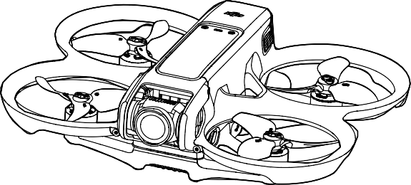

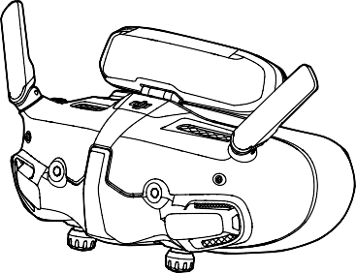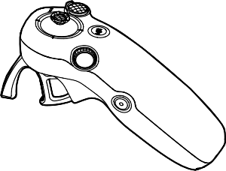

**DJI Avata 2** User Manual



This document is copyrighted by DJI with all rights reserved. Unless otherwise authorized by DJI, you are not eligible to use or allow others to use the document or any part of the document by reproducing, transferring, or selling the document. Users should only refer to this document and the content thereof as instructions to operate DJI UAV. The document should not be used for other purposes.



Searching for Keywords

Search for keywords such as “battery” and “install” to find a topic. If you are using Adobe Acrobat Reader to read this document, press Ctrl+F on Windows or Command+F on Mac to begin a search.

Navigating to a Topic

View a complete list of topics in the table of contents. Click on a topic to navigate to that section.

Printing this Document

This document supports high resolution printing.

2 © 2024 DJI All Rights Reserved.

Using the Manual

**DJI Avata 2** User Manual

Legend

 Important  Hints and Tips  Reference

Read Before the First Flight

Read the following documents before using DJI AVATATM 2.

1. Safety Guidelines
2. Quick Start Guide
3. User Manual

It is recommended to watch all tutorial videos and read the safety guidelines before using for the first time. Prepare for your first flight by reviewing the quick start guide and refer to this user manual for more information.

Video Tutorials

Go to the address below or scan the QR code to watch the tutorial videos, which demonstrate how to use the product safely:

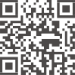



[https://www.dji.com/avata-2/video](http://www.dji.com/avata-2/video)

Download the DJI Fly App

Make sure to use DJI Fly during flight. Scan the QR code to download the latest version.

* + The Android version of DJI Fly is compatible with Android v7.0 and later. The iOS version of DJI Fly is compatible with iOS v11.0 and later.
  + The interface and functions of DJI Fly may vary as the software version is updated. Actual usage experience is based on the software version used.

© 2024 DJI All Rights Reserved. 3

**DJI Avata 2** User Manual

* For increased safety, flight is restricted to a height of 98.4 ft (30 m) and a range of 164 ft (50 m) when not connected or logged into the app during flight. This applies to DJI Fly and all apps compatible with DJI aircraft.

Download DJI Assistant 2

Download DJI ASSISTANTTM 2 (Consumer Drones Series) at: [https://www.dji.com/downloads/softwares/dji-assistant-2-consumer-drones-series](http://www.dji.com/downloads/softwares/dji-assistant-2-consumer-drones-series)

* + The operating temperature of this product is -10° to 40° C. It does not meet the standard operating temperature for military-grade application (-55° to 125° C), which is required to endure greater environmental variability. Operate the product appropriately and only for applications that meet the operating temperature range requirements of that grade.

4 © 2024 DJI All Rights Reserved.

Contents

|  |  |  |
| --- | --- | --- |
| Using the Manual | 3 |  |
| Legend | 3 |  |
| Read Before the First Flight | 3 |  |
| Video Tutorials | 3 |  |
| Download the DJI Fly App | 3 |  |
| Download DJI Assistant 2 | 4 |  |
| Product Profile | 10 |  |
| Introduction | 10 |  |
| Using for the First Time | 11 |  |
| Preparing the Aircraft | 11 |  |
| Preparing DJI Goggles 3 | 13 |  |
| Preparing DJI RC Motion 3 | 19 |  |
| Linking | 20 |  |
| Activation | 21 |  |
| Updating Firmware | 22 |  |
| Overview | 23 |  |
| Aircraft | 23 |  |
| DJI Goggles 3 | 23 |  |
| DJI RC Motion 3 | 24 |  |
| Flight Safety | 26 |  |
| Flight Restrictions | 26 |  |
| GEO (Geospatial Environment Online) System | 26 |  |
| Flight Limits | 26 |  |
| Unlocking GEO Zones | 28 |  |
| Flight Environment Requirements | 29 |  |
| Operating the Aircraft Responsibly | 30 |  |
| Pre-Flight Checklist | 30 |  |
| Flight Operation | 33 |  |
| Basic Flight Operations | 33 |  |
| Taking Off, Braking and Landing | 34 |  |
| Flying Forward and Backward | 35 |  |
| Adjusting Aircraft Orientation | 36 |  |
| Making the Aircraft Ascend or Descend at an Angle | 36 |  |
| Controlling the Gimbal and Camera | 37 |  |
|  | © 2024 DJI All Rights Reserved. | 5 |

**DJI Avata 2** User Manual

Switching Flight Modes 37

Head Tracking 37

Easy ACRO 38

Slide 39

180° Drift 39

Flip 40

Video Recording Suggestions and Tips 40

Aircraft 42

Flight Modes 42

Aircraft Status Indicator 43

Return to Home 44

Warnings 44

Trigger Method 44

RTH Procedure 45

Landing Protection 45

Vision System and Infrared Sensing System 46

Detection Range 47

Propellers 48

Attaching and Detaching the Propellers 49

Intelligent Flight Battery 51

Warnings 51

Using the Battery 52

Inserting/Removing the Battery 52

Charging the Battery 54

Gimbal and Camera 58

Gimbal Profile 58

Warnings 59

Footage Storage and Export 59

Footage Storage 59

Footage Export 60

QuickTransfer 60

DJI Goggles 3 63

Operating the Goggles 63

Buttons 63

AR Cursor 64

Goggles Screen 67

6 © 2024 DJI All Rights Reserved.

**DJI Avata 2** User Manual

|  |  |  |
| --- | --- | --- |
| FPV View | 67 |  |
| Shortcut Menu | 68 |  |
| Camera Settings | 69 |  |
| Goggles Menu | 70 |  |
| Goggles Footage Storage and Export | 73 |  |
| Footage Storage | 73 |  |
| Footage Export | 73 |  |
| Formatting the SD Card | 73 |  |
| Real View | 74 |  |
| Real View PiP | 74 |  |
| Liveview Sharing | 74 |  |
| Wired Connection with Mobile Device | 75 |  |
| Wireless Connection with Mobile Device | 75 |  |
| Broadcasting to Other Goggles | 75 |  |
| Panorama/3D Video Playback | 76 |  |
| Using the Wireless Streaming function | 76 |  |
| DJI Motion Controller | 78 |  |
| Operation | 78 |  |
| Powering On/Off | 78 |  |
| Charging the Battery | 78 |  |
| Button Features | 79 |  |
| Optimal Transmission Zone | 80 |  |
| Motion Controller Alert | 81 |  |
| Motion Controller Calibration | 81 |  |
| DJI Fly App | 83 |  |
| Appendix | 85 |  |
| Specifications | 85 |  |
| DJI Avata 2 | 85 |  |
| DJI Goggles 3 | 90 |  |
| DJI RC Motion 3 | 93 |  |
| Compatible Products | 93 |  |
| Updating Firmware | 94 |  |
| Using DJI Fly | 94 |  |
| Using DJI Assistant 2 (Consumer Drones Series) | 94 |  |
| Maintenance Instructions | 95 |  |
| Troubleshooting Procedures | 96 |  |
|  | © 2024 DJI All Rights Reserved. | 7 |

**DJI Avata 2** User Manual

Risk and Warnings 96

DJI Avata 2 96

DJI Goggles 3 96

Disposal 97

Battery Disposal 97

C1 Certification 98

MTOM Statement 98

Direct Remote ID 98

Low Blue Light Statement 98

List of Items, including qualified accessories 99

List of Spare and Replacement Parts 99

GEO Awareness 99

FAR Remote ID Compliance Information 103

Flight Data 104

Aftersales Information 104

Maintenance 105

Replacing the Foam Padding for Goggles 105

Cleaning and Maintenance of the Goggles 106

8 © 2024 DJI All Rights Reserved.

Product Profile

© 2024 DJI All Rights Reserved. 9

**DJI Avata 2** User Manual

Product Profile

Introduction

DJI Avata 2 is a compact and portable FPV camera drone equipped with built-in propeller guards. The aircraft uses both GNSS and a Vision System, allowing for stable hovering and smooth aerobatic maneuvers while flying both indoors and out. With a gimbal and 1/1.3″ sensor camera, the aircraft shoots stable 4K 100fps ultra-HD video and 4K photos. The maximum flight time of the aircraft is approximately 23 minutes [1].

When the aircraft is used with the compatible goggles and remote control devices in an unobstructed, interference-free environment, the maximum video transmission range can reach 8 mi (13 km) [2], with a bitrate up to 60 Mbps, providing an immersive flight experience.

DJI Goggles 3 (hereinafter referred to as goggles) are equipped with two high-performance screens, giving you a real-time FPV experience. To provide a more comfortable experience for users who wear glasses or have visual impairments, the goggles support diopter adjustment so that glasses are not required during use. There are two cameras on the front side of the goggles, so users can view the surrounding environment via Real View without having to take off the goggles. With DJI Goggles 3 and DJI RC Motion 3 (hereinafter referred to as motion controller), users can easily and intuitively control the aircraft, and enjoy a new and convenient flight control experience.

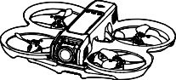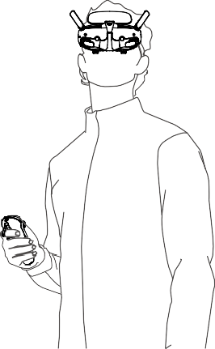

1. The maximum flight time of the aircraft is measured at a constant flying speed of 21.6 kph in a windless environment at sea level, with camera parameters set to 1080p/30fps, video mode off, and from 100% battery level until 0%. Data is for reference only. Always pay attention to reminders on the goggle screen during your flight.
2. The remote control devices reach their maximum transmission distance (FCC) in a wide open area with no electromagnetic interference at an altitude of about 120 m (400 ft). The maximum transmission distance refers to the maximum distance that the aircraft can still send and receive transmissions. It does not refer to the maximum distance the aircraft can fly in a single flight.

10 © 2024 DJI All Rights Reserved.

**DJI Avata 2** User Manual

* Visit the official DJI website to check the goggles and remote control devices supported by the aircraft. This manual only takes DJI Goggles 3 and DJI RC Motion 3 as examples for introduction. Refer to the user manuals of other supported devices respectively for use.
* Using the goggles does not satisfy the requirement of visual line of sight (VLOS). Some countries or regions require a visual observer to assist during flight. Make sure to comply with local regulations when using the goggles.
* DJI Goggles 3, DJI RC Motion 3, DJI FPV Remote Controller 3, and all types of ND filters are fully compatible with DJI Avata 2.

Using for the First Time



Click the link below or scan the QR code to watch the tutorial video before first time use.

[**https://www.dji.com/avata-2/video**](http://www.dji.com/avata-2/video)

Preparing the Aircraft

All Intelligent Flight Batteries are in hibernation mode before shipment to ensure safety. Charge to activate the batteries before first use. Connect the USB charger to the USB-C port on the aircraft to charge. The battery is activated when it begins charging.

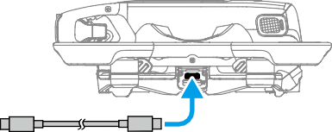

##### ≥30W

##### USB PD

© 2024 DJI All Rights Reserved. 11

**DJI Avata 2** User Manual

Remove the gimbal protector.

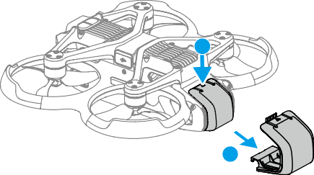

**1**

**2**

* It is recommended to use the DJI 65W USB-C Charger or other USB Power Delivery chargers with a charging power equal to or greater than 30W.
* It is recommended to attach the gimbal protector to protect the gimbal when the aircraft is not in use. Adjust the camera to keep it facing forward and horizontal, then install the gimbal protector and make sure it is secure.
* Peel off the protective stickers from the gimbal camera before first use.
* Make sure to remove the gimbal protector before powering on the aircraft. Otherwise, it may affect the aircraft when performing self-diagnostics.

12 © 2024 DJI All Rights Reserved.

**DJI Avata 2** User Manual

Preparing DJI Goggles 3

#### Powering on the Goggles

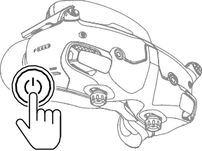

Press the power button once to check the current battery level.

Press once, then press and hold for two seconds to power the goggles on or off.

The battery level LEDs display the power level during charging and when in use:  LED is on

 LED is flashing  LED is off

|  |  |  |  |  |
| --- | --- | --- | --- | --- |
| LED1 | LED2 | LED3 | LED4 | Battery Level |
|  |  |  |  | 89%-100% |
|  |  |  |  | 76%-88% |
|  |  |  |  | 64%-75% |
|  |  |  |  | 51%-63% |
|  |  |  |  | 39%-50% |
|  |  |  |  | 26%-38% |
|  |  |  |  | 14%-25% |
|  |  |  |  | 1%-13% |

If the battery level is low, it is recommended to use a USB charger to charge the device.

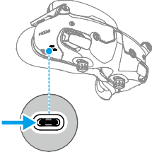

© 2024 DJI All Rights Reserved. 13

**DJI Avata 2** User Manual

###### The table below shows the battery level during charging:

|  |  |  |  |  |
| --- | --- | --- | --- | --- |
| LED1 | LED2 | LED3 | LED4 | Battery Level |
|  |  |  |  | 1%-50% |
|  |  |  |  | 51%-75% |
|  |  |  |  | 76%-99% |
|  |  |  |  | 100% |

* USB-C port spec: USB 2.0 (480 Mbps). The maximum input power is 9V/3A.

#### Wearing the Goggles

* The battery wires are embedded in the headband. DO NOT pull the headband with force to avoid damaging the wires.
* Fold the antennas to avoid damage when the goggles are not in use.
* DO NOT tear or scratch the foam padding, the additional forehead pad, and the soft side of the battery compartment with sharp objects.
* DO NOT bend the additional forehead pad with force.
* DO NOT rotate the headband adjustment knob or the diopter adjustment knob with force to avoid component damage.

1. Unfold the antennas.
2. Adjust the forehead pad downward to the lowest position.

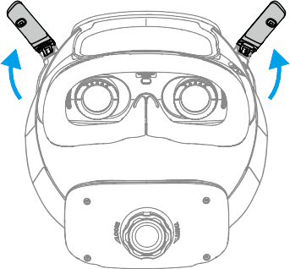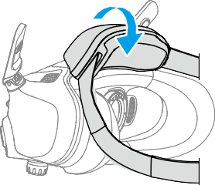

14 © 2024 DJI All Rights Reserved.

**DJI Avata 2** User Manual

1. Put on the goggles after the devices are powered on.
2. Rotate the headband adjustment knob on the battery compartment to adjust the length of the headband. Rotate clockwise to tighten the headband and counterclockwise to loosen the headband. It is recommended to wear the goggles with the battery compartment placed on the upper back part of the head to avoid it sliding down.

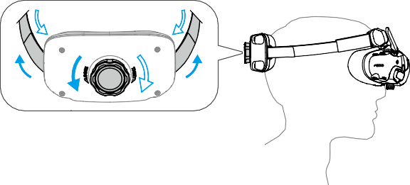

#### Getting Clear Vision

Rotate the knobs on the bottom of the goggles to adjust the diopters if your vision is in the range of -6.0D to +2.0D. The screen in the goggles will display the diopter value when rotating.

1. Rotate both the knobs in the direction as shown to unlock them. Once unlocked, the knobs will pop out.

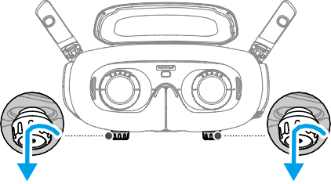

1. Slide left and right to adjust the distance between the lenses until the image is properly aligned.

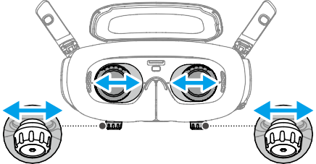

56~72 mm

© 2024 DJI All Rights Reserved. 15

**DJI Avata 2** User Manual

1. Slowly rotate the knobs to adjust the diopters. The supported adjustment range is from

-6.0D to +2.0D.

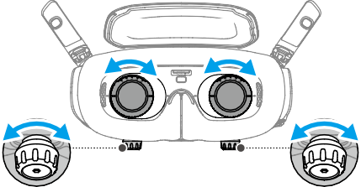

+2.0D ~ -6.0D

* + The goggles do not support astigmatism correction. If you require astigmatism correction or if the diopters of the goggles are unsuitable, you can purchase additional lenses and use the corrective lenses frames provided to install them on the goggles. Refer to “Using the Corrective Lenses” for more information.
  + When adjusting the diopters for the first time, you are advised to adjust to a degree that is slightly lower than the strength of your actual eyeglasses. Give your eyes enough time to adapt, then adjust the diopters again until you get a clear view. Do not use a diopter value higher than your actual eyeglass power to avoid eyestrain.

1. After you get a clear view, press the knobs in and rotate them in the direction as shown to lock in the lenses’ position of the lenses and the diopters.

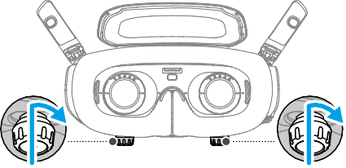

#### Using the Corrective Lenses

DJI Goggles 3 supports diopter adjustment from -6.0D to +2.0D.

If your vision is in the range of -6.0D to -8.0D, you can install the provided -2.0D Corrective Lenses.

16 © 2024 DJI All Rights Reserved.

**DJI Avata 2** User Manual

1. Detach the original lens frames from the goggles by rotating counterclockwise as shown.

###### +2.0D ~ -6.0D

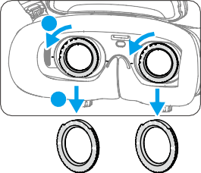

**1**

**2**

1. Take out the -2.0D Corrective Lenses and peel off the protective film. Distinguish the left and right lenses via the L and R marks on the bottom.
2. Align the positioning marks on the left and right sides of the corrective lens frame with the marks on the inner circle of the goggle lens frame. Mount the corrective lens by pressing it down, and then rotate it clockwise until the marks on the corrective lens frame are aligned with the marks on the goggle lens frame.

###### 0D ~ -8.0D

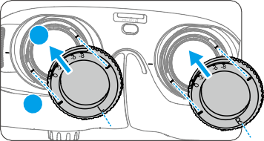

**2**

**1**

**L**

**R**

1. Adjust the diopters of the goggles according to your needs and lock the knobs.
   * After installing the -2.0D Corrective Lenses, the diopter value displayed on the screen is not the actual diopter value. The actual diopter value is the sum of the on-screen value and -2.0D.

© 2024 DJI All Rights Reserved. 17

**DJI Avata 2** User Manual

#### Purchasing and Installing Your Own Corrective Lenses

If you require astigmatism correction or the diopters of the goggles cannot meet your needs, you can purchase suitable lenses and use the corrective lens frames to install them.

* + When purchasing lenses, bring the full set of -2.0D Corrective Lenses (a pair with the frames) to a professional optician to ensure that the shape, size, astigmatism axis, and edge thickness (< 1.8 mm) of the lenses meet the installation requirements of the corrective lens frames.

1. Push and remove the -2.0D lens from the frame. Turn the frame over.

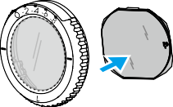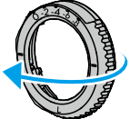

1. Identify the shortest cut edge (c) in the frame.

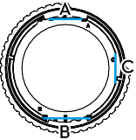

1. Take out the purchased lenses, also identify the shortest cut edge.
2. Distinguish the left and right lens and the corresponding frame. Align the shortest cut edge and install the lens into the frame with the concave side of the lens facing the eye.

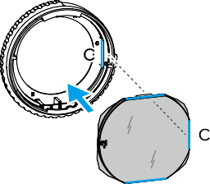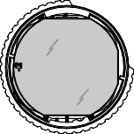

1. Make sure the lens is installed in the correct way and not tilted. Clean the lens with the lens cleaning cloth to wipe off fingerprints and dust.
2. Mount the corrective lenses to the goggles.

18 © 2024 DJI All Rights Reserved.

**DJI Avata 2** User Manual

1. Adjust the diopters of the goggles according to your needs and lock the knobs.
   * If you usually wear -9.0D glasses, you can purchase a pair of -3.0D lenses, and adjust the diopters of the goggles to -6.0D. Then the overall diopter value will be -9.0D after the self-prepared lenses are installed.

#### Using the Additional Forehead Pad

After installing the corrective lenses, the distance between the lenses and your eyes is reduced and your eyelashes might sweep the lenses. If you feel any discomfort, install the additional forehead pad.

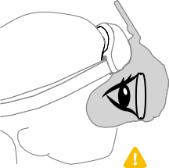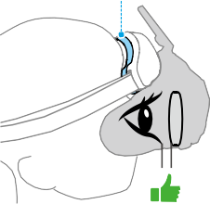Forehead Pad

1. Peel off the original forehead pad.
2. Attach the additional forehead pad and then install the original forehead pad on top.

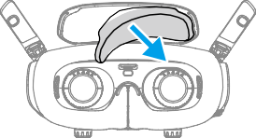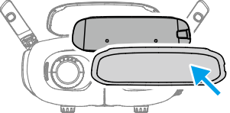

Preparing DJI RC Motion 3

Press the power button once to check the current battery level. Charge before using if the battery level is too low.

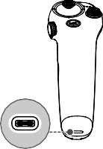



5V, 2A

© 2024 DJI All Rights Reserved. 19

**DJI Avata 2** User Manual

Linking

The aircraft, goggles, and motion controller are already linked when purchased together as a combo. Otherwise, follow the steps below to link the devices.

Make sure that the devices used with the aircraft have been updated to the latest firmware version via the DJI ASSISTANTTM 2 (Consumer Drone Series) software before linking and powered on.

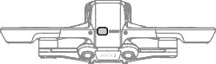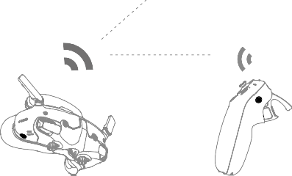

1. Linking the aircraft and the goggles:



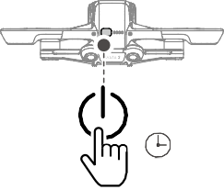

5s

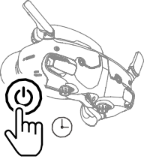

5s

* 1. Press and hold the power button on the aircraft until it beeps once and the battery level LEDs start to blink in sequence.
  2. Press and hold the power button on the goggles until the goggles start to beep continuously and the battery level LEDs start to blink in sequence.
  3. Once linking is completed, the battery level LEDs of the aircraft turn solid and display the battery level, the goggles stop beeping, and image transmission can be displayed normally.

20 © 2024 DJI All Rights Reserved.

**DJI Avata 2** User Manual

1. Linking the goggles and motion controller:



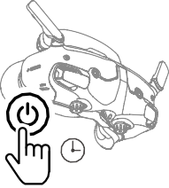

5s

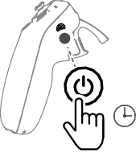

5s

* 1. Press and hold the power button on the goggles until the goggles start to beep continuously and the battery level LEDs start to blink in sequence.
  2. Press and hold the power button on the motion controller until it starts to beep continuously and the battery level LEDs start to blink in sequence.
  3. Once linking is successful, the goggles and the motion controller stop beeping and both the battery level LEDs turn solid and display the battery level.
     + Make sure the devices are within 0.5 m of each other during linking.
     + Restart the devices if the devices fail to link. Connect the goggles to a mobile device, run the DJI Fly app, select Connection Guide, and then follow the on-screen instructions to link.
     + The aircraft can be controlled with only one remote control device during flight. If your aircraft has been linked with multiple remote control devices, turn off the other remote control devices before flight.

Activation

DJI Avata 2 must be activated before using for the first time. Make sure all devices are linked after powering on the aircraft, goggles, and remote control device. Connect the USB-C port of the goggles to the mobile device, run DJI Fly, and follow the prompts to activate. An internet connection is required for activation. If automatic binding fails, follow the on-screen prompts on DJI Fly to bind the aircraft and goggles. The aircraft and goggles must be bound to receive service under warranty.

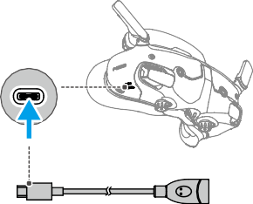

**DJI Fly App**

* + - The goggles only support standard USB-C protocols and MFi-certified Lightning cables. Non-standard cables are not supported. If the devices do not respond after connecting, use a different data cable and try again.

© 2024 DJI All Rights Reserved. 21

**DJI Avata 2** User Manual

Updating Firmware

A prompt will appear in DJI Fly when new firmware is available. Update the firmware whenever prompted to ensure optimal user experience. Refer to “Updating Firmware” for more information.

22 © 2024 DJI All Rights Reserved.

**DJI Avata 2** User Manual

Overview

Aircraft

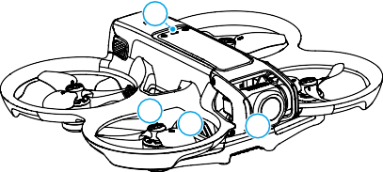

4

3

2

1

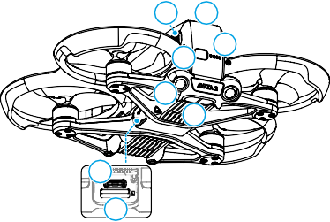

10 9

7

8

6

5

11

12

1. Gimbal and Camera
2. Propellers
3. Motors
4. Aircraft Status Indicator
5. Infrared Sensing System
6. Downward and Backward Vision System

DJI Goggles 3

1. Power Button
2. Battery Level LEDs
3. Intelligent Flight Battery
4. Battery Buckle
5. USB-C Port
6. microSD Card Slot

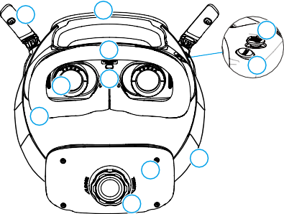

1

2

5

3

6

11

4

10

8

7

9

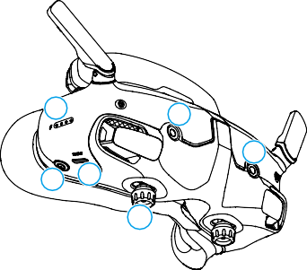

12

16

16

13

14

15

1. Antennas
2. Forehead Pad
3. microSD Card Slot
4. Proximity Sensor

Detects whether the user is wearing the goggles and automatically turns the screen on or off.

1. 5D Button
2. Back Button
3. Headband
4. Battery Compartment
5. Headband Adjustment Knob
6. Foam Padding
7. Lens
8. Battery Level LEDs
9. Power Button/Link Button
10. USB-C Ports
11. IPD (Interpupillary Distance) Slider / Diopter Adjustment Knob (hereinafter referred to as "knob")
12. Camera

© 2024 DJI All Rights Reserved. 23

**DJI Avata 2** User Manual

DJI RC Motion 3

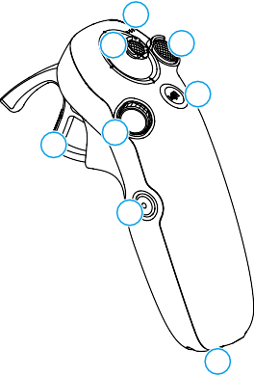

1

3

2

4

6

7

5

8

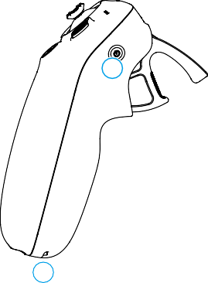

9

10

1. Battery Level LEDs
2. Lock Button
3. Joystick
4. Mode Button
5. Shutter/Record Button
6. Accelerator
7. Dial
8. USB-C Port
9. Power Button
10. Lanyard Hole

24 © 2024 DJI All Rights Reserved.

Flight Safety

© 2024 DJI All Rights Reserved. 25

**DJI Avata 2** User Manual

Flight Safety

After completing pre-flight preparations, it is recommended to train your flying skills and practice flying safely. Pick a suitable area to fly in according to the following flight requirements and restrictions. Strictly abide by local laws and regulations when flying. Read the Safety Guidelines before flight to ensure safe use of the product.

Flight Restrictions

GEO (Geospatial Environment Online) System

The DJI Geospatial Environment Online (GEO) System is a global information system that provides real-time information on flight safety and restriction updates and prevents UAVs from flying in restricted airspace. Under exceptional circumstances, restricted areas can be unlocked to allow flights in. Prior to that, the user must submit an unlocking request based on the current restriction level in the intended flight area. The GEO system may not fully comply with local laws and regulations. Users shall be responsible for their own flight safety and must consult with the local authorities on the relevant legal and regulatory requirements before requesting to unlock a flight in a restricted area. For more information about the GEO system, visit https://fly-safe.dji.com.

Flight Limits

For safety reasons, flight limits are enabled by default to help users operate this aircraft safely. Users can set flight limits on height and distance. Altitude limits, distance limits, and GEO zones function concurrently to manage flight safety when GNSS is available. Only altitude can be limited when GNSS is unavailable.

#### Flight Altitude and Distance Limits

Max altitude restricts the flight altitude of the aircraft, while max distance restricts the flight radius around the Home Point. These limits can be set using the goggles for improved flight safety.

Max Altitude

Home Point Max Distance

Height of aircraft when taking off

The Last updated Home Point



26 © 2024 DJI All Rights Reserved.

**DJI Avata 2** User Manual

###### Strong GNSS Signal

|  |  |  |
| --- | --- | --- |
|  | Flight Restrictions | Prompt in Goggles |
| Max Altitude | Flight altitude must be below the preset height. | Max flight altitude reached. |
| Max Distance | The straight-line distance from the aircraft to the Home Point cannot exceed the max flight distance set in the goggles. | Max flight distance reached. |

###### Weak GNSS Signal

|  |  |  |
| --- | --- | --- |
|  | Flight Restrictions | Prompt in Goggles |
| Max Altitude | * Altitude is restricted to 50 m from the takeoff point if lighting is sufficient. * Altitude is restricted to 3 m above the ground if lighting is not sufficient and the infrared sensing system is operating. * The altitude is restricted to 50 m from the takeoff point if lighting is not sufficient and the infrared   sensing system is not operating. | Max flight altitude reached. |
| Max Distance | No limits | |

* Each time the aircraft is powered on, the altitude limit of 3 m or 50 m will be automatically removed as long as the GNSS signal ever becomes strong (GNSS signal display white or yellow) once, and the limit will not take effect even if the GNSS signal becomes weak afterwards.



* If the aircraft flies out of the set flight range due to inertia, users can still control the aircraft but cannot fly it any further. If the aircraft flies above the altitude limit, it will descend below the altitude limit at 5 m/s. If the aircraft flies into an Altitude Zone, landing will be triggered after a 100-second countdown.
* For safety reasons, DO NOT fly the aircraft close to airports, highways, railway stations, railway lines, city centers, or other sensitive areas. Only fly the aircraft within a visual line of sight.

#### GEO Zones

The DJI GEO system designates safe flight locations, provides risk levels and safety notices for individual flights and offers information on restricted airspace. All restricted flight areas are referred to as GEO Zones, which are further divided into Restricted Zones, Authorization Zones, Warning Zones, Enhanced Warning Zones, and Altitude Zones. Users can view such information in real-time in DJI Fly. GEO Zones are specific flight areas, including but not limited to airports, large event venues, locations where public emergencies have occurred (such as forest fires), nuclear power plants, prisons, government properties, and military facilities. By default, the GEO system limits takeoffs and flights in zones that may cause safety or security concerns. A GEO Zone map that contains comprehensive information on GEO Zones around the globe is available on the official DJI website: https://fly-safe.dji.com/nfz/nfz-query.

© 2024 DJI All Rights Reserved. 27

**DJI Avata 2** User Manual

Unlocking GEO Zones

To satisfy the needs of different users, DJI provides two unlocking modes: Self-Unlocking and Custom Unlocking. Users may make a request on the DJI Fly Safe website.

Self-Unlocking is intended for unlocking Authorization Zones. To complete Self-Unlocking, the user must submit an unlocking request via the DJI Fly Safe website at https://fly-safe.dji.com. Once the unlocking request is approved, the user may synchronize the unlocking license through the DJI Fly app. Alternatively, to unlock a zone, the user may launch or fly the aircraft directly into the approved Authorization Zone and follow the prompts in DJI Fly to unlock the zone.

Custom Unlocking is tailored for users with special requirements. It designates user-defined custom flight areas and provides flight permission documents specific to the needs of different users. This unlocking option is available in all countries and regions and can be requested via the DJI Fly Safe website at [https://www.dji.com/flysafe.](http://www.dji.com/flysafe)

* To ensure flight safety, the aircraft will not be able to fly out of the unlocked zone after entering it. If the Home Point is outside the unlocked zone, the aircraft will not be able to return home.



28 © 2024 DJI All Rights Reserved.

**DJI Avata 2** User Manual

Flight Environment Requirements

1. DO NOT operate the aircraft in severe weather conditions including wind speeds exceeding

10.7 m/s, snow, thunder and lightning, rain, and fog.

1. Only fly in open areas. Tall buildings and large metal structures may affect the accuracy of the onboard compass and GNSS system. Therefore, DO NOT take off from a balcony or anywhere within 15 m of buildings. Keep a distance of at least 15 m from buildings during flight. After takeoff, make sure you are notified with the message prompt "Home Point has been updated" before continuing flight. If the aircraft has taken off near buildings, the accuracy of the Home Point cannot be guaranteed. In this case, pay close attention to the current position of the aircraft during auto RTH. When the aircraft is close to the Home Point, it is recommended to cancel auto RTH and manually control the aircraft to land at an appropriate location.
2. When the GNSS signal is weak, fly the aircraft in environments with good lighting and visibility. The vision system may not work properly in poor light conditions. Only fly the aircraft in the daytime.
3. Avoid obstacles, crowds, trees, and bodies of water (recommended height is at least 6 m above water).
4. Minimize interference by avoiding areas with high levels of electromagnetism, such as locations near power lines, base stations, electrical substations, and broadcasting towers.
5. Try to keep a distance of more than 200 m from strong electromagnetic wave interference sites, such as radar stations, microwave relay stations, mobile communication base stations, and drone jamming equipment.
6. The performance of the aircraft and its battery is limited when flying at altitudes above 5000 m (16,404 ft). Fly with caution.
7. The braking distance of the aircraft is affected by the flight altitude. The higher the altitude, the greater the braking distance. When flying at an altitude above 3000 m (9843 ft), the user should reserve at least 20 m for vertical braking distance and 25 m for horizontal braking distance to ensure flight safety.
8. GNSS cannot be used on the aircraft in polar regions. Use the vision system instead.
9. DO NOT take off from moving objects, such as cars and ships.
10. DO NOT take off from solid-colored surfaces or surfaces with strong reflections such as a car roof.
11. DO NOT operate the aircraft in an environment where there is risk of risk of a fire or explosion.
12. Operate the aircraft, goggles, remote control device, battery, battery charger, and the battery charging hub in a dry environment.
13. DO NOT use the aircraft, goggles, remote control device, battery, battery charger, and the battery charging hub near accidents, fire, explosions, floods, tsunamis, avalanches, landslides, earthquakes, dust, sandstorms, salt spray, or fungus.
14. DO NOT operate the aircraft near bird flocks.
15. DO NOT use the battery charger in humid environments.

© 2024 DJI All Rights Reserved. 29

**DJI Avata 2** User Manual

Operating the Aircraft Responsibly

To avoid serious injury and property damage, observe the following rules:

1. Make sure you are NOT under the influence of anesthesia, alcohol, or drugs or suffering from dizziness, fatigue, nausea, or other conditions that could impair the ability to operate the aircraft safely.
2. When landing, power off the aircraft first, then power off the remote control device.
3. DO NOT drop, launch, fire, or otherwise project any dangerous payloads on or at any buildings, persons, or animals, which could cause personal injury or property damage.
4. DO NOT use an aircraft that has been crashed or accidentally damaged or an aircraft that is not in good condition.
5. Make sure to train sufficiently and have contingency plans for emergencies or when an incident occurs.
6. Make sure to have a flight plan. DO NOT fly the aircraft recklessly.
7. Respect the privacy of others when using the camera. Make sure to comply with local privacy laws, regulations, and moral standards.
8. DO NOT use this product for any reason other than general personal use.
9. DO NOT use it for illegal or inappropriate purposes such as spying, military operations, or unauthorized investigations.
10. DO NOT use this product to defame, abuse, harass, stalk, threaten, or otherwise violate legal rights such as the right to privacy and publicity of others.
11. DO NOT trespass onto the private property of others.

Pre-Flight Checklist

1. Make sure the goggles, remote control devices, Intelligent Flight Battery, and mobile device are fully charged.
2. Make sure the propellers are mounted correctly and securely.
3. Make sure the Intelligent Flight Battery is properly connected and secure.
4. Make sure the dust-resistant covers of the USB-C port and the microSD card slot are firmly closed.
5. Make sure the gimbal protector has been removed. Make sure all camera lenses and sensors are clean.
6. Make sure the aircraft, the remote control device, the gimbal and the camera are functioning normally.
7. Make sure the goggles antennas are unfolded.
8. Make sure that the goggles are functioning normally and display the video transmission.
9. Make sure the max flight altitude, max flight distance and RTH altitude are all set properly in the goggles according to the local laws and regulations.
10. Only use genuine DJI parts or DJI-authorized parts. Unauthorized parts may cause system malfunctions and compromise flight safety.

30 © 2024 DJI All Rights Reserved.

**DJI Avata 2** User Manual

1. Check if the Remote ID is up to date and working.
2. DO NOT fly over densely populated areas.

© 2024 DJI All Rights Reserved. 31

Flight Operation

32 © 2024 DJI All Rights Reserved.

Flight Operation

**DJI Avata 2** User Manual

This section explains how to perform different actions with the aircraft. The steps below will help users operate the aircraft properly.

1. Place the aircraft in an open, flat area with the rear of the aircraft facing the user.
2. Power on the goggles, remote control device, and the aircraft.
3. Wait until the aircraft status indicator blinks green slowly and put on the goggles.
4. Start the motors.
5. Check the flight liveview in the goggles to make sure that there are no warning prompts and that the GNSS signal is strong.
6. Press the lock button twice to start the aircraft motors, then press and hold to make the aircraft take off. The aircraft will ascend to approximately 1.2 m and hover.
7. Press and hold the lock button while the aircraft is hovering to land it automatically and stop the motors.
8. Power off the aircraft, goggles, and remote control device.

Basic Flight Operations

* + It is recommended to watch the tutorial guide in the goggles before the first flight. Go to Settings > Control > Motion Controller > Flight Control > Motion Controller Instructions.

Operate the aircraft by using the lock button, joystick, and accelerator of the DJI Motion Controller 3.

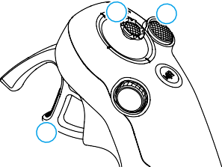

2

1

3

 Use the lock button to control the takeoff, landing, and braking of the aircraft.

1

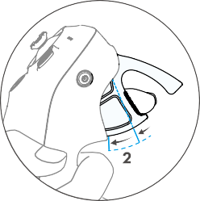

**2 1**

 Move the joystick to make the aircraft ascend, descend, or move left or right horizontally*.

2

 There are two levels of pressure when pressing the accelerator. When gently pressing to the position in the middle of the first and second stop, you can feel a noticeable pause. Press the accelerator to different stops to control different actions of the aircraft.

3

* When Easy ACRO is not enabled or the Easy ACRO action is selected as Slide.

© 2024 DJI All Rights Reserved. 33

**DJI Avata 2** User Manual

|  |  |
| --- | --- |
|  | When the accelerator is not pressed, the aircraft will hover. |
| **1** | When gently pressing the accelerator to the first stop, you can adjust the aircraft orientation by tilting the motion controller vertically to the left or right.  Note that the aircraft will not fly forward at this time. |
| **2** | Press the accelerator to the second stop to make the aircraft to fly in the direction of the circle in the goggles. |

Taking Off, Braking and Landing

Takeoff Press the lock button twice to start the aircraft motors, then press and hold the button again to make the aircraft take off. The aircraft will ascend to approximately 1.2 m and hover.

Braking Press the lock button during flight to make the aircraft brake and hover in place.

Press again to resume flight control.

Landing Press and hold the lock button while the aircraft is hovering to land it automatically and stop the motors.

* After the aircraft motors have been started by double-pressing the lock button, slowly push the joystick up to make the aircraft take off.
* When Easy ACRO is disabled, once the aircraft flies to the landing position, gently push the joystick downwards to land the aircraft. After landing, push the joystick down and hold in position until the motors stop.

34 © 2024 DJI All Rights Reserved.

**DJI Avata 2** User Manual

* If an emergency occurs (such as a collision or the aircraft is out of control) during flight, pressing the lock button four times will trigger Stop Motors Mid-flight, which will stop the aircraft motors immediately. The Stop Motors Mid-flight function will

###### cause the aircraft to crash. Operate with caution.

* To ensure flight safety when using the motion controller, press the lock button once to brake and hover before operating the goggles. Failure to do so is a safety risk and may lead to the aircraft losing control or injury.

Flying Forward and Backward

Press or push the accelerator of the motion controller to fly forward or backward. Apply more pressure when pressing or pushing to accelerate. Release to stop and hover.

|  |  |
| --- | --- |
| Flight Trajectory | Remarks |
|  | Press the accelerator to the second stop to make the aircraft fly in the direction of the circle in the goggles. |
|  | Push the accelerator forward to fly the aircraft in reverse. |

© 2024 DJI All Rights Reserved. 35

**DJI Avata 2** User Manual

Adjusting Aircraft Orientation

Gently press the accelerator to the first stop and simultaneously tilt the top of the motion controller in either direction to make the aircraft rotate. The greater the tilt angle of the motion controller, the faster the aircraft will rotate. The circle in the goggles will move left and right and the flight liveview will change accordingly.

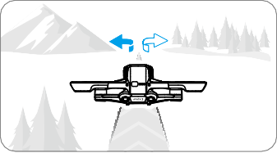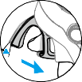

**+**

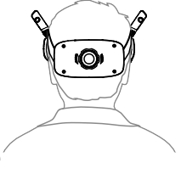Making the Aircraft Ascend or Descend at an Angle

When the aircraft needs to fly at an upward angle, press the accelerator to the second stop while simultaneously tilting the motion controller up.

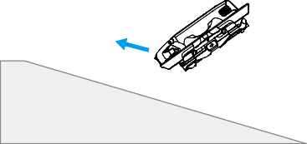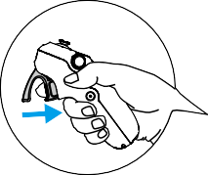

When the aircraft needs to fly at an downward angle, press the accelerator to the second stop while simultaneously tilting the motion controller down.

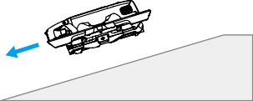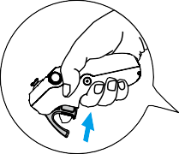

36 © 2024 DJI All Rights Reserved.

**DJI Avata 2** User Manual

Controlling the Gimbal and Camera

During flight, or when the accelerator is not being pressed and the aircraft is hovering, tilt the motion controller up and down to control the tilt of the gimbal. The tilt of the gimbal changes with the tilt of the motion controller accordingly and is always consistent with the orientation of the motion controller. The circle in the goggles will move up and down and the flight liveview will change accordingly.

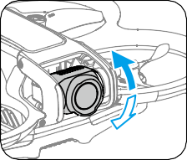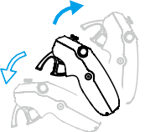

* Before takeoff or when using the lock button to trigger the aircraft to hover, the tilt of the gimbal cannot be controlled.
* Using the dial on the motion controller, scroll up or down to tilt the camera before takeoff or during RTH and landing.

### Switching Flight Modes

The motion controller has two modes: Normal mode and Sport mode. Normal mode is selected by default.

Press the mode button once to switch between Normal mode and Sport mode. While flying in Sport mode, the flight speed of the aircraft will be faster. The operation logic of the motion controller remains the same in Sport mode as it is in Normal mode.

Refer to the section "Flight Modes" to know more about the difference between each flight mode.

### Head Tracking

When Head Tracking is enabled, the horizontal orientation of the aircraft and the gimbal tilt can be controlled through head movements. Open the shortcut menu from the flight liveview, access the quick control menu, and click  to enable Head Tracking.

Once in Head Tracking mode, the motion controller will not be able to control the gimbal tilt, and only control via the aircraft is available. Users can still control the aircraft's heading by tilting the motion controller without pressing the accelerator.

* Head Tracking is not available after taking off the goggles.

© 2024 DJI All Rights Reserved. 37

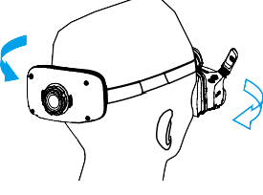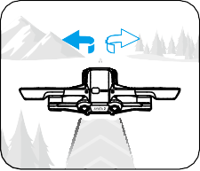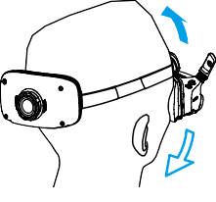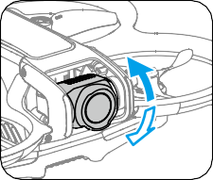**DJI Avata 2** User Manual

Easy ACRO

Use the motion controller to perform Easy ACRO actions including front flip, backflip, roll, and 180° drift.



* For flight safety, perform Easy ACRO actions in an open environment.



1. Open the shortcut menu and select Easy ACRO. The aircraft will be in Easy ACRO mode. Easy ACRO includes three actions: Slide, 180° Drift, and Flip. View the selected action on the left side of liveview in the goggles.

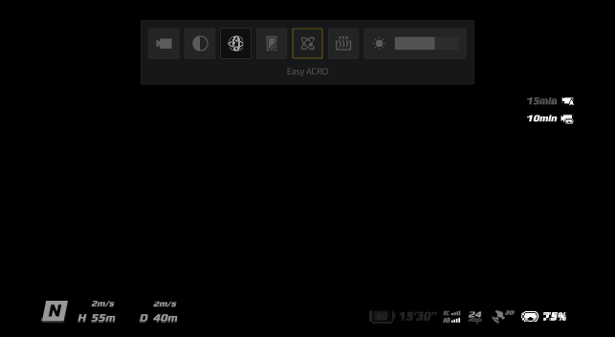

38 © 2024 DJI All Rights Reserved.

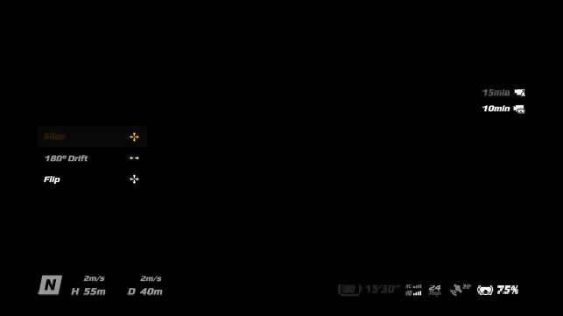**DJI Avata 2** User Manual

1. Use the dial on the motion controller to switch between Easy ACRO actions.
2. When Easy ACRO is enabled, move the joystick to perform different Easy ACRO actions as shown below.

### Slide

Push the joystick up or down to make the aircraft ascend or descend.

Push the joystick left or right to make the aircraft move left or right horizontally.

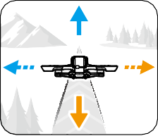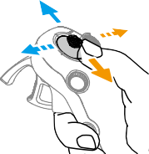

### 180° Drift

Push the joystick left or right to make the aircraft 180° drift left or right.

The aircraft will not respond when pushing the joystick up or down in this action mode.

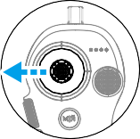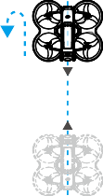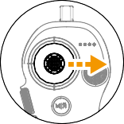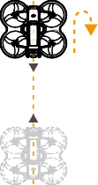

© 2024 DJI All Rights Reserved. 39

**DJI Avata 2** User Manual

### Flip

Push the joystick up or down to make the aircraft perform a front flip or backflip. Push the joystick left or right to make the aircraft do one roll to the left or right.

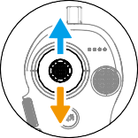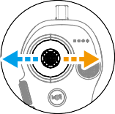

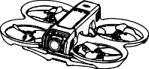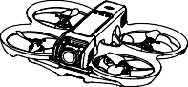

* Easy ACRO cannot be enabled in the following situations:
  1. When recording video;
  2. When Head Tracking is enabled;
  3. When used with DJI FPV Remote Controller 3.
* Pay attention to surroundings and make sure there are no obstacles nearby before performing Easy ACRO actions.
* Easy ACRO is unavailable in the following situations:
  1. The aircraft is taking off, hovering, landing, or returning to home;
  2. The aircraft is in Sport mode;
  3. The aircraft battery level is lower than 25%;
  4. The altitude of the aircraft is less than 1.5m;
  5. Flying in an environment with strong wind (wind speed exceeding 10 m/s);
  6. The positioning performance is not good (the GNSS signal is weak);
  7. The aircraft is in a buffer zone of a Restricted Zone or an Altitude Zone, or is approaching the Max Flight Distance.
* As the attitude angle of the aircraft increases (such as when making high-speed turns or when accelerating or decelerating quickly), the aircraft altitude will also need to be increased, otherwise Easy ACRO cannot be used.

Video Recording Suggestions and Tips

1. The pre-flight checklist is designed to help the user fly and shoot videos safely. Go through the full pre-flight checklist before each flight.
2. It is recommended to use Normal mode to take photos or record videos.
3. DO NOT fly in bad weather such as on rainy or windy days.
4. Choose the camera settings that best suit your needs.
5. Perform flight tests to establish flight routes and preview scenes.
6. When flying, control the pressure applied on the accelerator to ensure smooth and stable movement of the aircraft.

40 © 2024 DJI All Rights Reserved.

# Aircraft

© 2024 DJI All Rights Reserved. 41

**DJI Avata 2** User Manual

Aircraft

Flight Modes

The aircraft supports the following flight modes. Flight modes can be switched between Normal mode and Sport mode using the Mode button on the motion controller.

Normal Mode: The aircraft can hover precisely and fly with stability in this mode, making it suitable for most flight scenarios.

Sport Mode: The maximum horizontal flight speed of the aircraft will increase in Sport mode.

Manual Mode: Classic FPV aircraft control mode with the highest maneuverability. In Manual mode, all flight assistance functions including precise hovering and auto-brake are disabled and proficient control skills are required.

In Normal or Sport mode, the aircraft will experience horizontal drift and RTH will be unavailable when the downward vision system is unavailable or disabled and when the GNSS signal is weak or the compass experiences interference. In this case, the aircraft cannot hover or brake automatically. Land the aircraft as soon as possible in order to avoid accidents. Avoid flying in confined spaces, or in areas where the GNSS signal is weak or the lighting is not sufficient.

* For safety reasons, the aircraft flies in Beginner mode by default for the first flight. In Beginner mode, the maximum flight speed of the aircraft is 1 m/s. To exit Beginner mode, open the menu on the goggles, go to Settings > Control > Beginner Mode.
* Manual mode is only supported when using the DJI FPV Remote Controller 3 to operate the aircraft. Throttle stick resistance can also be adjusted. DJI Motion Controller 3 does not support Manual mode. Refer to the DJI FPV Remote Controller 3 User Manual for more information on Manual mode.
* A minimum braking distance of 10 m is required in windless conditions while the aircraft is ascending and descending in Sport mode or Normal mode.
* The maximum flight speed and braking distance of the aircraft significantly increases in Sport mode. A minimum braking distance of 30 m is required in windless conditions.
* The responsiveness of the aircraft significantly increases in Sport mode, which means a small control stick movement on the remote control device translates into the aircraft moving a large distance. Make sure to maintain adequate maneuvering space during flight.

42 © 2024 DJI All Rights Reserved.

**DJI Avata 2** User Manual

* When the flight altitude of the aircraft is less than 5 m or when there are obstacles within a radius of 5 m around the aircraft, use caution when enabling Manual mode. The attitude may become unstable when turning the aircraft in Manual mode in the situations mentioned below. Operate the aircraft with caution to ensure a stable flight.
  1. When turning the aircraft at a high speed;
  2. When the flight height is over 3000 meters above the sea level;
  3. When the flight speed exceeds 13 m/s or the wind speed exceeds 7.9 m/s.

Aircraft Status Indicator

The aircraft has an aircraft status indicator on the top of the body.

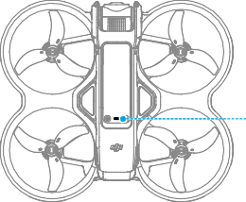Aircraft Status Indicator

###### Aircraft Status Indicator Descriptions



Normal States

Blinks red, yellow, and

green alternately Powering on and performing self-diagnostic tests

Blinks yellow slowly

GNSS and vision system disabled

Blinks yellow quickly

Remote control device signal lost

Blinks red quickly

Critically low battery

——

Solid red

Critical error

Warning States

The aircraft is in Manual mode

Blinks purple slowly

Blinks red and yellow Compass calibration required alternately

Blinks red IMU error

Blinks red slowly Takeoff is disabled, e.g. low battery [1]

Blinks green slowly GNSS or vision system enabled for positioning

1. If the aircraft cannot takeoff while the status indicators are blinking red slowly, view the warning prompt in the goggles.

© 2024 DJI All Rights Reserved. 43

**DJI Avata 2** User Manual

## Return to Home

The Return to Home (RTH) function will automatically fly the aircraft back to the last recorded Home Point. RTH can be triggered in three ways: the user actively triggers RTH, the aircraft has low battery, or the remote control signal or video transmission signal has been lost (Failsafe RTH is triggered). If the aircraft records the Home Point successfully and the positioning system is functioning normally, when the RTH function is triggered, the aircraft will automatically fly back and land at the Home Point.

|  |  |  |
| --- | --- | --- |
|  | GNSS | Description |
| Home Point | 10 | The first location where the aircraft receives a strong to moderately strong GNSS signal (indicated by a white icon) will be recorded as the default Home Point. The Home Point can be updated when taking off as long as the aircraft receives another strong to moderately strong GNSS signal. If the signal is weak, the Home Point will not be updated. The aircraft status indicator blinks green quickly and a prompt appears in the goggles to confirm the Home Point has been updated.  During flight an H symbol is displayed in the goggles to indicate the location of the last recorded Home Point of the aircraft. |

### Warnings

* + During RTH, obstacles around and above the aircraft cannot be detected or avoided.
  + The aircraft cannot return to the Home Point if the GNSS signal is weak or unavailable. If the GNSS signal becomes weak or unavailable after Failsafe RTH is triggered, the aircraft will automatically descend and land.
  + Make sure set the RTH altitude before each flight. Go to Settings > Safety on the goggles and set a suitable RTH altitude.
  + GEO Zones will affect RTH. The aircraft will hover if it flies into a GEO Zone during RTH.
  + The aircraft may not be able to return to the Home Point when the wind speed is too high. Fly with caution.
  + When the aircraft is flying in an environment surrounded by obstacles (such as near tall buildings), or when the GNSS signal is weak, the location of the Home Point may be inaccurate, leading to a large error in the horizontal distance between the aircraft and the Home Point displayed on the goggles. Fly with caution.

### Trigger Method

###### The user actively triggers RTH

Press and hold the Mode button on the motion controller to initiate RTH. The aircraft will fly back to the last updated Home Point. When the aircraft is performing RTH, press the lock button

44 © 2024 DJI All Rights Reserved.

**DJI Avata 2** User Manual

once to cancel RTH. After exiting RTH, users will regain control of the aircraft.

###### Aircraft low battery

When the battery level is low and only sufficient to fly to the Home Point, a warning prompt will appear in the goggles and RTH will be triggered following the prompt. RTH can be canceled using the remote control devices. If RTH is canceled following a low battery warning, the Intelligent Flight Battery may not have enough power for the aircraft to land safely, which may lead to the aircraft being crashed or lost.

The aircraft will land automatically if the current battery level can only support the aircraft long enough to descend from its current altitude. Auto landing cannot be canceled, but the remote control devices can be used to control the horizontal movement of the aircraft during landing.

###### Loss of remote control or video transmission signal

When the remote control signal or video transmission signal is lost, the aircraft will automatically initiate Failsafe RTH if the Signal Lost Action is set to RTH.

The aircraft will fly backwards 50 m along its original flight route and then perform the RTH procedure. The aircraft will directly perform the RTH procedure if the signal is restored when flying backward along the original flight route.

* The response of the aircraft when the wireless signal is lost can be modified in the goggles. The aircraft will not perform Failsafe RTH if land or hover has been selected in the settings.

### RTH Procedure

1. The Home Point is recorded.
2. RTH is triggered.
3. When RTH begins, the RTH procedure varies according to different RTH distances (the horizontal distance between the aircraft and the Home Point):
   1. The aircraft lands immediately if the RTH distance is less than 5 m.
   2. If the RTH distance is farther than 5 m but less than 20 m, it flies to the Home Point in a straight line at the current altitude.
   3. If RTH distance is farther than 20 m, it ascends to the RTH altitude and flies back to the Home Point. The aircraft flies to the Home Point at the current altitude if the RTH altitude is lower than the current altitude.
4. The aircraft begins to land when it reaches the spot above the Home Point.

### Landing Protection

Landing Protection activates during RTH and auto landing.

1. During Landing Protection, the aircraft will automatically detect and carefully land on suitable ground.
2. If the ground is determined unsuitable for landing, the aircraft will hover and wait for pilot confirmation.

© 2024 DJI All Rights Reserved. 45

**DJI Avata 2** User Manual

1. If Landing Protection is not operational, the goggles will display a landing prompt when the aircraft descends to 0.25 m. Press and hold the lock button on the motion controller and the aircraft will land.
   * Landing Protection only assists in determining the landing environment. Pay attention to the surrounding environment during landing to ensure safety.
   * In the following situations, Landing Protection may be unavailable and the aircraft may land directly on unsuitable ground:
     1. Flying over monochrome, reflective, or low-light surfaces, a large area of surfaces without clear texture, or surfaces with dynamic texture, such as smooth ceramic tiles, garage ground with insufficient light, and grass blowing in the wind;
     2. Flying over obstacles without clear texture, such as large rocks, or reflective or monochrome surfaces, such as raised tiles;
     3. Flying over small or fine obstacles, such as power lines and tree branches;
     4. Flying over surfaces that are similar to flat ground, such as trimmed and flat shrubs, flat tree tops, and hemispherical ground.
   * In the following situations, Landing Protection may be triggered by mistake and a prompt will appear in the goggles that the aircraft is unable to land:
     1. Flying over surfaces that the vision system may confuse for water, such as wet ground and areas with puddles;
     2. Flying over flat surfaces, but there are surfaces with clear texture (oblique surfaces or stairs) nearby, such as monochrome car tops and monochrome tables.

Vision System and Infrared Sensing System

The aircraft is equipped with both a Downward and Backward Vision System and Infrared Sensing System.

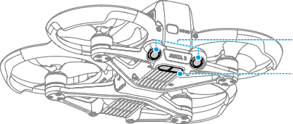Downward and Backward Vision System Infrared Sensing System

The positioning function of the downward vision system is applicable when GNSS signals are unavailable or weak. It is automatically enabled in Normal or Sport mode.

46 © 2024 DJI All Rights Reserved.

**DJI Avata 2** User Manual

### Detection Range

Backward FOV: 78° (horizontal), 78° (vertical)

Downward FOV: 78° (horizontal), 78° (vertical)

Precision Measurement Range: 0.3-20 m; Precision Hovering Range: 0.3-10 m.

* Pay attention to the flight environment. The vision system and infrared sensing system only work in certain scenarios and cannot replace human control and judgment. During flight, pay attention to the surrounding environment and to the warnings on the goggles. Be responsible for and maintain control of the aircraft at all times.



* The aircraft has a maximum hovering altitude of 20 m when using the vision system in an open and flat environment with clear texture. The vision system works best when the aircraft is at an altitude from 0.5-10 m. Extra caution is required if the altitude of the aircraft is above 10 m as vision positioning performance may be affected.
* The vision system may not work properly when the aircraft is flying near water. Therefore, the aircraft may not be able to actively avoid water below it when landing. It is recommended to maintain flight control at all times, make reasonable judgments based on the surrounding environment, and avoid over-relying on the downward vision system.
* The vision system and infrared sensing system may not function properly when the aircraft is flying too fast.
* The vision system cannot work properly near surfaces without clear pattern variations or where the light is too weak or too strong. The vision system cannot work properly in the following situations:
  1. Flying near monochrome surfaces (e.g., pure black, pure white, pure green);
  2. Flying near highly reflective surfaces;
  3. Flying near water or transparent surfaces;
  4. Flying near moving surfaces or objects;
  5. Flying in an area where the lighting changes frequently or drastically;
  6. Flying near extremely dark (< 10 lux) or bright (> 40,000 lux) surfaces;
  7. Flying near surfaces that strongly reflect or absorb infrared waves (e.g., mirrors);
  8. Flying near surfaces without clear patterns or texture (e.g., power poles);
  9. Flying near surfaces with repeating identical patterns or textures (e.g., tiles with the same design);
  10. Flying near obstacles with small surface areas (e.g., tree branches and power lines).
* Keep the sensors clean at all times. DO NOT tamper with the sensors. DO NOT use the aircraft in environments with significant dust or humidity. DO NOT obstruct the infrared sensing system.
* If the aircraft is involved in a collision, it may be necessary to calibrate the vision system.
* DO NOT fly when it is rainy, smoggy, or the visibility is lower than 100 m.

© 2024 DJI All Rights Reserved. 47

**DJI Avata 2** User Manual

* Check the following every time before takeoff:
  1. Make sure there are no stickers or any other obstructions over the glass of the infrared sensing system and vision system;
  2. Use a soft cloth if there is any dirt, dust, or water on the glass of the vision systems and infrared sensing systems. DO NOT use any cleaning product that contains alcohol;
  3. Contact DJI Support if there is any damage to the glass of infrared sensing system and vision system.

Propellers

There are two types of propellers, which are designed to spin in different directions. Make sure to match the propellers and motors by following the instructions.

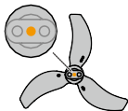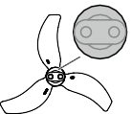

Illustration

Propellers With Orange Marks Without Orange Marks

Mounting Position

Attach to the motors of the marked arm.

Attach to the motors of the unmarked arm.

48 © 2024 DJI All Rights Reserved.

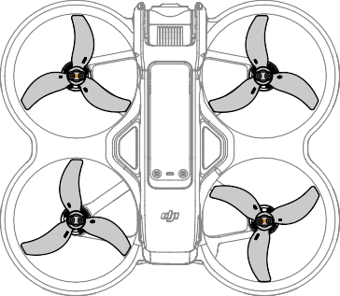**DJI Avata 2** User Manual

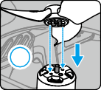

**1**

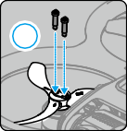

**2**

### Attaching and Detaching the Propellers

Attach the marked propellers to the motors of the marked arm, and the unmarked propellers to the motors of the unmarked arm. Use the 1.5mm screwdriver from the aircraft package to mount the propellers. Make sure the propellers are secure.

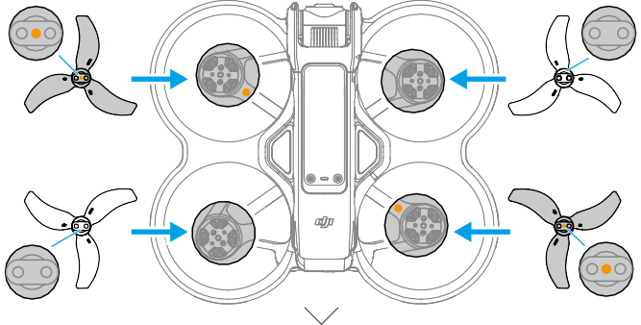



© 2024 DJI All Rights Reserved. 49

**DJI Avata 2** User Manual

Use the screwdriver from the aircraft package to loosen the screws and detach the propellers from the motors.

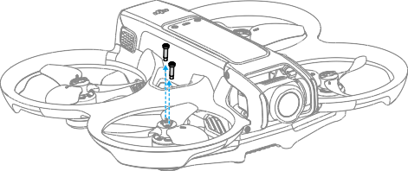

* Propeller blades are sharp. Handle with care.
* Only use official DJI propellers. DO NOT mix propeller types.
* Propellers are consumable components. Purchase additional propellers if necessary.
* Make sure to only use the screwdriver from the aircraft package for mounting propellers. Using other screwdrivers may damage the screws.
* If a propeller is broken, remove the propeller and screws on the corresponding motor and discard them.
* Make sure that the propellers and motors are installed securely before each flight. Check to make sure the screws on the propellers are tightened after every 30 hours of flying time (approx. 60 flights).
* Make sure that all propellers are in good condition and clean (without any foreign matter in or on them) before each flight. DO NOT use aged, chipped, or broken propellers. Clean the propellers with a soft, dry cloth if there is any foreign matter attached.
* To avoid injury, stay away from rotating propellers or motors.
* To avoid damaging the propellers, pack the aircraft correctly for transportation or storage. DO NOT squeeze or bend the propellers. If the propellers are damaged, the flight performance may be affected.
* Make sure the motors are mounted securely and rotating smoothly. Land the aircraft immediately if a motor is stuck and unable to rotate freely.
* DO NOT attempt to modify the structure of the motors.
* DO NOT touch or let hands or body parts come in contact with the motors after flight, as they may be hot.
* DO NOT block any of the ventilation holes on the motors or the body of the aircraft.
* Make sure the aircraft beeps when powered on.

50 © 2024 DJI All Rights Reserved.

**DJI Avata 2** User Manual

Intelligent Flight Battery

The aircraft can be used with DJI Avata 2 Intelligent Flight Battery (BWX520-2150-14.76). This battery is a 14.76V, 2150mAh battery that adopts high-energy battery cells and uses an advanced battery management system.

### Warnings

* Refer to the Safety Guidelines and the stickers on the battery before use. Users shall take full responsibility for all operation and usage.

1. DO NOT charge an Intelligent Flight Battery immediately after flight as it may be too hot. Wait for the battery to cool down to the charging temperature before charging again.
2. To prevent damage, the battery only charges when the temperature is between 5° and 40° C (41° and 104° F). The ideal charging temperature is from 22° to 28° C (71.6° to 82.4° F). Charging stops automatically if the temperature of the battery cells exceed 55° C (131° F) during charging.
3. Low Temperature Notice:
   1. Batteries cannot be used in extremely low-temperature environments of lower than

-10° C (14° F).

* 1. Battery capacity is significantly reduced when flying at low temperatures from -10° to 5° C (14° to 41° F). Make sure to fully charge the battery before takeoff. It is recommended to hover the aircraft in place for a while to heat the battery.
  2. When in low-temperature environments, end the flight as soon as the goggles display the low battery voltage warning.
  3. To ensure optimal performance, keep the battery temperature above 20° C (68° F).
  4. The reduced battery capacity in low-temperature environments reduces the wind speed resistance performance of the aircraft. Fly with caution.
  5. Take extra caution when flying at a high elevation with a low temperature.

1. To prevent swelling, the battery automatically discharges to 96% of the battery level when it is idle for three days, and automatically discharges to 60% of the battery level when it is idle for nine days. Note that it is normal for the battery to emit heat during the discharging process.
2. Over-discharging will lead to serious damage of the battery. If the battery level is too low, the battery will enter Hibernation mode to prevent over-discharge.

© 2024 DJI All Rights Reserved. 51

**DJI Avata 2** User Manual

1. Over-discharge protection is enabled and discharging stops automatically to prevent over- discharge when the battery is not in use. Charge the battery to wake it from over-discharge protection before using again. Over-discharge protection is not enabled when the battery is in use.
2. Fully charge the battery at least once every three months to maintain battery health. If the battery is not used for an extended period, battery performance may be affected or may even cause permanent battery damage.
3. For safety purposes, keep the batteries at a low power level in transit. Before transportation, it is recommended to discharge the batteries to 30% or lower.

Inserting/Removing the Battery

Insert the Intelligent Flight Battery into the battery compartment of the aircraft. Make sure the battery is fully inserted with a clicking sound, which indicates the battery buckles are securely fastened.

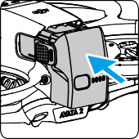

Press the textured part of the battery buckles on the sides of the battery to remove it from the compartment.

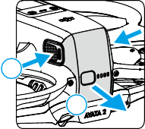

1

2

* DO NOT insert or remove the battery while the aircraft is powered on.
* Make sure the battery is inserted with a clicking sound. DO NOT take off when the battery is not securely mounted, as this may cause poor contact between the battery and the aircraft and present hazards. Make sure the battery is mounted securely.

### Using the Battery

#### Checking the Battery Level

Press the power button once to check the current battery level.

52 © 2024 DJI All Rights Reserved.

**DJI Avata 2** User Manual

LED2 LED3

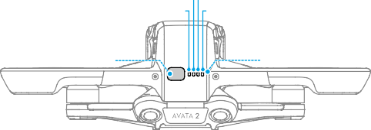

LED1 LED4

Power Button

Battery Level LEDs

The battery level LEDs display the power level of the battery during charging and discharging. The statuses of the LEDs are defined below:



LED is on. LED is flashing. LED is off.



|  |  |  |  |  |
| --- | --- | --- | --- | --- |
| LED1 | LED2 | LED3 | LED4 | Battery Level |
|  |  |  |  | 88%-100% |
|  |  |  |  | 76%-87% |
|  |  |  |  | 63%-75% |
|  |  |  |  | 51%-62% |
|  |  |  |  | 38%-50% |
|  |  |  |  | 26%-37% |
|  |  |  |  | 13%-25% |
|  |  |  |  | 0%-12% |

#### Powering On/Off

Press the power button once and then press and hold for two seconds to power the aircraft on or off. The battery level LEDs display the battery level when the aircraft is powered on. The battery level LEDs turn off when the aircraft is powered off.

#### Updating Firmware

If an additional battery needs to be updated, insert it into the aircraft and power it on. A prompt will appear in the goggles to update the battery. Make sure to update the battery before takeoff.

The table below shows battery information during the update process and corresponding LED blinking patterns.

|  |  |  |  |  |
| --- | --- | --- | --- | --- |
| Blinking Pattern | | | | Information |
| LED1 | LED2 | LED3 | LED4 |
|  |  |  |  | Updating battery firmware |
|  |  |  |  | Firmware update failed |

* If the update fails, reinsert the battery into the aircraft and power on, and retry the firmware update using DJI Assistant 2 (Consumer Drones Series). Refer to the Firmware Update section for more information.

© 2024 DJI All Rights Reserved. 53

**DJI Avata 2** User Manual

### Charging the Battery

Fully charge the battery before each use. It is recommended to use the charging devices provided by DJI, such as the DJI Avata 2 Two-Way Charging Hub, DJI 65W Portable Charger or other USB Power Delivery chargers. The DJI Avata 2 Two-Way Charging Hub and the DJI 65W Portable Charger are both optional accessories. Visit the official DJI online store for more information.

* When charging a battery mounted in the aircraft, the maximum charging power supported is 30 W.

#### Using a Charger

1. Make sure the battery has been correctly installed in the aircraft.
2. Connect a charger to an AC power supply (100-240 V, 50/60 Hz; use a power adapter if necessary).
3. Connect the charger to the charging port on the aircraft.
4. The battery level LEDs display the current battery level during charging.
5. The battery is fully charged when all the battery level LEDs are off. Detach the charger when the battery is fully charged.
   * The battery cannot be charged if the aircraft is powered on.

#### Using the Charging Hub



Visit the link below to watch the tutorial videos for DJI Avata 2 Two-Way Charging Hub.

**https://s.dji.com/guide77**

When used with a compatible charger, the DJI Avata 2 Two-Way Charging Hub can charge up to three DJI Avata 2 Intelligent Flight Batteries in sequence from high to low power level. After the Intelligent Flight Batteries are inserted, the charging hub can supply power to external devices via the USB-C port, such as a remote controller or a mobile phone. The charging hub can also use the power accumulation function to transfer the remaining power of multiple low-power batteries into the battery with the highest remaining power.

54 © 2024 DJI All Rights Reserved.

**DJI Avata 2** User Manual

1. Battery Port

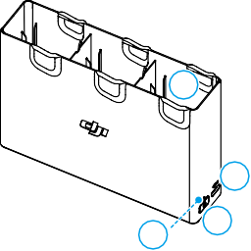

1

2

4

3

1. USB-C Port
2. Function Button
3. Status LED
   * When using the charging hub to charge the Intelligent Flight Batteries, it is recommended to use the DJI 65W Portable Charger or a USB Power Delivery charger. When used with the DJI 65W Portable Charger, the charging hub can fully charge one Intelligent Flight Battery in approximately 45 minutes.
   * The charging hub is only compatible with the BWX520-2150-14.76 Intelligent Flight Battery. DO NOT use the charging hub with other battery models.
   * Place the charging hub on a flat, stable surface with good ventilation when charging an external device or accumulating power. Make sure the device is properly insulated to prevent fire hazards.
   * DO NOT touch the metal terminals on the battery ports. Clean the metal terminals with a clean, dry cloth if there is any noticeable buildup.
   * Make sure to charge batteries with low battery power in time. It is recommended to store the batteries in the charging hub.

###### Charging Intelligent Flight Batteries

1. Insert the batteries into the charging hub until it clicks into place.
2. Connect the charging hub to a power outlet using a USB-C charger. The Intelligent Flight Battery with the highest power level will be charged first, and then the rest will be charged in sequence according to their power levels. The status LED indicates the battery level during charging. Refer to the Status LED Indicator Descriptions for more information about the blinking patterns of the status LED indicator. Press the function button to check the battery level of the inserted batteries.
3. The battery can be stored in the charging hub after charging. Remove the battery from the charging hub for use.

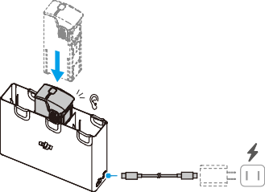

Click

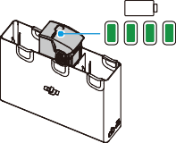

100%

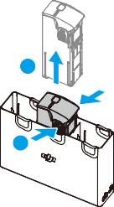

**2**

**1**

© 2024 DJI All Rights Reserved. 55

**DJI Avata 2** User Manual

###### Using the Charging Hub as a Power Bank

1. Insert an Intelligent Flight Battery into the charging hub. Connect an external device via the USB-C port, such as a mobile phone or remote controller.
2. The battery with the lowest power level will be discharged first, followed by the remaining batteries which will be discharged sequentially. To stop charging the external device, disconnect the external device from the charging hub.
   * If the remaining charge of a battery is lower than 7%, the battery cannot charge the external device.
   * Press the function button to activate charging if charging does not start automatically.

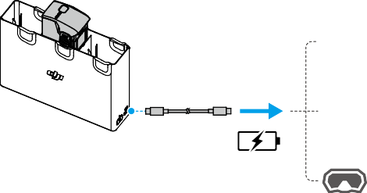

###### Power Accumulation

1. Insert more than one battery into the charging hub, and press and hold the function button until the status LED turns green. When the status LED of the charging hub pulses green, the charge is transferred from the battery with the lowest power level to the battery with the highest power level.
2. To stop accumulating power, press and hold the function button until the status LED turns yellow. After stopping power accumulation, press the function button to check the power level of the batteries.
   * Power accumulation stops automatically in the following situations:
     1. The receiving battery is fully charged, or the power of the output battery is lower than 5%.
     2. A charger or external device is connected to the charging hub or any battery is inserted or withdrawn from the charging hub during power accumulation.
     3. Power accumulation is interrupted for more than 15 minutes due to abnormal battery temperature.
   * After power accumulation, charge the battery with the lowest power level as soon as possible to avoid over-discharge.

56 © 2024 DJI All Rights Reserved.

**DJI Avata 2** User Manual

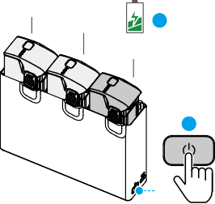

10%

10%

**2**

30%

**1**

###### Status LED Indicator Descriptions

|  |  |  |
| --- | --- | --- |
| Blinking Pattern | Description |  |
| — | Solid yellow | The charging hub is idle |
|  | Pulses green | Charging the battery or accumulating power |
| — | Solid green | All batteries fully charged or are supplying power to external devices |
|  | Blinks yellow | Temperature of batteries is too low or too high (no further operation needed) |
| — | Solid red | Power supply or battery error (remove and reinsert the batteries or unplug and plug in the charger) |

#### Battery Protection Mechanisms

The battery level LEDs can display battery protection notifications triggered by abnormal charging conditions.

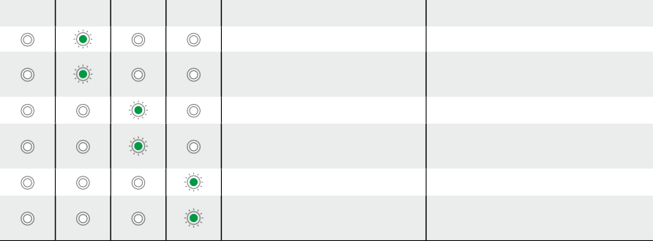

LED1 LED2 LED3 LED4

Blinking Pattern

LED2 blinks twice per second

LED2 blinks three times per second

LED3 blinks twice per second

LED3 blinks three times per second

LED4 blinks twice per second

LED4 blinks three times per second

Status

Overcurrent detected

Short circuit detected

Overcharge detected

Over-voltage charger detected Charging temperature is too low Charging temperature is too high

Battery Protection Mechanisms

© 2024 DJI All Rights Reserved. 57

**DJI Avata 2** User Manual

If any of the battery protection mechanisms are activated, unplug the charger, and plug it in again to resume charging. If the charging temperature is abnormal, wait for it to return to normal. The battery will automatically resume charging without the need to unplug and plug the charger again.

Gimbal and Camera

### Gimbal Profile

The gimbal of the aircraft stabilizes the camera, allowing users to capture clear and steady images and videos at a high flight speed.

#### Gimbal Angle

The gimbal has a control tilt range of -85° to 80°. Use the remote control devices to control the tilt of the camera.

###### 0°

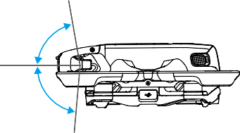

80°

-85°

#### Gimbal Mode

The gimbal mode will automatically switch according to the flight mode.

Normal/Sport mode: The gimbal is in attitude stabilization mode. The tilt angle of the gimbal remains stable relative to the horizontal plane, which is suitable for shooting stable images.

Manual mode: The gimbal is in lock mode. The tilt angle of the gimbal remains stable relative to the aircraft body.

* Make sure there are no stickers or objects on the gimbal before taking off. DO NOT tap or knock the gimbal after the aircraft is powered on. Take off the aircraft from open and flat ground to protect the gimbal.
* Precision elements in the gimbal may be damaged by a collision or impact, which may cause the gimbal to function abnormally. Make sure to protect the gimbal from damage.
* Avoid getting dust or sand on the gimbal, especially in the gimbal motors.
* A gimbal motor error may occur if the aircraft is on uneven ground, the gimbal is obstructed, or the gimbal experiences a collision or crash.
* DO NOT apply external force to the gimbal after the aircraft is powered on.

58 © 2024 DJI All Rights Reserved.

**DJI Avata 2** User Manual

* DO NOT add any extra payload other than an official accessory to the gimbal, as this may cause the gimbal to function abnormally or even lead to permanent motor damage.
* Make sure to remove the gimbal protector before powering on the aircraft. Make sure to mount the gimbal protector when the aircraft is not in use.
* Flying in heavy fog or clouds may make the gimbal wet, leading to temporary failure. The gimbal will recover full functionality once it is dry.

### Warnings

1. DO NOT expose the camera lens to an environment with laser beams, such as a laser show, or point the camera at intense light sources for an extended period, such as the sun on a clear day, in order to avoid damaging the sensor.
2. Make sure the temperature and humidity are within suitable ranges for the camera during use and storage.
3. Use a lens cleaner to clean the lens to avoid damage or poor image quality.
4. DO NOT block any ventilation holes on the camera as the heat generated may damage the device or injure the user.
5. If offline stabilization software such as Gyroflow is used for post-processing the recorded videos, make sure to disable EIS and set the camera FOV to Wide in the goggles when recording.
6. The cameras may not focus correctly in the following situations:
   1. Shooting dark objects far away.
   2. Shooting objects with repeating identical patterns and textures or objects without clear patterns or textures.
   3. Shooting shiny or reflective objects (such as street lighting and glass).
   4. Shooting flashing objects.
   5. Shooting fast-moving objects.
   6. When the aircraft or the gimbal is moving fast.
   7. Shooting objects with varying distances in the focus range.

Footage Storage and Export

### Footage Storage

The aircraft comes with a 46GB internal storage. Photos and videos can be saved in the internal storage of the aircraft when no microSD card is available. The aircraft supports the use of a microSD card to store photos and videos. A UHS-I Speed Grade 3 rating or above microSD card is required due to the fast read and write speeds necessary for high-resolution video data. Refer to the Specifications for more information about recommended microSD cards.

It is recommended to use a microSD card for large data storage.

© 2024 DJI All Rights Reserved. 59

**DJI Avata 2** User Manual

* + - Photos and videos recorded by the aircraft can be previewed. Insert the microSD card of the aircraft into the microSD card slot of the goggles.
    - DO NOT remove the microSD card from the aircraft while it is powered on or taking photos or videos. Otherwise, the microSD card may be damaged.
    - Check camera settings before use to ensure they are configured correctly.
    - Before shooting important photos or videos, shoot a few images to test whether the camera is operating correctly.
    - Make sure to power off the aircraft correctly. Otherwise, the camera parameters will not be saved and any recorded videos may be affected. DJI is not responsible for any loss caused by an image or video recorded in a way that is not machine-readable.
    - The internal storage performance may be lowered after using for a long time. Follow the instructions in the goggles to migrate and format the data to ensure good internal storage performance.

### Footage Export

Use QuickTransfer to export the footage to a mobile device. Refer to the QuickTransfer section for more information.

1. Connect the aircraft to a computer using a data cable, export the footage in the internal storage of the aircraft or in the microSD card mounted on the aircraft. The aircraft does not need to be powered on during the exporting process.
2. Remove the microSD card from the aircraft and insert it into a card reader, and export the footage in the microSD card through the card reader.

QuickTransfer

The aircraft can connect directly to mobile devices via Wi-Fi, enabling users to download photos and videos from the aircraft to the mobile device through DJI Fly at a high rate.

Follow the steps below to export footage using QuickTransfer:

1. Power on the aircraft and wait until the self-diagnostic tests of the aircraft are complete.
2. Enable Bluetooth, Wi-Fi, and location services on the mobile device.
3. Run DJI Fly, tap the QuickTransfer card on the bottom left corner of the home screen,  and select the aircraft to be connected. When connecting DJI Fly to the aircraft for the first time, press and hold the power button for two seconds after a prompt appears on the app. The battery level LEDs blink from inside to out and then turn solid. DJI Fly will prompt users whether to connect to the aircraft or not.
4. Once successfully connected, the files on the aircraft can be accessed and downloaded at high speed.

60 © 2024 DJI All Rights Reserved.

**DJI Avata 2** User Manual

* When the aircraft is connected to DJI Fly using QuickTransfer, the aircraft will be disconnected from the goggles and the remote controller. Connection will be automatically restored after exiting QuickTransfer. If DJI Fly is closed abnormally, connection can only be automatically restored after restarting the aircraft.
* The maximum download rate can only be achieved in countries and regions where the 5.8 GHz frequency is permitted by laws and regulations, when using devices that support 5.8 GHz frequency band and Wi-Fi connection, and in an environment without interference or obstruction. If 5.8 GHz is not allowed by local regulations (such as in Japan), or the mobile device of the user does not support the 5.8 GHz frequency band, or the environment has severe interference, then QuickTransfer will use the 2.4 GHz frequency band and its maximum download rate will be significantly lowered.
* Use QuickTransfer in an unobstructed environment with no interference and stay away from sources of interference such as wireless routers, Bluetooth speakers, or headphones.
* DO NOT press the power button of the aircraft for a long time to avoid triggering the linking process.

© 2024 DJI All Rights Reserved. 61

# DJI Goggles 3

62 © 2024 DJI All Rights Reserved.

DJI Goggles 3

**DJI Avata 2** User Manual

DJI Goggles 3 are equipped with two high-performance screens and ultra-low-latency image transmission for use with DJI aircraft, allowing for a real-time aerial First Person View (FPV) experience. DJI Goggles 3 supports the Head Tracking function. With this function, the aircraft and gimbal can be controlled using head movements. When used with the DJI Motion Controller 3, users can control the aircraft and the gimbal camera freely to meet their shooting needs in various scenarios.

To provide a more comfortable experience, the goggles support diopter adjustment so that glasses are not required during use. Two cameras are positioned on the front side of the goggles, in order to allow users to view the surrounding environment via Real View without removing the goggles. The goggles can also share the liveview to a mobile device via Wi-Fi.

## Operating the Goggles

### Buttons

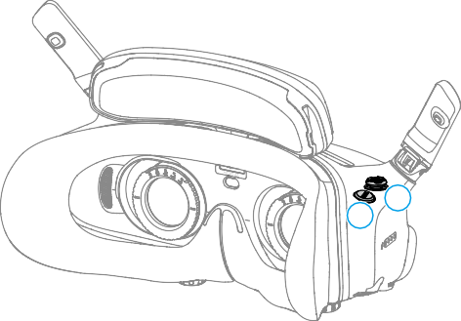

2

1

###### 5D Button

Press or push to the right to open the menu from the FPV view of the goggles. Push forward to open the camera settings panel and push backward to open the shortcut menu.

After the settings panel is opened, push to navigate through the menu or adjust the parameter value. Press to confirm the selection.

###### Back Button

Press to return to the previous menu or exit the current view.

© 2024 DJI All Rights Reserved. 63

**DJI Avata 2** User Manual

### AR Cursor

Before takeoff or when using the lock button to trigger the aircraft to hover, users can use the AR Cursor (the white line with a circle at the end) to interact with the screen of the goggles.

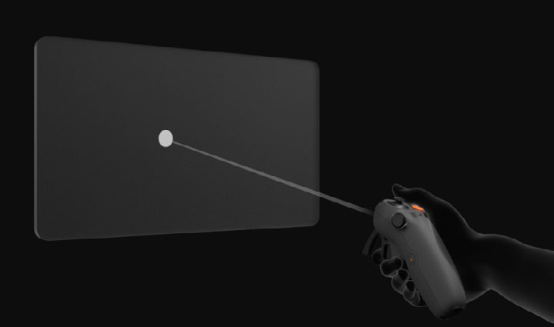

* + AR Cursor cannot function properly when being used on moving objects, such as cars and ships.

#### Recenter the Cursor

If the cursor is not displayed on the screen of the goggles, hold the motion controller as shown below, and then press and hold the dial on the left side of the motion controller to recenter the cursor.

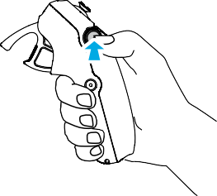

If the cursor still cannot be found, tilt the motion controller up or down until the cursor appears on the screen.

64 © 2024 DJI All Rights Reserved.

**DJI Avata 2** User Manual

#### Operating the Menu

* Using motion controller movements, move the cursor to the arrow on the left side of the screen. Gently press the accelerator to the first stop position, then the cursor will become small and the menu will be opened.

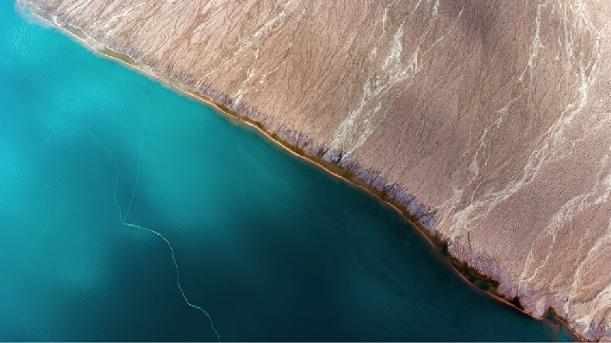

Use the joystick on the motion controller to scroll up or down in the menu.

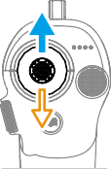

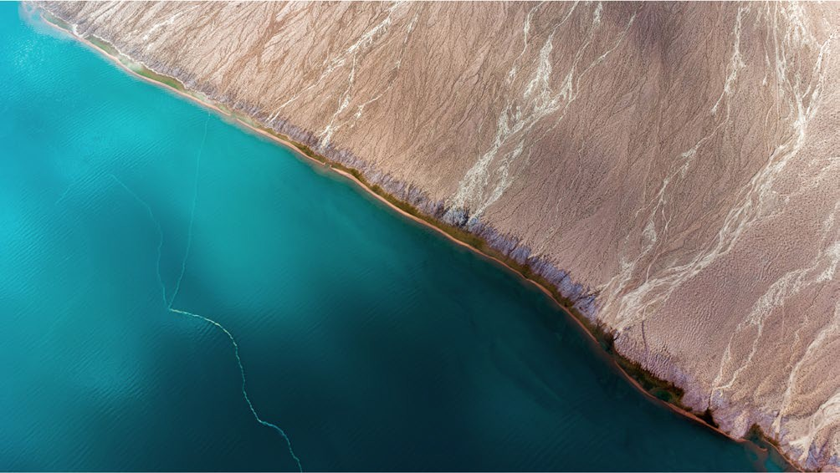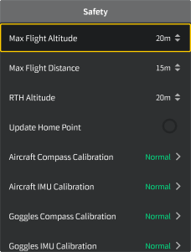

To exit or return to the previous menu, push the accelerator forward, or gently press the accelerator when the cursor is on any empty spot on the screen.

© 2024 DJI All Rights Reserved. 65

**DJI Avata 2** User Manual

* Move the cursor to the arrow on the top of the screen, press the accelerator to enter the shortcut menu, and configure settings such as Recording or Enhanced Display.

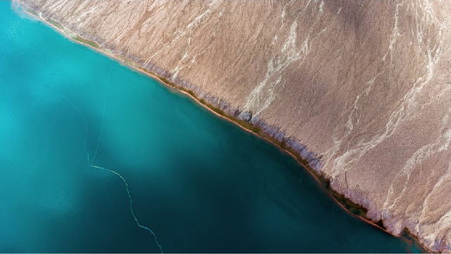

* Move the cursor to the arrow on the bottom of the screen, press the accelerator to enter camera settings, and configure settings for the parameters of the aircraft camera.



#### Controlling Video Playback

When previewing photos or videos stored on the microSD card of the goggles, the cursor can be used to control playback, or complete other operations such as:

* Press the accelerator to pause or continue to play, push the accelerator forward to exit.
* Move the cursor left or right while pressing the accelerator down to adjust the progress bar.
* Move the cursor to the arrow on the top of the screen, press down the accelerator to enter playback settings and adjust the screen brightness or volume.

66 © 2024 DJI All Rights Reserved.

**DJI Avata 2** User Manual

## Goggles Screen

FPV View

###### 1

###### 2

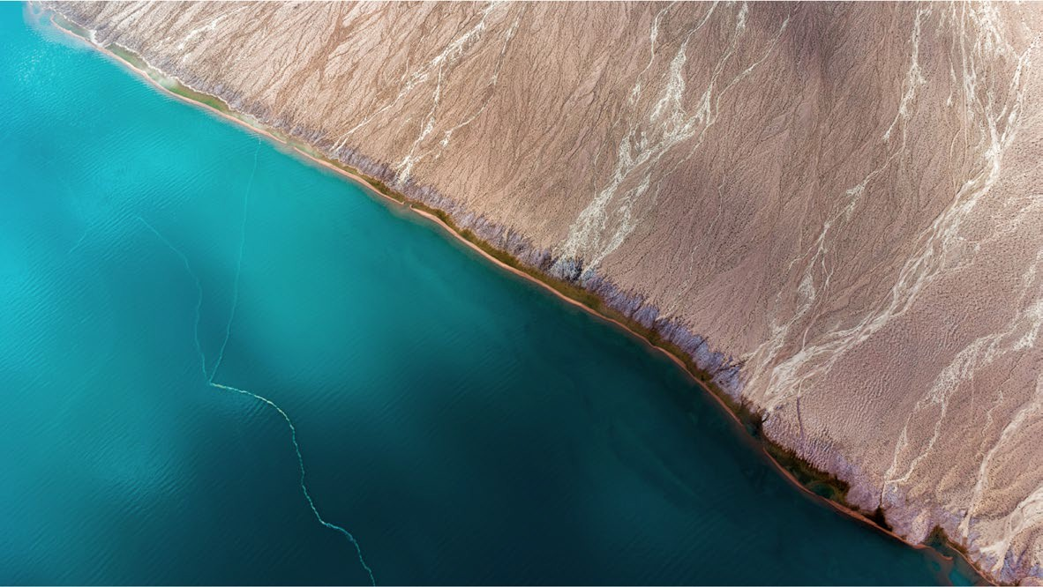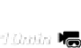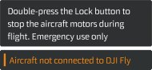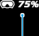

###### 3

###### 14

###### 4

###### 13 12 11 10 9 8 7 6 5

###### Flight Direction Indicator

When controlling the aircraft with the motion controller, the circle indicates the direction in which the aircraft is heading.

###### Storage Information

Displays the remaining capacity of the aircraft or goggles storage.

###### Gimbal Slider

Displays the gimbal tilt angle.

###### Prompts

Displays notifications and information such as when a new mode is applied or the battery level is low.

###### Goggles Battery Level

Displays the battery level of the goggles.

###### GNSS Status

Displays the current strength of the aircraft GNSS signal.

If the devices are not used for an extended period of time, it may take longer than usual to search for the GNSS signal. If the signal is unobstructed, it takes approximately 20 seconds to search for the GNSS signal when powering on and off within a short period of time. When the icon is white, the GNSS signal is strong. When the icon is orange, the GNSS signal is weak. When the icon is red, the GNSS signal is extremely weak.

© 2024 DJI All Rights Reserved. 67

**DJI Avata 2** User Manual

###### Video Bitrate

Displays the current video bitrate of the liveview.

###### Remote Controller and Image Transmission Signal Strength

Displays the signal strength of the remote control device, and the image transmission signal strength between the aircraft and the goggles.

The icon is white when the signal is strong, and turns gray when the signal is lost.

The icon is orange when the signal is moderately weak, and turns red when the signal is extremely weak. A prompt bar of the same color is displayed in the bottom of the flight liveview.

###### Remaining Flight Time

Displays the remaining flight time of the aircraft.

###### Aircraft Battery Level

###### Distance to the Ground

Displays the current altitude information of the aircraft from the ground when the aircraft is less than 10 m above the ground.

###### Flight Telemetry

Displays the horizontal distance (D) between the aircraft and the Home Point, height (H) from the Home Point, aircraft horizontal speed, and aircraft vertical speed.

###### Flight Modes

Displays the current flight mode.

###### Home Point

Indicates the relative position of the Home Point.

Shortcut Menu

Push the 5D button backward to open the shortcut menu from the FPV view and access the quick controls of the following functions:

* + Take a photo, or start/stop recording
  + Enable/disable Enhanced Display
  + Enable/disable Head Tracking
  + Enable/disable Share Liveview to Mobile Device via Wi-Fi
  + Enable/disable Easy ACRO
  + Enable/disable Goggles Defog
  + Adjust brightness

68 © 2024 DJI All Rights Reserved.

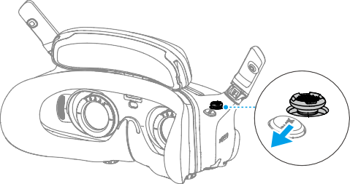**DJI Avata 2** User Manual

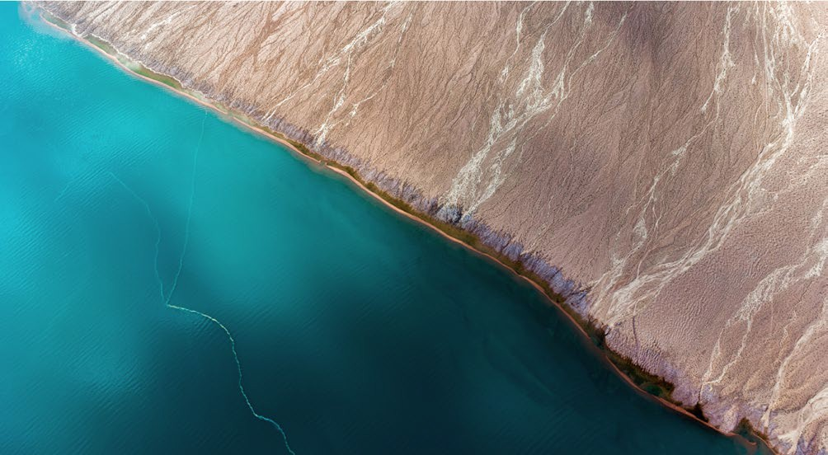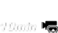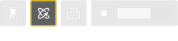

Camera Settings

Push the 5D button forward from the FPV view to open the camera settings panel and change camera-related parameters.

In the parameter panel, push to the right to view and set more parameters.

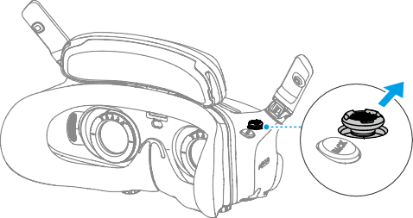

© 2024 DJI All Rights Reserved. 69

**DJI Avata 2** User Manual

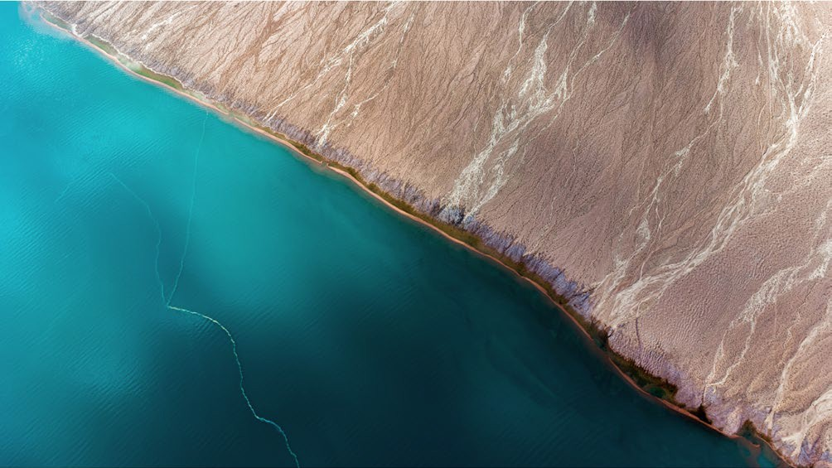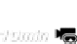

Goggles Menu

Press down the 5D button or push it to the right to open the menu from the FPV view.

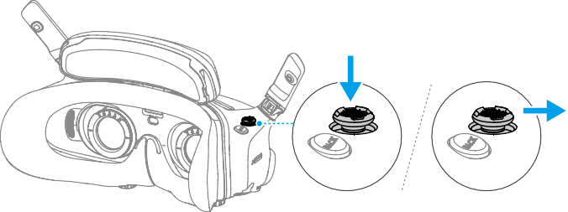

###### 1

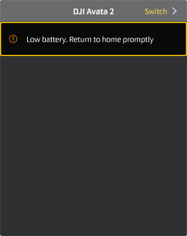

###### 2

###### 3

###### 4

70 © 2024 DJI All Rights Reserved.

**DJI Avata 2** User Manual

###### Status

* + Displays the in-use aircraft model and detailed information of prompt alerts.
  + Use the switch function in the upper right corner to change the aircraft.

###### Album

Shows the photos or videos stored on the microSD card of the goggles. Select any file to preview.

###### Transmission

The Transmission menu has a Pilot sub-menu and Audience sub-menu.

* + The video transmission mode for the current device can be set under the Pilot sub-menu, including but not limited to the following:
    1. Enable or disable Broadcasting mode. The device number will be displayed when Broadcasting mode is enabled so that other devices can find the device and enter the channel to see the flight liveview.
    2. Disable the Focus mode, or set to auto.
    3. Set the Channel mode to auto or manual. It is recommended to select auto so that the video transmission will automatically switch between different frequency bands and select the channel with the best signal.
    4. Set the frequency band. If the channel mode is set to manual, either 2.4 or 5.8 GHz can be selected.
    5. Set the bandwidth of the video transmission. The number of channels available varies according to the bandwidth. The channel with the best signal strength can be manually selected. The higher the bandwidth, the higher video transmission rate and clearer image quality. However, there will also be a higher chance of wireless interference and the amount of equipment that can be accommodated will be more limited. To avoid interference in a multiplayer competition, manually select a fixed bandwidth and channel.
  + If any nearby video transmission device turns on the Broadcasting mode, the device and its signal strength can be viewed in the Audience sub-menu. Select a channel to see the flight liveview.

###### Settings

* + Safety
    1. Set the safety configurations such as max flight altitude, max flight distance, and RTH altitude. Users can also update the Home Point, and view the IMU and compass status of the aircraft or the goggles and calibrate them if necessary.
    2. Camera View Before Loss helps to find the location of the aircraft on the ground by using the cached video of the aircraft 30 seconds before signal is lost. If the aircraft still has signal and battery power, turn on ESC beeping to locate the aircraft using a beeping sound that is emitted from the aircraft.
    3. Advanced Safety Settings include the following:
       - Aircraft Signal Lost Action: The aircraft behavior can be set to hover, land, or RTH when the remote controller signal is lost.
       - Emergency Propeller Stop (disabled by default): When enabled, the motors of the aircraft can be stopped mid-flight anytime once the user presses the motion

© 2024 DJI All Rights Reserved. 71

**DJI Avata 2** User Manual

controller lock button four times. If the switch is disabled, the motors can only be stopped with this action in an emergency, such as if a collision occurs, a motor stalls, the aircraft rolls in the air, or the aircraft is out of control and is ascending or descending quickly.

* + - * + Stopping motors mid-flight will cause the aircraft to crash. Operate with caution.
  + Control
    1. Configure remote controller-related functions, such as setting the stick mode, customizable buttons, and calibrating the IMU and compass.
    2. View motion controller instructions, switch Handedness, adjust Gain Tuning, or calibrate the motion controller.
    3. Calibrate the gimbal, adjust the gimbal tilt speed, set the unit, or use turtle mode to flip the overturned aircraft upright.
    4. View the goggles tutorial.
  + Camera
    1. Set the aspect ratio, video quality, video format, gridlines, storage device, format the SD card, and so on.
       - Data cannot be recovered after formatting. Operate with caution.
    2. Advanced Camera Settings:
       - Set the recording device, screen related parameters, enable or disable auto record at takeoff, and so on.
       - Camera View Recording (enabled by default): If disabled, the recording of the goggles screen will not include the OSD elements.
    3. Select Reset Camera Parameters to restore all camera settings to default.
  + Display
    1. Adjust screen brightness, display scaling, and display or hide the Home Point.
    2. Goggles Defog: If enabled, the cooling fan will keep running at high speed to alleviate the fogging of the lenses.
    3. Set the display of Real View.
  + About
    1. View device information, such as the serial number, the firmware of the goggles, and linked devices.
    2. Set the system language.
    3. OTG Wired Connection: In this mode, the goggles can be connected to the PC via the USB-C fast charging cable.
    4. View the compliance information.
    5. Reset the goggles and the linked devices to their default settings.
    6. Clear All Device Data: All user data generated during use and stored on the aircraft will be erased.

72 © 2024 DJI All Rights Reserved.

**DJI Avata 2** User Manual

Goggles Footage Storage and Export

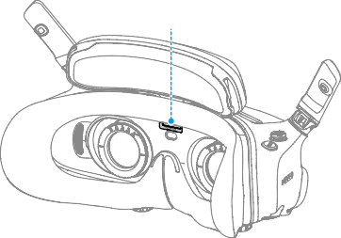

microSD Card Slot

Footage Storage

The goggles support the installation of a microSD card. After a microSD card is inserted, if Record With is set to both the aircraft and the goggles while the aircraft is recording video the goggles will simultaneously record the flight live view displayed on the screen and store it on the microSD card of the goggles.

Footage Export

To export the recorded footage, follow the steps below:

1. Power on the goggles.
2. Connect the USB-C port of the goggles to a PC using a USB-A to USB-C cable, and follow the on-screen prompts to export the footage.
   * If the goggles are connected to a PC via the USB-C fast charging cable, go to the goggles menu and select Settings > About, and enter the OTG Wired Connection mode to export the footage.

The screen recording includes the OSD elements by default. To record the screen without the OSD elements, change the settings as shown below:

1. Open the goggles menu.
2. Select Settings > Camera > Advanced Camera Settings, and disable Camera View Recording.

Formatting the SD Card

To format the microSD card, follow the steps as shown below:

1. Open the goggles menu.
2. Select Settings > Camera > Format
3. Select the storage device to format and follow the on-screen instructions to complete the operation.
   * Data cannot be recovered after formatting. Operate with caution.

© 2024 DJI All Rights Reserved. 73

**DJI Avata 2** User Manual

Real View

DJI Goggles 3 are equipped with binocular cameras, in order for users to view the surrounding environment without removing the goggles.

Tap twice firmly on the right side of the goggles, or press twice on the dial of the motion controller to enter Real View.

Perform the same action again to exit and return to the flight liveview.

Enter the goggles menu, select Settings > Display, and then Real View can be set to 2D or 3D.

3D will bring a more immersive three-dimensional real view. Please select based on personal preference.

Real View PiP

When the goggles are used with the aircraft, Real View supports displaying the real-time flight liveview.

1. Enter the goggles menu, select Settings > Display, and then enable Real View PiP.
2. Tap twice firmly on the right side of the goggles, or press twice on the motion controller dial, the flight liveview will be displayed in the upper left corner of the real view. Both the surroundings and the aircraft video transmission will be displayed on the goggles screen simultaneously.
   * If the Real View is set to 3D, the flight liveview cannot be displayed on the screen simultaneously.
   * When using Real View PiP, the flight liveview is only used to show the status of the aircraft. DO NOT rely on this screen for flight.

Liveview Sharing

DJI Goggles 3 can share a flight liveview via three different methods.

* + Power on the aircraft, goggles, and remote control device. Make sure all the devices are linked.
  + Operate Liveview Sharing prior to taking off, or when the aircraft is braking or hovering, to avoid interfering with the pilot's operation.
  + The goggles only support connecting to one mobile device for sharing the liveview either in wireless or wired connection.
  + When connected to a mobile device, liveview sharing will be paused if the goggles switch to Real View, and the sharing will be recovered when the goggles switch back the flight liveview.
  + When connected to a mobile device, liveview sharing will be paused when viewing the images or videos in the album. Exit the album to recover sharing.

74 © 2024 DJI All Rights Reserved.

**DJI Avata 2** User Manual

Wired Connection with Mobile Device

1. It is recommended to use a suitable data cable or the USB-C OTG cable provided to connect the mobile device to the USB-C port on the goggles.
2. Launch DJI Fly app and tap GO FLY in the lower right corner of the screen to enter the liveview.

Wireless Connection with Mobile Device

1. Open the shortcut menu, and select  Share Liveview to Mobile Device via Wi-Fi.
2. Turn on Wi-Fi and Bluetooth on your mobile device, and enable the Location feature on your phone.
3. Launch the DJI Fly app, a new device available for Wi-Fi connection will appear in a box on the home page.
4. Tap the box and select the goggles to be connected.
5. When connecting DJI Fly to the goggles for the first time, press and hold the power button on the goggles for two seconds when the prompt appears. The battery level LEDs blink from inside to out and then turn solid. DJI Fly will prompt the user to connect to the goggles if needed. Select Join.
6. Tap Watch Liveview to access the liveview from the goggles.
   * DO NOT press the power button of the goggles for a long period of time to avoid triggering the linking process.
   * If Share Liveview to Mobile Device via Wi-Fi is enabled, wired connection with mobile device is not supported.
   * In wireless connection mode, disconnect the goggles from the current connected mobile device before connecting the goggles to another new mobile device for liveview sharing.
   * If 5.8 GHz is not allowed by local regulations (such as in Japan), Share Liveview to Mobile Device via Wi-Fi cannot be used.

Broadcasting to Other Goggles

Broadcasting mode is available for sharing the liveview to other goggles if there are other DJI Goggles 3 nearby.

1. Enter the goggles menu, select Transmission and enter the Pilot sub-menu.
2. Turn on Broadcasting mode, and the device number will be displayed.
3. On the other DJI Goggles 3, enter the goggles menu, select Transmission and enter the Audience sub-menu.
4. If any nearby DJI Goggles 3 turns on the Broadcasting mode, the device and its signal strength can be viewed in the Audience sub-menu. Select the device number to access the liveview. Switching to Pilot sub-menu to exit the shared liveview.

© 2024 DJI All Rights Reserved. 75

**DJI Avata 2** User Manual

Panorama/3D Video Playback

The goggles support playing panoramic videos and 3D videos, bringing you an immersive viewing experience.

1. Import panoramic/3D videos to a microSD card, and insert it into the goggles.
2. Enter the goggles menu and then Album, then select the video file to play.



**2D**

1. Push the 5D button backward to open the playback menu, and select Settings.
2. Set the display mode.

Display Switch

* If the video is panoramic, select 2D first, and then set the FOV to panorama.
* If the video is a 3D, first select the 3D display mode based on the video format, then select the FOV, and whether to reverse left and right.

1. Exit the shortcut menu after confirming the selections, then the panoramic/3D video will be played based on the display settings.

* Refer to the Specifications for more information about the supported video formats.
* The goggles have no speaker but can be connected to headphones via the USB-C port. Only supports Type-C headphones and headphone adapters with built-in DAC (digital- to-analog converter).

Using the Wireless Streaming function

The wireless streaming function enables you to project the video playing on your mobile phone or computer to the goggles display. For this to work, the video player must support wireless streaming.

To use this function, open the goggles menu and select More, then tap Wireless Streaming and follow the on-screen instructions.

* There is no speaker in the goggles but they can be connected to headphones through the USB-C port. Only Type-C headphones and headphone adapters with built-in DAC (digital-to-analog conversion) are supported.

76 © 2024 DJI All Rights Reserved.

DJI Motion Controller

© 2024 DJI All Rights Reserved. 77

**DJI Avata 2** User Manual

DJI Motion Controller

Operation

Powering On/Off

Press the power button once to check the current battery level. Charge before using if the battery level is too low.

Press once then press again and hold for two seconds to power the motion controller on or off.

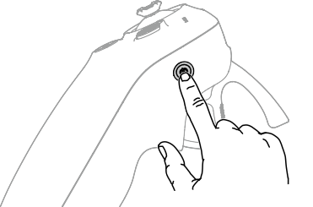

Charging the Battery

Use a USB-C cable to connect a charger to the USB-C port of the motion controller.

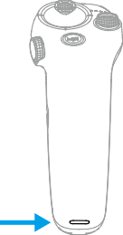

5V, 2A

* Fully charge the remote controller before each flight. The remote controller sounds an alert when the battery level is low.
* Fully charge the battery at least once every three months to maintain good battery health.

78 © 2024 DJI All Rights Reserved.

**DJI Avata 2** User Manual

Button Features

###### Lock Button

* 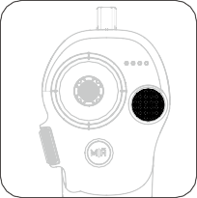Takeoff: Press twice to start the aircraft motors, then press and hold to make the aircraft take off. The aircraft will ascend to approximately 1.2 m and hover.
* Landing: While the aircraft is hovering, press and hold to land the aircraft and stop the motors.
* Brake: Press during flight to make the aircraft brake and hover in place.

###### Joystick

* Move up or down to make the aircraft ascend or descend.
* Move it left or right to make the aircraft move left or right horizontally.

When Easy ACRO is enabled, move the joystick to perform different Easy ACRO actions.

###### Mode Button

* 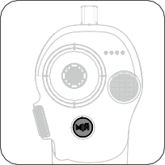Press to switch between Normal and Sport mode.
* Press and hold to initiate RTH. When the aircraft is performing RTH, press the mode button or lock button once to cancel RTH.
* When the battery level is low and only sufficient to fly to the Home Point, a warning prompt will appear in the goggles and RTH will be triggered following the prompt. Press the mode button once to cancel the prompt.

###### Dial

* Press twice to switch between the flight liveview and Real View in the goggles.
* Scroll up or down to tilt the camera before takeoff or during RTH and landing.
* Scroll the dial to switch between Easy ACRO actions when Easy ACRO is enabled.
* 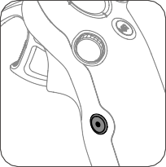Press and hold the dial to recenter the cursor on the screen when using AR Cursor.

###### Shutter/Record Button

* Press once: Take a photo or start or stop recording.
* Press and hold: Switch between photo and video mode.

© 2024 DJI All Rights Reserved. 79

**DJI Avata 2** User Manual

###### Accelerator

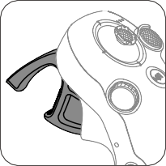The accelerator is used for controlling aircraft orientation and acceleration. There are two stops when pressing the accelerator. After gently pressing the accelerator, users will feel noticeable resistance when the accelerator reaches the first stop.

* After gently pressing the accelerator to the first stop, users can adjust the aircraft orientation by tilting the top of the motion controller to the left or right. Note that the aircraft will not fly forward at this time.
* Press the accelerator past the first stop to fly in the direction of the circle in the goggles. Push the accelerator forward to fly the aircraft backward. Apply more pressure in either direction to accelerate.
* When the accelerator is not being pressed, the aircraft will hover.

Optimal Transmission Zone

The signal between all the devices is most reliable when the relative distance between the motion controller and the goggles is less than 3 m.



 ≤3m



* It is recommended to use the device in an open, outdoor environment to avoid having obstacles between the motion controller and the goggles. Otherwise, the transmission may be affected.
* In order to avoid interference, DO NOT use other wireless devices on the same frequency as the motion controller.

80 © 2024 DJI All Rights Reserved.

**DJI Avata 2** User Manual

Motion Controller Alert

The remote controller sounds an alert when the battery level is between 6% and 10%. A low battery level alert can be canceled by pressing the power button. A critical battery level alert will sound when the battery level is less than 5% and cannot be canceled The remote controller sounds an alert during RTH, which cannot be canceled.

Motion Controller Calibration

The compass, IMU, and accelerator of the motion controller can be calibrated. Immediately calibrate any of the modules when prompted to do so:

1. Press down the 5D button in flight liveview to open the menu.
2. Select Settings > Control > Motion Controller >RC Calibration.
3. Select the module and follow the prompts to complete calibration.
   * DO NOT calibrate the compass in locations with strong magnetic interference, such as near magnets, parking lots, or construction sites with underground reinforced concrete structures.
   * DO NOT carry ferromagnetic materials such as mobile phones during calibration.

© 2024 DJI All Rights Reserved. 81

DJI Fly App

82 © 2024 DJI All Rights Reserved.

DJI Fly App

**DJI Avata 2** User Manual

Connect the goggles to the mobile device, launch DJI Fly, and enter the home screen. Users can do the following from the home screen:

* Discover recommended Fly Spots, check for GEO Zones and find information about local laws and regulations, watch function tutorials, and read product manuals.
* Visit the album to view photos and videos, or explore more shared footage from SkyPixel.
* Log in with your DJI account to check your account information and flight records.
* Update firmware, locate a lost aircraft using Find My Drone, visit the DJI Forum, or shop the DJI Store.

Tap GO FLY to display the video transmission, which allows you to share the FPV camera view.

* + Fully charge your mobile device before launching DJI Fly.
  + Mobile cellular data is required when using DJI Fly. Contact your wireless carrier regarding data charges.
  + DO NOT accept phone calls or use texting features during flight if you are using a mobile phone as your display device.
  + Read all safety prompts, warning messages, and disclaimers carefully. Familiarize yourself with relevant regulations in your area. You are solely responsible for being aware of all relevant regulations and flying in a way that is compliant.
  + The use of the app is subject to DJI Fly Terms of Use and DJI Privacy Policy. These Terms of Use and Privacy Policy limit some of DJI's legal responsibilities. Read them carefully at https://developer.dji.com/policies/.

© 2024 DJI All Rights Reserved. 83

Appendix

84 © 2024 DJI All Rights Reserved.

Appendix

**DJI Avata 2** User Manual

Specifications

DJI Avata 2

Max Ascent Speed

6 m/s (Normal mode) 9 m/s (Sport mode)

Dimensions

185×212×64 mm (L×W×H)

Takeoff Weight Approx. 377 g

Max Descent Speed 6 m/s (Normal mode)

9 m/s (Sport mode)

Max Horizontal Speed 8 m/s (Normal mode) (near sea level, no wind) 16 m/s (Sport mode)

27 m/s (Manual mode)*

* No faster than 19 m/s with the Manual mode in the EU regions.

Max Takeoff Altitude[1] 5000 m

Max Flight Time[2] Approx. 23 mins

Max Hovering Time[3] Approx. 23 mins

Max Flight Distance[4] 13.0 km

Max Wind Speed Resistance

10.7 m/s (Level 5)

Operating Temperature -10° to 40° C (14° to 104° F)

Global Navigation Satellite System

GPS + Galileo + BeiDou

Hovering accuracy range Vertical:

±0.1 m (with vision positioning)

±0.5 m (with GNSS positioning) Horizontal:

±0.3 m (with vision positioning)

±1.5 m (with GNSS positioning)

Internal Storage 46 GB

Camera

Image Sensor 1/1.3-inch image sensor Effective Pixels: 12 MP

Lens

FOV: 155°

Format Equivalent: 12 mm Aperture: f/2.8

Focus: 0.6 m to ∞

ISO Range 100-25600 (Auto) 100-25600 (Manual)

© 2024 DJI All Rights Reserved. 85

**DJI Avata 2** User Manual

Shutter Speed

Video: 1/8000-1/30 s Photo: 1/8000-1/50 s

Max Image Size 4000×2256 (16:9)

4000×3000 (4:3)

Still Photography Mode Single shot

Photo Format JPEG

Video Resolution

4K (4:3): 3840×2880@30/50/60fps

4K (16:9): 3840×2160@30/50/60fps

2.7K (4:3): 2688×2016@30/50/60fps

2.7K (16:9): 2688×1512@30/50/120fps

1080p (4:3): 1440×1080@30/50/120fps

1080p (16:9): 1920×1080@30/50/120fps

Video Format MP4 (H.264/H.265)

Max Video Bitrate 130 Mbps

Supported File System exFAT

Color Mode

Standard D-Log M

Camera FOV Supports standard mode, wide-angle mode, and super-wide-angle mode,

Supports RockSteady 3.0+ and HorizonSteady Can be disabled*

* When stabilization is turned off, footage captured with the wide-angle view supports offline stabilization Gyroflow.

EIS

Single-axis mechanical gimbal (tilt)

Stabilization

Gimbal

Mechanical Range Tilt: -95° to 90°

Controllable Range Tilt: -85° to 80°

Max Control Speed (tilt) 100°/s

Angular Vibration Range ±0.01°

Electronic Roll Axis Real-time screen correction is unavailable during recording, but can be applied to the footage recorded on the drone.

Sensing

Sensing Type Downward and backward visual positioning

Downward

ToF Effective Measurement Height: 10 m Precise Hovering Range: 0.3-10 m Measurement Range: 0.3-20 m

FOV: Horizontal 78°, Vertical 78°

Backward Measurement Range: 0.5-20 m FOV: Horizontal 78°, Vertical 78°

86 © 2024 DJI All Rights Reserved.

**DJI Avata 2** User Manual

O4

Video Transmission System

Video Transmission

Operating Environment Diffuse reflective surfaces with discernible patterns, diffuse reflectivity > 20% (such as concrete pavement)

Adequate lighting (lux > 15, normal indoor lighting conditions)

Live View Quality 1080p@30/50/60/100fps

Operating Frequency

2.4000-2.4835 GHz

5.170-5.250 GHz*

5.725-5.850 GHz*

* 5.170-5.250 GHz and 5.725-5.850 GHz can be used only in countries and regions where permitted by local laws and regulations.

Transmitter Power (EIRP) 2.4 GHz: <33 dBm (FCC), <20 dBm (CE/SRRC/MIC)

5.1 GHz: < 23 dBm (CE)

5.8 GHz: <33 dBm (FCC), <30 dBm (SRRC), <14 dBm (CE)

Communication Bandwidth

Max 60 MHz

Max Transmission Distance (unobstructed, free of interference)[5]

FCC: 13 km (subject to the aircraft's max flight time) CE: 10 km

SRRC: 10 km

MIC: 10 km

Max Transmission Strong Interference: Urban landscape, approx. 1.5-4 km Distance (unobstructed, Medium Interference: Suburban landscape, approx. 4-10 km with interference)[6] Low Interference: Suburb/seaside, approx. 10-13 km

Max Transmission Distance (obstructed, with interference)[7]

Low Interference and Obstructed by Buildings: approx. 0-0.5 km Low Interference and Obstructed by Trees: approx. 0.5-3 km

Max Download Speed

Wi-Fi: 25 MB/s*

* Measured in a laboratory environment with little interference in countries/ regions that support both 2.4 GHz and 5.8 GHz. Download speeds may vary depending on the actual conditions.

Lowest Latency With DJI Goggles 3:

1080p/100fps Video Transmission Quality: 24 ms 1080p/60fps Video Transmission Quality: 40 ms

Max Video Bitrate 60Mbps

Antennas 4 antennas, 2T4R

Wi-Fi

Protocol 802.11a/b/g/n/ac

Operating Frequency

2.4000-2.4835 GHz

5.725-5.850 GHz

Transmitter Power (EIRP) 2.4 GHz: <20 dBm (FCC/CE/SRRC/MIC)

5.8 GHz: <20 dBm (FCC/SRRC),< 14 dBm (CE)

© 2024 DJI All Rights Reserved. 87

**DJI Avata 2** User Manual

Bluetooth

Protocol Bluetooth 5.0

Operating Frequency 2.4000-2.4835 GHz

Transmitter Power (EIRP) <10 dBm

Intelligent Flight Battery

Capacity 2150 mAh

Weight Approx. 145 g

Standard Voltage 14.76 V

Max Charging Voltage 17 V

Battery Type Li-ion

Energy 31.7 [Wh@0.5C](mailto:Wh@0.5C)

Charging Temperature 5° to 40° C (41° to 104° F)

|  |  |  |
| --- | --- | --- |
| Charging Time | | With Charging Hub (60W max charging power): From 0 to 100%: approx. 45 min  From 10 to 90%: approx. 30 min  Directly Charging the Drone: (30W max charging power): From 0 to 100%: approx. 88 min  From 10 to 90%: approx. 60 min |
| Charger | | |
| Recommended Charger DJI 65W Portable Charger  DJI 65W Car Charger  USB Power Delivery charger | | |
| Battery | Charging | Hub |
| Input | 5-20 V, max 3 A | |

###### Charging Hub

Output (power accumulation)

Max 65 W

Output (charging) Max 17 V

Output (USB) 5 V, 2 A

Charging Type Three batteries charged in sequence.

Compatibility DJI Avata 2 Intelligent Flight Battery

88 © 2024 DJI All Rights Reserved.

**DJI Avata 2** User Manual

Recommended microSD Cards

Storage

lexar_1066x_64G lexar_1066x_128G lexar_1066x_256G lexar_1066x_512G kingston_canvas_go_plus_64G kingston_canvas_go_plus_128G kingston_canvas_go_plus_256G kingston_canvas_go_plus_512G

1. Measured in a windless environment when taking off from an altitude of 5000 m and ascending vertically by 500 m, using Sport mode, and from 100% battery level until 20%. Data is for reference only. Always pay attention to reminders on the goggles' screens during your flight.
2. Measured when flying forward at a speed of 21.6 kph in a windless environment at sea level, with camera parameters set to 1080p/30fps, video mode off, and from 100% battery level until 0%. Data is for reference only. Always pay attention to reminders on the goggles' screens during your flight.
3. Measured when hovering in a windless environment at sea level, with camera parameters set to 1080p/30fps, video mode off, and from 100% battery level until 0%. Data is for reference only. Always pay attention to reminders on the goggles' screens during your flight.
4. Measured when flying forward at a speed of 43.2 kph in a windless environment at sea level, with camera parameters set to 1080p/30fps, video mode off, and from 100% battery level until 0%. Data is for reference only. Always pay attention to reminders on the goggles' screens during your flight.
5. Measured in an unobstructed outdoor environment free of interference. The above data shows the farthest communication range for one-way, non-return flights under each standard. Always pay attention to RTH reminders on the goggles screen during your flight.
6. Data tested under FCC standard in unobstructed environments with typical interference. Used for reference purposes only and provides no guarantee for actual transmission distance.
7. Data tested under FCC standard in environments with typical low interference. Used for reference purposes only and provides no guarantee for actual transmission distance.

© 2024 DJI All Rights Reserved. 89

**DJI Avata 2** User Manual

DJI Goggles 3

Dimensions (L×W×H)

With antennas folded: 170×109×112 mm (L×W×H) With antennas unfolded: 205×109×112 mm (L×W×H)

Weight

Approx. 470 g

Model TKGS3

Screen Size (single screen) 0.49 inch

Resolution (single screen) 1920×1080

Refresh Rate Up to 100 Hz

Interpupillary Distance 56-72 mm Range

Diopter Adjustment Range

-6.0 D to +2.0 D

FOV (single screen) 44°

Video Recording Format MOV

Supported Video and MP4, MOV (video coding formats: H.264, H.265; audio formats: Audio Playback Formats AAC, PCM)

Panoramic Video: Spherical 2D panoramic videos.

3D Video: Half-Side-by-Side (HSBS), Full-Side-by-Side (FSBS), Half Over-Under (HOU), Full Over-Under (FOU).

Max Video Specification: 4K/60fps

Real View Display 1080p/60fps

Operating Temperature -10° to 40° C (14° to 104° F)

Power Input Built-in battery

Supported SD Cards microSD (up to 512 GB)

Recommended microSD Cards

lexar_1066x_64G lexar_1066x_128G lexar_1066x_256G lexar_1066x_512G kingston_canvas_go_plus_64G kingston_canvas_go_plus_128G kingston_canvas_go_plus_256G kingston_canvas_go_plus_512G

Video Transmission

Video Transmission When used with different aircrafts, the goggles will automatically select the corresponding firmware to match the video transmission specification of the aircraft.

With DJI Avata 2: DJI O4

Operating Frequency [1] 2.4000-2.4835 GHz

5.170-5.250 GHz

5.725-5.850 GHz

90 © 2024 DJI All Rights Reserved.

**DJI Avata 2** User Manual

Transmitter Power (EIRP) 2.4 GHz: <33 dBm (FCC), <20 dBm (CE/SRRC/MIC)

5.1 GHz: <23 dBm (CE)

5.8 GHz: <33 dBm (FCC), <30 dBm (SRRC), <14 dBm (CE)

Latency [2]

With DJI Avata 2:

1080p/100fps video transmission quality: latency down to 24 ms 1080p/60fps video transmission quality: latency down to 40 ms

Max Transmission Distance

When used with DJI Avata 2, DJI Goggles 3 can achieve the following max video transmission distance:

13 km (FCC), 10 km (CE/SRRC/MIC)

Wi-Fi

60Mbps

Max Video Bitrate [3]

802.11a/b/g/n/ac

Protocol

Operating Frequency [1] 2.4000-2.4835 GHz

5.170-5.250 GHz

5.725-5.850 GHz

Transmitter Power (EIRP)

Bluetooth 5.0

Protocol

Bluetooth

2.4 GHz: <20 dBm (FCC/CE/SRRC/MIC)

* 1. GHz: <20 dBm (FCC/CE/MIC)

5.8 GHz: <20 dBm (FCC/SRRC), <14 dBm (CE)

Operating Frequency 2.4000-2.4835 GHz

2.4000-2.4835 GHz

Operating Frequency

GFSK

Transmitter Power (EIRP)

<10 dBm

Transmitter Power (EIRP)

<26 dBm (FCC),

<20 dBm (CE/SRRC/MIC)

Battery

Dimensions 121×65×52.5 mm (L×W×H)

Capacity 3000 mAh

Voltage 5.6-8.4 V

Category Li-ion

Chemical System LiNiMnCoO2

Energy 21.6 Wh

Charging Temperature 0° to 50° C (32° to 122° F)

Max Charging Power 20 W (charging when powered off)

Runtime [4] Approx. 3 hours

1. Some countries and regions prohibit the use of the 5.1GHz or 5.8GHz frequency band, or both. In some countries and regions, the 5.1GHz frequency is only allowed for indoor use. Before flying, make sure to check and comply with local regulations.

© 2024 DJI All Rights Reserved. 91

**DJI Avata 2** User Manual

1. Measured in an open outdoor environment without interference. Actual data varies with different aircraft models.
2. Measured in an outdoor open environment without interference. Actual data varies with the operating environment.
3. The 3-hour max operating time was measured at an ambient temperature of 25° C (77° F), screen brightness at 4, connected to the DJI Avata 2 aircraft, video transmission set to 1080p/100fps, Head Tracking off, Real View off, and the goggles fully charged and not supplying power to external devices such as smartphones.

92 © 2024 DJI All Rights Reserved.

**DJI Avata 2** User Manual

###### DJI RC Motion 3

Model TKMO3

Weight Approx. 118 g

Operating Frequency 2.4000-2.4835 GHz

Transmitter Power (EIRP) 2.4000-2.4835 GHz: <26 dBm (FCC), <20 dBm (CE/SRRC/MIC)

Max Transmission With DJI Avata 2 and DJI Goggles 3:

Distance (unobstructed, FCC: 13 km

free of interference)[1] CE/SRRC/MIC: 10 km

Operating Temperature -10° to 40° C (14° to 104° F)

Operating Time

Approx. 10 hours*

* Measured with an ambient temperature of 25° C (77° F), when connected to DJI Avata 2, and in a stationary state.

###### Battery

Charging Temperature 0° to 50° C (32° to 122° F)

Charging Time Approx. 2 hours

Charging Type 5 V, 2 A

Battery Capacity 2600 mAh

[1] Measured in an unobstructed outdoor environment free of interference. The above data shows the farthest communication range for one-way, non-return flights under each standard. Always pay attention to RTH reminders on the goggles screen during your flight.

Compatible Products

Visit the following link to view compatible products: [https://www.dji.com/avata-2/faq](http://www.dji.com/avata-2/faq)

© 2024 DJI All Rights Reserved. 93

**DJI Avata 2** User Manual

Updating Firmware

Use one of the following methods to update the firmware:

1. Use the DJI Fly App to update the firmware for the entire set of devices including the aircraft, goggles, and remote control device.
2. Use DJI Assistant 2 (Consumer Drones Series) to update the firmware for a single device.

Using DJI Fly

Power on the aircraft, goggles, and remote control device. Make sure all the devices are linked. Connect the USB-C port of the goggles to the mobile device, run DJI Fly, and follow the prompt to update. An internet connection is required.

Using DJI Assistant 2 (Consumer Drones Series)

1. Power on the device. Connect the device to a computer with a USB-C cable.
2. Launch DJI Assistant 2 (Consumer Drones Series) and log in with your DJI account.
3. Select the device and click Firmware Update on the left side of the screen.
4. Select and confirm the firmware version to update to.
5. Wait for the firmware to download. The firmware update will start automatically.
6. The device will restart automatically after the firmware update is complete.
   * If there are any additional batteries that need to be updated, insert the battery into the aircraft and power on the aircraft. A prompt will appear in the goggles to update the battery. Make sure to update the battery before takeoff.
   * Make sure to follow all the steps to update the firmware, otherwise the update may fail.
   * Make sure the computer is connected to the internet during the update.
   * Do not unplug the USB-C cable during an update.
   * The firmware update will take several minutes. During the update process, it is normal for the gimbal to go limp, the aircraft status indicators to blink, and the aircraft to reboot and beep. Wait patiently for the update to complete.
   * Before performing an update, make sure the goggles are at least 20% charged and the remote control device is at least 15% charged.
   * Note that the update may reset various flight parameters, such as the RTH altitude and the maximum flight distance. Before updating, take note of your preferred settings and readjust them after the update.
   * DO NOT use Hardware and Software that is not specified by DJI.

Visit the following link and refer to the Release Notes for firmware update information: [https://www.dji.com/avata-2/downloads](http://www.dji.com/avata-2/downloads)

94 © 2024 DJI All Rights Reserved.

**DJI Avata 2** User Manual

Maintenance Instructions

To avoid serious injury to children and animals, observe the following rule:

1. Small parts, such as cables and straps, are dangerous if swallowed. Keep all parts out of reach of children and animals.
2. Store the Intelligent Flight Battery and remote controller in a cool, dry place away from direct sunlight to ensure the built-in LiPo battery does NOT overheat. Recommended storage temperature: between 22° and 28° C (71° and 82° F) for storage periods of more than three months. Never store in environments outside the temperature range of 14° to 113° F (-10° to 45° C).
3. DO NOT allow the camera to come into contact with or become immersed in water or other liquids. If it gets wet, wipe dry with a soft, absorbent cloth. Turning on an aircraft that has fallen in water may cause permanent component damage. DO NOT use substances containing alcohol, benzene, thinners, or other flammable substances to clean or maintain the camera. DO NOT store the camera in humid or dusty areas.
4. DO NOT connect this product to any USB interface older than version 3.0. DO NOT connect this product to any “power USB” or similar devices.
5. Check every aircraft part after any crash or serious impact. If there are any problems or questions, contact a DJI authorized dealer.
6. Regularly check the Battery Level Indicators to see the current battery level and overall battery life. The battery is rated for 200 cycles. It is not recommended to continue use afterward.
7. After-Flight Checklist
   1. Make sure the Intelligent Flight Battery and the propellers are in good condition.
   2. Make sure that the camera lens and Vision System sensors are clean.
   3. Make sure to attach the gimbal protector before storing or transporting the aircraft.
8. Make sure to transport the aircraft with the arms folded when powered off.
9. Make sure to transport the remote controller with antennas folded when powered off.
10. The battery will enter sleep mode after long-term storage. Charge the battery to exit from sleep mode.
11. Use the ND filter if the exposure time needs to prolonged. Refer to the product information on how to install the ND filters.
12. Store the aircraft, remote controller, battery, and charger in a dry environment.
13. Remove the battery before servicing the aircraft (e.g., cleaning or attaching and detaching the propellers). Make sure that the aircraft and the propellers are clean by removing any dirt or dust with a soft cloth. Do not clean the aircraft with a wet cloth or use a cleanser that contains alcohol. Liquids can penetrate the aircraft housing, which can cause a short circuit and destroy the electronics.
14. Make sure to turn off the battery to replace or to check the propellers.

© 2024 DJI All Rights Reserved. 95

**DJI Avata 2** User Manual

Troubleshooting Procedures

1. Why can the battery not be used before the first flight?

The battery must be activated by charging before using it for the first time.

1. How to solve the gimbal drift issue during flight?

Calibrate IMU and compass in DJI Fly. If the problem persists, contact DJI Support.

1. No function

Check if the Intelligent Flight battery and the remote controller are activated by charging. If the problems persist, contact DJI support.

1. Power-on and start-up problems

Check if the battery has power. If yes, contact DJI support if it cannot be started normally.

1. SW update issues

Follow the instructions in the user manual to update the firmware. If the firmware update fails, restart all the devices and try again. If the problem persists, contact DJI support.

1. Procedures to reset to factory default or last known working configuration Open the goggles menu and select Settings > About > Reset to Factory Default.
2. Shutdown and power-off problems Contact DJI support.
3. How to detect careless handling or storage in unsafe conditions Contact DJI support.
4. How to restore use after long-term storage?

Fully charge the device first and then it can be used normally.

## Risk and Warnings

### DJI Avata 2

When the aircraft detects a risk after powering on, there will be a warning prompt on DJI Fly. Pay attention to the list of situations below.

1. If the location is not suitable for takeoff.
2. If an obstacle is detected during flight.
3. If the location is not suitable for landing.
4. If the compass and IMU experience interference and need to be calibrated.
5. Follow the on-screen instructions when prompted.

### DJI Goggles 3

When the aircraft detects any risk after powering on, there will be a warning prompt on the goggles screen. Pay attention to the prompt during flight and take necessary actions accordingly

96 © 2024 DJI All Rights Reserved.

**DJI Avata 2** User Manual

to avoid product damage or risk of injury.

If the Signal Lost Action of the aircraft is set to RTH, when the control signal or transmission is lost during flight, the aircraft will automatically initiate Failsafe RTH and fly back to the last recorded Home Point.

In emergency situations during flight, such as if a collision occurs, a motor stalls, the aircraft rolls in the air, or the aircraft is out of control and is ascending or descending quickly, the motors can be stopped by pressing the motion controller lock button four times.

* Stopping motors mid-flight will cause the aircraft to crash. Operate with caution.

If the goggles screen goes off unexpectedly during flight, press the motion controller lock button once to brake the aircraft first, and then initiate RTH manually. After the aircraft is back, check the goggles power level and try to restart the goggles. If the problem persists, contact DJI support.

Disposal



Observe the local regulations related to electronic devices when disposing of the aircraft and remote controller.

### Battery Disposal

Dispose of the batteries in specific recycling containers only after a complete discharge. DO NOT dispose of the batteries in regular trash containers. Strictly follow the local regulations regarding the disposal and recycling of batteries.

Dispose of a battery immediately if it cannot be powered on after over-discharging.

If the power on/off button on the Intelligent Flight Battery is disabled and the battery cannot be fully discharged, contact a professional battery disposal/recycling agency for further assistance.

© 2024 DJI All Rights Reserved. 97

**DJI Avata 2** User Manual

## C1 Certification

DJI Avata 2 is comply with C1 certification, there are some requirements and restrictions when using DJI Avata 2 in European Economic Area (EEA, i.e. EU plus Norway, Iceland and Liechtenstein).

|  |  |
| --- | --- |
| UAS Class | C1 |
| Sound Power Level | 81 dB |
| Maximum Propeller Speed | 51430 RPM |

### MTOM Statement

The MTOM of DJI Avata 2 (Model QF3W4K), including the SD card, is 377 g to comply with C1 requirements.

Users must follow the instructions below to comply with the MTOM C1 requirements. Otherwise, the aircraft cannot be used as a C1 UAV:

* DO NOT add any payload to the aircraft, such as the propeller guards, etc.
* DO NOT use any non-qualified replacement parts, such as intelligent flight batteries or propellers, etc.
* DO NOT retrofit the aircraft.
  + The prompt "Low Battery RTH" will not appear in case of a horizontal distance between the pilot and aircraft is lower than 5 m.



### Direct Remote ID

1. Transport Method: Wi-Fi Beacon
2. Method of uploading the UAS Operator Registration Number to the aircraft:
   1. Connect the goggles to the mobile device.
   2. Launch DJI Fly on the mobile device.
   3. Enter DJI Fly > Enter the camera view > Tap  in the top right of the screen > Safety > UAS Remote Identification, and then upload UAS Operator Registration Number.

### Low Blue Light Statement

Light from displays can cause eyestrain and retina damage which can affect vision over time. DJI Goggles 3 adopts micro-OLED eye-protection screens, which can effectively reduce the high- energy shortwave blue light and its emission range, therefore protecting users from exposure to harmful blue light. DJI Goggles 3 has obtained the Low Blue Light certification.

It is highly recommended to follow the instructions below to protect your eyes against prolonged display use:

* Look away from the screen and then at a distant place for 20 seconds every 20 minutes.
* Rest your eyes for 10 minutes after 2 hours of continuous use.
* Roll your eyes upward and then in a large circle every few hours.

98 © 2024 DJI All Rights Reserved.

**DJI Avata 2** User Manual

* When your eyes get tired, try to blink at a normal rate, then close your eyes and rest for a minute.

### List of Items, including qualified accessories

1. DJI Avata 2 Propellers (Pair) (Model: 3032S, 3.4g)
2. DJI Avata 2 ND Filters Set (ND 8/16/32) (2.1 g)
3. DJI Avata 2 Intelligent Flight Battery (Model: BWX520-2150-14.76, Approx. 145 g)
4. MicroSD Card (Approx. 0.3 g)

### List of Spare and Replacement Parts

1. DJI Avata 2 Propellers (Model: 3032S)
2. DJI Avata 2 Intelligent Flight Battery (Model: BWX520-2150-14.76, Approx. 145 g)

### GEO Awareness

Drone Geo-Zones UGZ Zone and DJI Geo Zone

DJI is committed to maintaining a safe flying environment. This includes abiding by local regulations and Unmanned Geographical Zones (UGZs) defined by EU national authorities. DJI has its own Geospatial Environment Online system (GEO) with broader geographical zones, including regulated areas where flight may raise concerns. DJI's GEO system has been running successfully for many years, effectively protecting flight safety and public safety in the absence of official UGZ databases.

In the future, DJI Geo zones will coexist with EU UGZs, as UGZs are still not available in many countries. Users are responsible for checking local regulations and for any flight restrictions where they intend to operate.

The GEO zones mentioned in the manual and DJI official website refers to the DJI Geo zones and Geo fencing function, not the UGZs for Geo awareness function required by regulations.

GEO Awareness contains the features listed below.

UGZ (Unmanned Geographical Zone) Data update: user can update the FlySafe data by using the data update feature automatically or storing the data in the aircraft manually.

* Method 1: Go to Settings in DJI Fly, tap About > FlySafe Data, tap Check for Updates to update the FlySafe data automatically.
* Method 2: Check on website of your national aviation authority regularly and obtain latest UGZ data to import to your aircraft. Go to Settings in DJI Fly, tap About > FlySafe Data, tap Import from Files, and then follow the on-screen instructions to store and import the UGZ data manually.

Note: A prompt will appear in the DJI Fly app when the import completes successfully. If the import fails due to improper data format, follow the on-screen prompt and retry.

GEO Awareness Map Drawing: after the latest UGZ data is updated, a flight map with a restricted zone will be displayed in the DJI Fly app. Name, effective time, height limit, etc., can be viewed by tapping the area.

GEO Awareness Pre-Warning: the app will prompt the user with warning information when the

© 2024 DJI All Rights Reserved. 99

**DJI Avata 2** User Manual

aircraft is near or in a restricted area, the horizontal distance is less than 160 m, or the vertical distance is less than 40 m from the zone to remind the user to fly with caution.

* + Before takeoff, users must download the latest GEO Zone data from the official aviation regulation website of the country or region where the aircraft is being used. It is the responsibility of the user to make sure that the GEO zone data is the latest version and that it is applied to every flight.

###### AGL (Above Ground Level) Statement

The vertical part of “Geo-awareness” may use the AMSL altitude or the AGL height. The choice between these two references is specified individually for each UGZ. Neither AMSL altitude nor the AGL height is supported by DJI Avata 2. The height H appears in the DJI Fly app camera view, which is the height from the aircraft takeoff point to the aircraft. The height above the takeoff point may be used as an approximation but may differ more or less from the given altitude/ height for a specific UGZ. The remote pilot remains responsible for not breaching the vertical limits of the UGZ.



H

AGL (not supported)

Takeoff

Height error

###### Restricted Zones

Appear red in the DJI app. Users will be prompted with a warning, and flight is prevented. UA cannot fly or takeoff in these zones. Restricted Zones may be unlocked, to unlock contact [flysafe@dji.com](mailto:flysafe@dji.com) or go to Unlock A Zone at dji.com/flysafe.

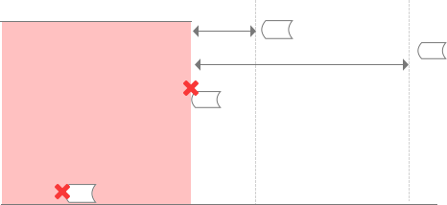20 m

Receiving a warning

100 m Limit maximum speed

###### Restricted Zones

When approaching:

* 1. Receiving a warning
  2. Can not fly in
  3. User can apply on the DJI official website after manual approval

Ground

When taking off:

1. Receiving a warning
2. Can not take off
3. User can apply on the DJI official website after manual approval

100 © 2024 DJI All Rights Reserved.

**DJI Avata 2** User Manual

###### Authorization Zones

Appear blue in the DJI app. Users will be prompted with a warning, and flight is limited by default. UA cannot fly or take off in these zones unless authorized. Authorization Zones may be unlocked by authorized users using a DJI verified account.

20 m

Receiving a warning

100 m

Limit maximum speed

###### Authorization Zones

When approaching:

1. Receiving a warning
2. Can not fly in
3. User can quickly apply on the DJI App with a phone number

Ground

###### Altitude Zones

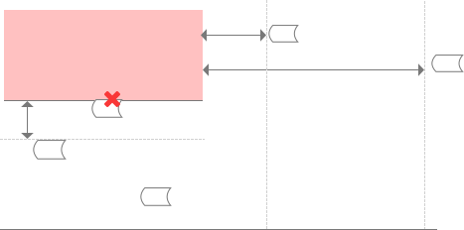Altitude zones are zones with a limited altitude and appear in gray on the map. When approaching, users receive warnings in the DJI app.

Limited altitude

###### Altitude Zone

10 m

20 m

Receiving a warning

100 m

Limit maximum speed

Ground

Limit maximum speed

1. UA can take off and fly into these zones in specific height with a warning message
2. User can apply for permission on the DJI official website after manual approval

© 2024 DJI All Rights Reserved. 101

**DJI Avata 2** User Manual

###### Enhanced Warning Zones

A warning message will prompt users when the drone reaches the edge of the zone.

###### Enhanced Warning Zones

* 1. UA can take off and fly into these zones with a warning message which needs user confirmation

Ground

* + - When the aircraft and DJI Fly app cannot obtain a GPS signal, the GEO awareness function will be inoperative. Interference of the aircraft antenna or disabling the GPS authorization in DJI Fly will cause the GPS signal fails to be obtained.



###### Warning Zones

A warning message will prompt users when the drone reaches the edge of the zone.

###### Warning Zones

1. UA can take off and fly into these zones with a warning message

Ground

#### EASA Notice

Make sure to read the Drone Information Notices document included in the package before use. Visit the link below for more EASA notice information on traceability. [https://www.easa.europa.eu/en/document-library/general-publications/drones-informationnotices](http://www.easa.europa.eu/en/document-library/general-publications/drones-informationnotices)

#### Original Instructions

This manual is provided by SZ DJI TECHNOLOGY CO., LTD., and the content is subject to change.

Address: Lobby of T2, DJI Sky City, No. 53 Xianyuan Road, Xili Community, Xili Street, Nanshan District, Shenzhen, China.

102 © 2024 DJI All Rights Reserved.

**DJI Avata 2** User Manual

## FAR Remote ID Compliance Information

The unmanned aircraft system is equipped with a Remote ID system that meets the requirements of 14 CFR Part 89.

The aircraft automatically broadcasts Remote ID messages from takeoff to shut down. An external device such as a cell phone or tablet is required to be connected as a location source to DJI mobile devices without an integrated GNSS system [1], and must run the DJI flight control app such as DJI Fly in the foreground and always allow the DJI flight control app to obtain its accurate location information. The connected external device must minimally be one of the following:

1. FCC Certified personal wireless device that uses GPS with SBAS (WAAS) for location services; or
2. FCC Certified personal wireless device with integrated GNSS.

Also, the external device must be operated in a way that does not interfere with the location reported and its correlation to the operator location.

* + The aircraft automatically initiates a pre-flight self-test (PFST) of the Remote ID system before takeoff and cannot take off if it does not pass the PFST [2]. The results of the PFST of the Remote ID system can be viewed in either a DJI flight control app such as DJI Fly or DJI goggles.
  + The aircraft monitors the Remote ID system functionality from pre-flight to shut down. If the Remote ID system malfunctions or has a failure, an alarm will be displayed in either a DJI flight control app such as DJI Fly or DJI goggles.
  + You can visit the official website of FAA to learn more about aircraft registration and Remote ID requirements.

#### Footnotes

1. DJI mobile devices without an integrated GNSS system such as DJI RC Motion 3, DJI FPV Remote Controller 3.
2. The pass criterion for PFST is that the hardware and software of the Remote ID required-data source and transmitter radio in the Remote ID system are functioning properly.

© 2024 DJI All Rights Reserved. 103

**DJI Avata 2** User Manual

## Flight Data

Flight data including flight telemetry, aircraft status information, and other parameters are automatically saved to the internal data recorder of the aircraft. The data can be accessed using DJI Assistant 2 (Consumer Drones Series).

## Aftersales Information

Visit https:/[/www.dji.com/support](http://www.dji.com/support) to learn more about aftersales service policies, repair services, and support.

104 © 2024 DJI All Rights Reserved.

**DJI Avata 2** User Manual

Maintenance

### Replacing the Foam Padding for Goggles

1. Hold the bottom of the foam padding and remove it gently, as shown below.

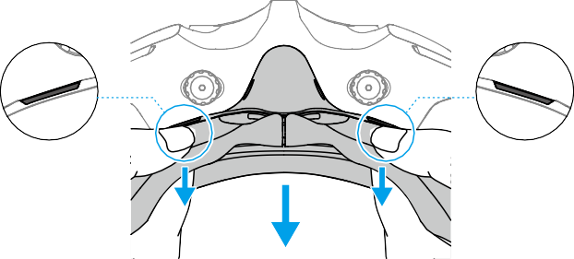



* DO NOT pull the sides when removing the foam padding. Otherwise, the padding

may be damaged.

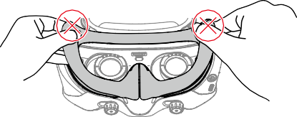

1. Align the positioning columns of the new foam padding with the positioning holes on the goggles. Install it and press along the contour. You will hear a "click" sound when pressing the two sides of the foam padding, check and make sure that there is no gap between the foam padding and the goggles.

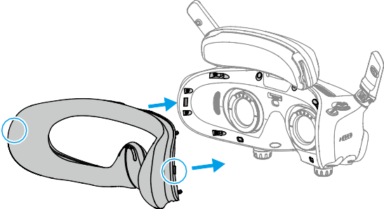

© 2024 DJI All Rights Reserved. 105

**DJI Avata 2** User Manual

### Cleaning and Maintenance of the Goggles

Clean the surface of the goggles with a soft, dry, clean cloth. Use the lens cleaning cloth to clean the lenses in a circular motion from the center to the outer edges.

* + DO NOT clean the integrated goggle lenses with alcohol wipes. The installed corrective lenses can be cleaned with disposable alcohol pads.



* + Clean the lenses gently. DO NOT scratch them as this will affect viewing quality.
  + DO NOT use alcohol or other cleanser to wipe the foam padding and the soft side of the battery compartment.
  + DO NOT tear or scratch the foam padding, the additional forehead pad, and the soft side of the battery compartment with sharp objects.
  + Store the goggles in a dry place at room temperature to avoid damage to the lenses and other optical components from high temperatures and humid environments.
  + Keep the lenses away from direct sunlight to avoid screen damage.

106 © 2024 DJI All Rights Reserved.

WE ARE HERE FOR YOU



Contact

**DJI SUPPORT**

This content is subject to change.



###### [https://www.dji.com/avata-2/downloads](http://www.dji.com/avata-2/downloads)

If you have any questions about this document, please contact DJI by sending a message to [DocSupport@dji.com.](mailto:DocSupport@dji.com)

DJI and DJI AVATA are trademarks of DJI. Copyright © 2024 DJI All Rights Reserved.





Two-Way Charging Hub

User Guide

使用说明使用說明

ユーザーガイド 사용자 가이드 Benutzerhandbuch

Guía del usuario Guide de l'utilisateur Guida all’uso Gebruiksaanwijzing Manual do utilizador Guia do usuário

Руководство пользователя

v1.0

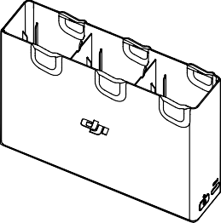

WE ARE HERE FOR YOU

在线技术支持

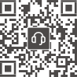 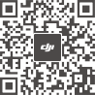

Contact

DJI SUPPORT

微信扫一扫获取技术支持

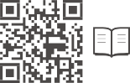[https://www.dji.com/avata-2/downloads](http://www.dji.com/avata-2/downloads)

This content is subject to change without prior notice. DJI and DJI AVATA are trademarks of DJI.

Copyright © 2024 DJI All Rights Reserved.

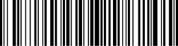

YCBZSS00276902



Carefully read this entire document and all safe and lawful practices provided before use.



EN

使用本产品前，请仔细阅读并遵循本文及与本产品相关的所有安全与合规操作指引。



CHS

使用本產品前，請仔細閱讀並遵循本文及與本產品相關的所有安全與合規操作指南。



CHT

ご使用前に、この文書全体に目を通し、安全で合法的慣行についての説明を注意深くお読みください。



JP

본 문서 및 제공된 모든 안전 및 적법한 사용 방법을 사용 전에 주의 깊게 읽어 주십시오.



KR

Bitte lies vor dem ersten Gebrauch dieses gesamte Dokument und alle sicheren und rechtmäßigen Praktiken sorgfältig durch.



DE

Antes de usar el producto, lea atentamente este documento al comple- to y todas las prácticas de seguridad y legales proporcionadas.



ES

Veuillez lire attentivement ce document dans son intégralité, ainsi que toutes les pratiques sécuritaires et légales avant l’utilisation.



FR

Prima dell’utilizzo, leggere con attenzione l’intero documento e tutte le pratiche sicure e legali fornite.



IT

Lees vóór gebruik dit hele document zorgvuldig door, evenals alle veilige en wettelijke praktijken.



NL

Leia atentamente este documento na íntegra e todas as práticas seguras e legais indicadas antes de utilizar o produto.



PT

Leia com atenção este documento por inteiro e todas as práticas seguras e legais fornecidas antes do uso.



PT-BR

Внимательно ознакомьтесь с данным документом и правилами техники безопасности перед использованием продукта.



RU

1

A1

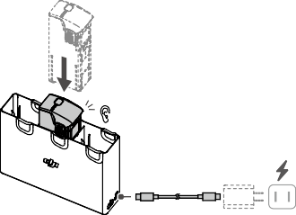

Click

A2

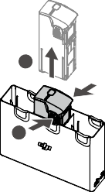

**2**

**1**

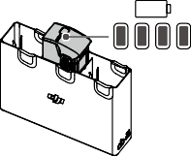

100%

B

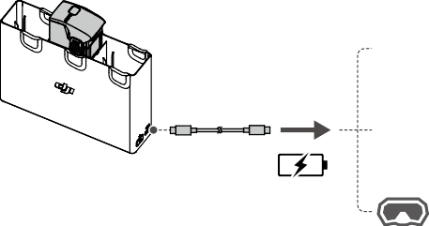

C

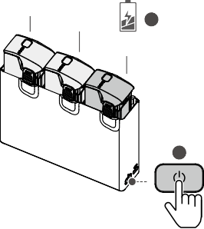

10%

10%

**2**

30%

**1**

1

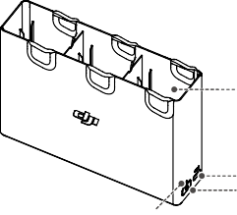

4

2

3

|  |  |  |  |
| --- | --- | --- | --- |
| 1 | 2 | 3 | 4 |
| Battery Port | USB-C Port | Function Button | Status LED |
| 电池接口 | USB-C 接口 | 功能按键 | 状态指示灯 |
| 電池連接埠 | USB-C 連接埠 | 功能按鍵 | 狀態指示燈 |
| バッテリーポート | USB-C ポート | 機能ボタン | ステータス LED |
| 배터리 포트 | USB-C 포트 | 기능 버튼 | 상태 LED |
| Akkuschacht | USB-C-Anschluss | Funktionstaste | Status-LED |
| Puerto de la batería | Puerto USB-C | Botón de función | Led de estado |
| Port de batterie | Port USB-C | Bouton fonction | LED d’état |
| Vano batteria | Porta USB-C | Tasto funzione | LED di stato |
| Batterijpoort | USB-C-poort | Functieknop | Statusled |
| Porta da bateria | Porta USB-C | Botão de função | LED de estado |
| Entrada da bateria | Entrada USB-C | Botão Função | LED de status |
| Порт для аккумулятора | Порт USB-C | Кнопка функций | Светодиодный индикатор состояния |



EN

Warnings

1. When using the DJI AVATATM 2 Two-Way Charging Hub (hereinafter referred to as “charging hub”) to charge DJI Avata 2 Intelligent Flight Batteries, it is recommended to use the DJI 65W Portable Charger or a USB Power Delivery charger.
2. The charging hub is only compatible with the BWX520-2150-14.76 Intelligent Flight Battery. DO NOT use the charging hub with other battery models.
3. Place the charging hub on a flat, stable surface with good ventilation when charging an external device or accumulating power. Make sure the device is properly insulated to prevent fire hazards.
4. DO NOT attempt to touch the metal terminals on the battery ports. Clean the metal terminals with a dry cloth if there is any noticeable buildup.
5. Make sure to charge batteries with low battery power in time. It is recommended to store the batteries in the charging hub.

Introduction

The DJI Avata 2 Two-Way Charging Hub is designed to charge up to three DJI Avata 2 Intelligent Flight Batteries. After the Intelligent Flight Batteries are inserted, the charging hub can supply power to external devices via the USB-C port, such as a remote controller or a mobile phone. The charging hub can also use the power accumulation function to transfer the remaining power of multiple low- power batteries into the battery with the highest remaining power.

Usage

Charging Intelligent Flight Batteries

1. Insert the batteries into the charging hub until they click into place. (Figure A1)
2. Connect the charging hub to a power outlet using a USB-C charger. The Intelligent Flight Battery with the highest power level will be charged first. The status LED indicates the battery level during charging. Refer to the Status LED Descriptions for more information about the blinking patterns.
3. The battery can be stored in the charging hub after charging. Remove the battery from the charging hub for use. (Figure A2)

Using the Charging Hub as a Power Bank

1. Insert an Intelligent Flight Battery into the charging hub. Connect an external device via the USB-C port, such as a mobile phone or remote controller. (Figure B)
2. The battery with the lowest power level will be discharged first, followed by the remaining batteries to be discharged sequentially. To stop charging the external device, disconnect the external device from the charging hub.
   * If the remaining charge of a battery is lower than 7%, the battery cannot charge the external device.



* + Press the function button to activate charging if charging does not start automatically.

Power Accumulation

1. Insert more than one battery into the charging hub, and press and hold the function button until the status LED turns green. The status LED of the charging hub pulses green, and the charge is transferred from the battery with the lowest power level to the battery with the highest power level. (Figure C)
2. To stop accumulating power, press and hold the function button until the status LED turns yellow. After stopping power accumulation, press the function button to check the power level of the batteries.

2



* Power accumulation stops automatically in the following situations:

a) The receiving battery is fully charged, or the power of the output battery is lower than 5%.

* 1. A charger or external device is connected to the charging hub or any battery is inserted or withdrawn from the charging hub during power accumulation.
  2. Power accumulation is interrupted for more than 15 minutes due to abnormal battery temperature.
  + After accumulating power, charge the battery with the lowest power level as soon as possible to avoid over-discharging.

Status LED Descriptions

Blinks yellow

Temperature of the batteries is too low or too high (no further operation needed)

Solid yellow

The charging hub is idle

Solid green

All batteries fully charged or supplying power to external devices

Solid Red

Power supply error or battery error (remove and reinsert the batteries or unplug and plug in the charger)

Pulses green Charging the battery or accumulating power

Blinking Pattern Description

Specifications

Compatible Battery BWX-2150-14.76

Model

Charging Time (Single DJI 65W Portable Charger: Approx. 45 mins

Battery)

Compatible Power Adapter

DJI 65W Portable Charger, DJI 65W Car Charger, or other USB PD chargers

Dimensions

141.8×37.1×100.2 mm

Operating Temperature

5° to 40° C (41° to 104° F)

Output (USB-C)

5V 2A

Input (USB-C) 5V/9V/12V/15V/20V, MAX 3A

Weight Approx. 114 g

Product Model CHX520-80



CHS

注意事项

1. 使用 DJI AVATATM 2 双向充电管家（简称“充电管家”）为智能飞行电池充电时，推荐配合 DJI 65W 便携充电器或其他支持 USB PD 快充协议 USB 充电器。
2. 充电管家仅适用于 BWX520-2150-14.76 智能飞行电池充电。请勿使用充电管家为其他型号电池充电。
3. 使用时，尤其是在给外部设备充电或进行集电时，需将充电管家平稳放置于通风环境，并注意绝缘及防火。
4. 请勿用手或其他物体触碰金属端子。若金属端子附着异物，请用干布擦拭干净。
5. 务必及时给低电量电池充电。推荐将电池放置于充电管家中保存。

简介

DJI Avata 2 双向充电管家最多可为三块 DJI Avata 2 智能飞行电池充电。安装电池后，可通过 USB-C 接口为遥控器或手机等外接设备充电，还可通过集电功能，将多块低电量电池中的剩余电量集中到剩余电量最高的电池中。

使用

为智能飞行电池充电

1. 将智能飞行电池插入充电管家的电池接口，直到听到“咔”的一声。( 图 A1)
2. 使用 USB-C 充电器将充电管家连接至交流电源。充电管家将根据电池的电量由高到低依次为电池充电。充电过程中，充电管家状态指示灯显示当前状态（详见“状态指示灯描述”）。按下功能按键可通过电池的状态指示灯查看电池电量。
3. 充电完成后，电池可放置于充电管家中保存。如需使用，按下电池卡扣将电池从充电管家中取出。（图

A2）

将充电管家作为移动电源

1. 将智能飞行电池插入充电管家，连接外部设备（如遥控器、手机）至充电管家 USB-C 接口。（图 B）
2. 电池根据剩余电量，由低到高依次放电，给外部设备供电。若要停止供电，需断开外部设备与充电管家的连接。
   * 若电池的剩余电量少于 7%，则无法为外部设备供电。



* + 若充电未自动开始，可短按功能按键启动充电。

集电

1. 将多个智能飞行电池插入充电管家，长按功能按键，直至充电管家状态指示灯变为绿灯呼吸。此时低电量电池中的剩余电量向剩余电量最高的电池集中。（图 C）
2. 若需停止集电，可再次长按功能按键，直至充电管家状态指示灯变为黄灯。集电完成后，短按功能按键可查看各电池电量。



* 出现以下情况时，集电将自动停止：

a) 接收电池已充满或输出电池的电量低于 5%；

* 1. 集电过程中连接充电器、外部设备到充电管家或插拔任一电池；
  2. 电池温度异常导致集电中断 15 分钟以上。
  + 使用集电功能后，务必及时给低电量电池充电避免电池过放。

状态指示灯描述

闪灯方式 描述

黄灯常亮 充电管家处于空闲状态

绿灯呼吸 正在充电或正在集电

绿灯常亮 所有电池电量充满或电池正给外部设备供电

黄灯闪烁 电池温度过高或过低（无需操作，等待电池温度恢复正常后可继续充电）

红灯常亮 充电过流、输入电压异常或其它错误（需要重新插拔电池或充电器以恢复充电）

规格参数

产品型号 CHX520-80

适配电源适配器 DJI 65W 便携充电器、DJI 65W 车载充电器或其他支持 USB PD 快充协议 USB 充电器

适用电池型号 BWX-2150-14.76

尺寸 141.8×37.1×100.2 mm

重量 约 114 g

工作环境温度 5 ℃至 40 ℃

充电时间（单块 DJI 65W 便携充电器：约 45 分钟

电池）

输出（USB-C） 5V 2A

输入（USB-C） 5V/9V/12V/15V/20V，最大 3 A



CHT

注意事項

1. 使用 DJI AVATATM 2 雙向充電管家（簡稱「充電管家」）為智慧飛行電池充電時，建議搭配 DJI 65W 便攜充電器或其他支援 USB PD 快充通訊協定的 USB 充電器。
2. 充電管家僅適用於為 BWX520-2150-14.76 智慧飛行電池充電。請勿使用充電管家為其他型號的電池充電。
3. 使用時，尤其是在為外部裝置進行充電或集電時，需將充電管家平穩放置於通風環境，並注意保持絕緣及防火。
4. 請勿用手或其他物體觸碰金屬端點。若金屬端點上附著異物，請用乾布擦拭乾淨。
5. 請及時為低電量電池充電。建議將電池放置於充電管家中保存。

簡介

DJI Avata 2 雙向充電管家最多可為三顆 DJI Avata 2 智慧飛行電池充電。安裝電池後，可透過 USB-C 連接埠為遙控器或手機等外接裝置充電，還可透過集電功能，將多顆低電量電池中的剩餘電量集中到剩餘電量最高的電池中。

使用

為智慧飛行電池充電

1. 將智慧飛行電池插入充電管家的電池連接埠，直到聽見「卡嗒」聲響。（圖 A1）
2. 使用 USB-C 充電器將充電管家連接至交流電源。充電管家將根據電池的電量，由高至低依次為電池充電。在充電過程中，充電管家狀態指示燈將顯示目前狀態（詳情請見「狀態指示燈說明」）。按下功能按鍵，可透過電池的狀態指示燈查看電池電量。
3. 充電完成後，電池可放置於充電管家中保存。如需使用，請按下電池卡扣，將電池從充電管家中取出。

（圖 A2）

將充電管家作為行動電源使用

1. 將智慧飛行電池插入充電管家，再將外部裝置（如遙控器、手機）連接至充電管家 USB-C 連接埠。（圖 B）
2. 電池將根據剩餘電量，由低至高依次放電，為外部裝置供電。若要停止供電，需中斷外部裝置與充電管家的連接。
   * 若電池的剩餘電量少於 7%，則無法為外部裝置供電。



* + 若充電未自動開始，可短按功能按鍵啟動充電。

集電

1. 將多個智慧飛行電池插入充電管家，長按功能按鍵，直至充電管家狀態指示燈變為緩慢閃爍綠燈。此時低電量電池中的剩餘電量將向剩餘電量最高的電池集中。（圖 C）
2. 若需停止集電，可再次長按功能按鍵，直至充電管家狀態指示燈變為黃燈。集電完成後，短按功能按鍵可查看各電池電量。
   * 出現以下情況時，集電將自動停止：



* + 1. 接收端電池已充飽或輸出端電池電量低於 5%；
    2. 在集電過程中將充電器、外部裝置連接至充電管家，或插拔任一電池；
    3. 因電池溫度異常導致集電中斷 15 分鐘以上。
  + 使用集電功能後，務必及時為低電量電池充電，以避免電池過度放電。

狀態指示燈說明

閃燈方式 說明

黃燈恆亮 充電管家處於空閒狀態

綠燈緩慢閃爍 正在充電或正在集電

綠燈恆亮 所有電池電量均充飽或電池正在為外部裝置供電

黃燈閃爍 電池溫度過高或過低（無需操作，等待電池溫度恢復正常後即可繼續充電）

紅燈恆亮 充電電流過大、輸入電壓異常或其他錯誤（需要重新插拔電池或充電器以恢復充電）

規格參數

產品型號 CHX520-80

適用電源轉接器 DJI 65W 便攜充電器、DJI 65W 車用充電器或其他支援 USB PD 快充通訊協定的 USB 充電器

適用電池型號 BWX-2150-14.76

尺寸 141.8×37.1×100.2 mm

重量 約 114 g

運作環境溫度 5 ℃ 至 40 ℃

輸出（USB-C）

5V 2A

充電時間（單顆電池） DJI 65W 便攜充電器：約 45 分鐘

輸入（USB-C） 5V/9V/12V/15V/20V，最大 3 A

3



JP

**警告**

1. DJI AVATATM 2 2WAY 充電ハブ（以下「充電ハブ」といいます）を使用して DJI Avata 2 インテリジェント フライトバッテリーを充電する場合、DJI 65W ポータブル充電器、または USB PD 規格対応充電器の使用を推奨します。
2. 充電ハブは、BWX520-2150-14.76 インテリジェント フライトバッテリーとのみ互換性があります。それ以外のバッテリーモデルと一緒に充電ハブを使用してしないでください。
3. 外部デバイスを充電するとき、または集電するときは、充電ハブを換気が良い、平らで安定した面に 置いてください。火災の危険を防ぐために、本機器が適切に絶縁されていることを確認してください。
4. バッテリーポートの金属端子には、触れないでください。金属端子の汚れが目立つ場合は、乾いた布で拭いてください。
5. バッテリー残量の少ないバッテリーは適時に充電してください。充電ハブにバッテリーを保管することをお勧めします。

**はじめに**

DJI Avata 2 2WAY 充電ハブは、最大 3 つの DJI Avata 2 インテリジェント フライトバッテリーを充電できるように設計されています。インテリジェント フライトバッテリーを挿入した後、充電ハブから、 USB-C ポート経由で外部デバイス（送信機やスマートフォンなど）に電力を供給することができます。充電ハブの集電機能を使用すると、複数の低電力バッテリーの残量を、残量の一番多いバッテリーに移動することもできます。

**使用方法**

インテリジェント フライトバッテリーの充電

1. カチッと音がするまで、バッテリーを充電ハブに挿入します。（図 A1）
2. USB-C 充電器を使用して、充電ハブを電源コンセントに接続します。残量が一番高いインテリジェント フライトバッテリーが最初に充電されます。充電中は [ ステータス LED] でバッテリー残量を表示します。点滅パターンの詳細については、[ ステータス LED] の説明を参照してください。
3. バッテリーの充電後、充電ハブにバッテリーを保管できます。使用するときは、充電ハブからバッテリーを取り外します。（図 A2）

充電ハブをモバイルバッテリーとして使用

1. インテリジェント フライトバッテリーを充電ハブに挿入します。スマートフォンや送信機などの外部デバイスを USB-C ポート経由で接続します。（図 B）
2. バッテリー残量の少ないバッテリーから先に放電され、その後、バッテリー残量が少ない順に放電されます。外部デバイスの充電を停止するには、外部デバイスを充電ハブから取り外します。
   * バッテリー残量が 7% 未満の場合、バッテリーは外部デバイスを充電できません。



* + 充電が自動的に開始されない場合は、充電ハブの機能ボタンを押して充電を有効にします。

集電機能

1. 充電ハブにバッテリーを 2 個以上挿入し、ステータス LED が緑色になるまで、機能ボタンを長押ししてください。充電ハブのステータス LED が緑色に点滅し、バッテリー残量が最も低いバッテリーからバッテリー残量が最も高いバッテリーに電力が移動します。（図 C）
2. 集電を停止するには、ステータス LED が黄色になるまで、機能ボタンを長押ししてください。集電を停止した後、機能ボタンを押してバッテリー残量を確認してください。
   * 以下の状況では、集電は自動停止します。



* + 1. 充電される側のバッテリーが完全に充電されているか、出力する側のバッテリーの電力が

5% 未満の場合。

* + 1. 集電中に、充電器や外部デバイスを充電ハブに接続したり、バッテリーを充電ハブに挿入、または、充電ハブから引き抜かれたりした場合。
    2. バッテリーの温度異常により、集電が 15 分以上中断した場合。
  + 集電後は、過放電を避けるため、できるだけ早く、バッテリー残量の一番少ないバッテリーを充電してください。

**ステータス** LED **の説明**

点滅パターン 概要

黄色点灯 充電ハブがアイドリング状態

緑色のパルス点滅 バッテリーを充電中または集電中

緑色点灯 全てのバッテリーが完全に充電済み、または、外部デバイスに電力供給中

黄色点滅 バッテリーの温度が低すぎるか高すぎる（それ以上の操作は不要）

赤色点灯 電源エラーまたはバッテリーエラー（バッテリーを取り外し再挿入するか、充電器のプラグを抜き差ししてください）

仕様

製品モデル CHX520-80

対応電源アダプター DJI 65W ポータブル充電器、DJI 65W 車載充電器、またはその他の USB PD 充電器

対応バッテリーモデル BWX-2150-14.76

寸法 141.8 × 37.1 × 100.2 mm

重量 約 114 g

動作環境温度 5℃～ 40℃

充電時間（シングルバ DJI 65W ポータブル充電器：約 45 分

ッテリー）

出力 (USB-C)

5 V 2 A

入力 (USB-C) 5 V/9 V/12 V/15 V/20 V、最大 3 A



KR

**경고**

1. DJI Avata 2 인텔리전트 플라이트 배터리를 충전하기 위해 DJI AVATATM 2 양방향 충전 허브 ( 이하 “충전 허 브”) 를 사용하는 경우 , DJI 65W 휴대용 충전기 또는 USB Power Delivery(USB 파워 딜리버리 , USB PD) 충전기를 사용하는 것이 좋습니다 .
2. 충전 허브는 BWX520-2150-14.76 인텔리전트 플라이트 배터리와만 호환됩니다 . 다른 배터리 모델과 함께 충전 허브를 사용하지 마십시오 .
3. 외장 기기를 충전하거나 전하를 축적할 때 충전 허브를 통풍이 잘되는 평평하고 안정된 표면에 놓으십시오 .

화재가 발생하지 않도록 기기가 올바르게 절연되어 있는지 확인하십시오 .

1. 배터리 포트의 금속 단자를 만지려고 시도하지 마십시오 . 눈에 띄는 이물질이 있으면 마른 천으로 금속 단 자를 닦으십시오 .
2. 전원이 부족한 배터리는 제 시간에 충전하십시오 . 배터리는 충전 허브에 보관하는 것이 좋습니다 .

**소개**

DJI Avata 2 양방향 충전 허브는 최대 3 개의 DJI Avata 2 인텔리전트 플라이트 배터리를 충전하도록 설계되었습 니다 . 인텔리전트 플라이트 배터리를 삽입한 후 충전 허브는 USB-C 포트를 통해 조종기 또는 휴대폰과 같은 외장 기기에 전원을 공급할 수 있습니다 . 충전 허브는 또한 전하 축적 기능을 사용하여 여러 개의 전력이 낮은 배터리의 남은 전력을 잔여 전력이 가장 높은 배터리로 전달할 수 있습니다 .

**사용**

인텔리전트 플라이트 배터리 충전

1. 딸깍 소리가 날 때까지 배터리를 충전 허브에 삽입합니다 . ( 그림 A1)
2. USB-C 충전기를 사용하여 충전 허브를 전원 콘센트에 연결합니다 . 배터리 잔량이 높은 인텔리전트 플라이 트 배터리를 먼저 충전합니다 . 충전하는 동안 LED 에 현재 배터리 잔량이 표시됩니다 . 깜박임 패턴에 대한 자세한 내용은 상태 LED 설명을 참조하십시오 .
3. 배터리는 충전 후 충전 허브에 보관할 수 있습니다 . 사용 시 충전 허브에서 배터리를 제거합니다 . ( 그림 A2)

충전 허브를 보조 배터리로 사용하기

1. 인텔리전트 플라이트 배터리를 충전 허브에 삽입합니다 . USB-C 포트를 통해 휴대폰 또는 조종기 등 외장 기기를 연결합니다 . ( 그림 B)
2. 배터리 잔량이 가장 낮은 배터리부터 먼저 방전되고 나머지 배터리가 차례대로 방전됩니다 . 외장 기기 충전 을 중지하려면 충전 허브에서 외장 기기의 연결을 해제합니다 .



* 배터리 잔량이 7% 미만이면 , 배터리로 외장 기기를 충전할 수 없습니다 .
* 충전이 자동으로 시작되지 않으면 기능 버튼을 눌러 충전을 활성화합니다 .

전하 축적

1. 충전 허브에 배터리를 1 개 이상 삽입하고 , 상태 LED 가 녹색으로 켜질 때까지 기능 버튼을 길게 누릅니다 . 충전 허브의 상태 LED 가 녹색으로 깜박이고 전력 수준이 가장 낮은 배터리에서 전력 수준이 가장 높은 배터 리로 전하를 전송합니다 . ( 그림 C)
2. 전하 축적을 중단하려면 , 상태 LED 가 노란색으로 변할 때까지 기능 버튼을 길게 누릅니다 . 전하 축적을 중 지한 후 기능 버튼을 눌러 배터리의 전력 수준을 확인합니다 .



* 다음과 같은 상황에서는 전하 축적이 자동으로 중지됩니다 .

a) 전하를 받는 배터리가 완전히 충전되었거나 출력 배터리의 전력이 5% 미만일 경우

* 1. 전하 축적 동안에 충전기 또는 외장 기기가 충전 허브에 연결되거나 배터리가 충전 허브에 삽입 되거나 충전 허브에서 분리되는 경우
  2. 비정상적인 배터리 온도로 인해 전하 축적이 15 분 이상 중단되는 경우
* 전하를 축적한 후 과방전을 방지하기 위해 가능한 한 빨리 전력 수준이 가장 낮은 배터리를 충전하십 시오 .

**상태** LED **설명**

깜박임 패턴 설명

노란색 유지 충전 허브 유휴 상태

녹색 깜박임 배터리 충전 또는 전하 축적

녹색 유지 배터리 모두 완전히 충전 완료 또는 외장 기기에 전력 공급

노란색 깜박임 배터리 온도가 너무 낮거나 너무 높음 ( 추가적인 작업 불필요 )

빨간색 유지 전원 공급 장치 오류 또는 배터리 오류 ( 배터리를 분리하고 다시 삽입하거나 , 충전기를 뽑았 다가 연결 )

**사양**

제품 모델명 CHX520-80

호환 전원 어댑터 DJI 65W 휴대용 충전기 , DJI 65W 차량용 충전기 또는 기타 USB PD 충전기

호환 배터리 모델 BWX-2150-14.76

크기 141.8 × 37.1 × 100.2 mm

무게 약 114 g

작동 온도 5~40 ° C

충전 시간 ( 단일 DJI 65W 휴대용 충전기 : 약 45 분

배터리 )

출력 (USB-C) 5V 2A

입력 (USB-C) 5V/9V/12V/15V/20V, 최대 3A



DE

Warnhinweise

1. Bei Verwendung der DJI AVATATM 2 Zweiwege-Akkuladestation (im Folgenden als „Akkuladestation“ bezeichnet) zum Aufladen von DJI Avata 2 Intelligent Flight Batteries wird die Nutzung eines tragbaren DJI-Ladegeräts mit 65 Watt oder eines USB-Ladegeräts empfohlen, welches das USB- Leistungsversorgungsprotokoll (USB Power Delivery Protocol) unterstützt.
2. Die Akkuladestation ist nur mit den BWX520-2150-14.76 Intelligent Flight Batteries kompatibel. Verwende die Akkuladestation NICHT mit anderen Akkumodellen.
3. Stelle die Akkuladestation auf eine flache, stabile, gut belüftete Oberfläche, wenn du ein externes Gerät auflädst oder Strom speicherst. Stelle sicher, dass das Gerät ordnungsgemäß isoliert ist, um das Risiko eines Brandes zu vermeiden.
4. Versuche NICHT, die Metallanschlüsse in den Akkuschächten zu berühren. Reinige erkennbare Verschmutzungen mit einem trockenen Tuch.
5. Achte darauf, Akkus bei niedrigem Ladestand rechtzeitig aufzuladen. Es wird empfohlen, die Akkus in der Akkuladestation aufzubewahren.

Einleitung

Die DJI Avata 2 Zweiwege-Akkuladestation kann bis zu drei DJI Avata 2 Intelligent Flight Batteries

4

aufnehmen. Wenn die Intelligent Flight Batteries eingesetzt sind, kann die Akkuladestation externe Geräte, wie eine Fernsteuerung oder ein Mobiltelefon, über den USB-C-Anschluss mit Strom versorgen. Die Akkuladestation kann mithilfe der Stromakkumulatorfunktion die verbliebene Restleistung mehrerer Akkus mit niedrigem Ladestand auf den Akku mit der höchsten Restleistung übertragen.

Verwendung

Aufladen der Intelligent Flight Batteries

1. Setze die Akkus in die Akkuladestation ein, bis ein Klicken zu hören ist. (Abbildung A1)
2. Schließe die Akkuladestation mit einem USB-C-Ladekabel an eine Steckdose an. Die Intelligent Flight Battery mit dem höchsten Ladestand wird zuerst geladen. Die Status-LED zeigt den Akkustand an. Weitere Informationen zur Blinkfolge siehe „Beschreibung der Status-LEDs“.
3. Der Akku kann nach dem Laden in der Akkuladestation aufbewahrt werden. Nimm den Akku aus der Akkuladestation heraus. (Abbildung A2)

Verwenden der Akkuladestation als Powerbank

1. Setze eine Intelligent Flight Battery in die Akkuladestation ein. Schließe ein externes Gerät, wie ein Mobiltelefon oder eine Fernsteuerung, über den USB-C-Anschluss an. (Abbildung B)
2. Der Akku mit dem niedrigsten Ladestand wird zuerst entladen, gefolgt von den verbleibenden Akkus, die der Reihe nach entladen werden. Um den Ladevorgang des externen Geräts zu beenden, trennst du die Verbindung zwischen externem Gerät und Akkuladestation.



* Wenn die Restspannung eines Akkus weniger als 7 % beträgt, kann der Akku das externe Gerät nicht laden.
  + Drücke die Funktionstaste, um den Ladevorgang zu aktivieren, wenn der Ladevorgang nicht automatisch beginnt.

Stromakkumulation

1. Setzte mehr als einen Akku in die Akkuladestation ein, drücke die Funktionstaste und halte sie gedrückt, bis die Status-LED grün leuchtet. Die Status-LED der Akkuladestation pulsiert grün und die Ladung wird vom Akku mit dem niedrigsten Ladestand auf den Akku mit dem höchsten Ladestand übertragen. (Abbildung C)
2. Um die Stromakkumulation zu beenden, halte die Funktionstaste gedrückt, bis die Status-LED gelb leuchtet. Wenn die Stromakkumulation beendet ist, drücke die Funktionstaste, um den Ladestand der Akkus zu prüfen.



* Die Stromakkumulation wird in folgenden Situationen automatisch beendet:
  1. Der Akku, der Strom erhält, ist vollständig aufgeladen, oder der Ladestand des Akkus, der Strom überträgt, beträgt weniger als 5 %.
  2. Ein Ladegerät oder ein externes Gerät wird an die Akkuladestation angeschlossen oder ein Akku wird während der Stromakkumulation in die Akkuladestation eingelegt oder daraus entfernt.
  3. Die Stromakkumulation wird aufgrund einer anormalen Akkutemperatur für mehr als 15 Minuten unterbrochen.
  + Nach der Stromakkumulation musst du den Akku mit dem niedrigsten Ladestand so bald wie möglich aufladen, um Tiefentladung zu verhindern.

Beschreibung der Status-LEDs

Blinkfolge Beschreibung

Leuchtet kontinuierlich Die Akkuladestation ist außer Betrieb gelb

Pulsiert grün Aufladen des Akkus oder Stromakkumulation

Leuchtet kontinuierlich Alle Akkus sind vollständig aufgeladen oder versorgen externe Geräte mit

grün Strom

Blinkt gelb

Die Temperatur der Akkus ist zu niedrig oder zu hoch (keine weiteren Maßnahmen erforderlich)

Leuchtet kontinuierlich Stromversorgungsfehler oder Akkufehler (entnimm die Akkus und lege

rot

sie wieder ein oder ziehe den Stecker aus der Steckdose und stecke ihn wieder ein)

Technische Daten

Produktmodell CHX520-80

Kompatibles Netzteil Tragbares DJI-Ladegerät mit 65 Watt, DJI-Autoladegerät mit 65 Watt oder andere USB-PD-Ladegeräte

Kompatible Akkus BWX-2150-14.76

Abmessungen 141,8 × 37,1 × 100,2 mm

Gewicht Ca. 114 g

Betriebstemperatur 5 °C bis 40 °C

Eingang (USB-C) 5 V/9 V/12 V/15 V/20 V, Max. 3 A

Ausgang (USB-C) 5 V 2 A

Ladezeit (einzelner Akku)

Tragbares DJI-Ladegerät mit 65 Watt: ca. 45 Minuten



ES

Advertencias

1. Al usar el centro de carga bidireccional DJI AVATATM 2 (en lo sucesivo denominado “centro de carga”) para cargar baterías de vuelo inteligentes DJI Avata 2, se recomienda utilizar el cargador portátil DJI de 65 W o un cargador USB Power Delivery.
2. El centro de carga solo es compatible con la Batería de vuelo inteligente BWX520-2150-14.76. NO use el centro de carga con otros modelos de batería.
3. Coloque el centro de carga en una superficie plana y estable con buena ventilación cuando vaya a cargar un dispositivo externo o a usar la acumulación de energía. Asegúrese de que el dispositivo esté debidamente aislado para evitar el riesgo de incendio.
4. NO intente tocar los terminales metálicos que hay en los puertos de batería. Limpie los terminales metálicos con un paño seco si están sucios.
5. Asegúrese de cargar a tiempo las baterías que tengan un nivel de carga bajo. Se recomienda guardar las baterías en el centro de carga.

Introducción

El centro de carga bidireccional DJI Avata 2 está diseñado para cargar hasta tres baterías de vuelo inteligentes DJI Avata 2. Una vez insertadas las baterías de vuelo inteligentes, el centro de carga puede suministrar alimentación a dispositivos externos, como controles remotos o teléfonos móviles, con el puerto USB-C. Además, el centro de carga cuenta con la función de acumulación de energía, que permite transferir la energía restante de baterías cuyo nivel de carga sea bajo a la batería que tenga el mayor nivel de carga.

Uso

Carga de baterías de vuelo inteligentes

1. Inserte las baterías en el centro de carga hasta que encajen en su sitio con un clic. (Imagen A1)
2. Conecte el centro de carga a una toma de corriente con el cargador USB-C. Se cargará primero la batería de vuelo inteligente con mayor nivel de carga. El led de estado indica el nivel de la batería durante la carga. Consulte más información sobre los patrones de parpadeo en la sección Descripciones del led de estado.
3. La batería se puede guardar en el centro de carga una vez terminada la carga. Retire la batería del centro de carga para utilizarla. (Imagen A2)

Uso del centro de carga como batería externa

1. Inserte una batería de vuelo inteligente en el centro de carga. Conecte un dispositivo externo (p. ej., un teléfono móvil o un control remoto) con el puerto USB-C. (Imagen B)
2. La batería con el menor nivel de carga se descargará en primer lugar; a continuación, las baterías restantes se descargarán secuencialmente. Para detener la carga del dispositivo externo, desconéctelo del centro de carga.
   * Si el nivel de carga restante de la batería es inferior al 7 %, esta no podrá cargar el dispositivo externo.



* + Si la carga no comienza automáticamente, presione el botón de función para activarla.

Acumulación de energía

1. Inserte varias baterías en el centro de carga y mantenga presionado el botón de función hasta que el led de estado se ilumine en verde. Cuando el led de estado del centro de carga parpadee en verde, la carga se transferirá de la batería con el nivel de carga más bajo a la batería con el nivel de carga más alto. (Imagen C)
2. Para detener la acumulación de energía, mantenga presionado el botón de función hasta que el led de estado se ilumine en amarillo. Tras detener la acumulación de energía, presione el botón de función para comprobar el nivel de carga de las baterías.
   * La acumulación de energía se detiene automáticamente en los siguientes casos:



* + 1. La batería receptora está totalmente cargada, o el nivel de carga de la batería emisora es inferior al 5 %.
    2. Se conecta un cargador o un dispositivo externo al centro de carga, o se inserta o se extrae una batería de dicho centro, durante la acumulación de energía.
    3. Se interrumpe el proceso de acumulación durante más de 15 minutos debido a una anomalía en la temperatura de las baterías.
  + Una vez terminada la acumulación de energía, cargue la batería con menor nivel de carga lo antes posible para evitar sobredescargas.

Descripciones del led de estado

Patrón de parpadeo Descripción

Amarillo fijo El centro de carga está inactivo

Parpadea en verde Cargando la batería o acumulando energía

Verde fijo Todas las baterías están totalmente cargadas o alimentando a dispositivos externos

Parpadea en amarillo La temperatura de las baterías es demasiado baja o demasiado alta (no es necesario realizar ninguna otra acción)

Rojo fijo Error de la fuente de alimentación o error de batería (retire y vuelva a insertar las baterías, o desenchufe y vuelva a enchufar el cargador)

Especificaciones

Modelo de producto CHX520-80

Adaptador de corriente compatible

Cargador portátil DJI de 65 W, cargador para coche DJI de 65 W u otros cargadores USB PD

Modelo de batería compatible BWX-2150-14.76

Dimensiones 141.8 × 37.1 × 100.2 mm

Peso Aprox. 114 g

Temperatura de funcionamiento

De 5 a 40 °C (de 41 a 104 °F)

Entrada (USB-C) 5 V/9 V/12 V/15 V/20 V, MAX 3 A

Salida (USB-C) 5 V 2 A

Tiempo de carga (una batería) Cargador portátil DJI de 65 W: Aprox. 45 min



FR

Avertissements

1. Lorsque vous utilisez la station de recharge bidirectionnelle DJI AVATATM 2 (ci-après appelée « station de recharge ») pour charger les Batteries de vol intelligentes DJI Avata 2, il est recommandé d’utiliser le chargeur portable DJI 65 W ou un chargeur USB Power Delivery.
2. La station de recharge est uniquement compatible avec les Batteries de vol intelligentes BWX520- 2150-14.76. N’utilisez PAS la station de recharge avec d’autres modèles de batterie.
3. Placez la station de recharge sur une surface plane et stable avec une bonne ventilation lors de la recharge d’un appareil externe ou de l’accumulation d’énergie. Assurez-vous que le dispositif est correctement isolé pour éviter tout risque d’incendie.
4. N’essayez PAS de toucher les bornes métalliques des ports de batterie. Nettoyez les bornes métalliques à l’aide d’un chiffon sec si vous voyez apparaître des dépôts.

5

1. Veillez à recharger à temps les batteries dont la charge est faible. Il est recommandé de stocker les batteries dans la station de recharge.

Introduction

La station de recharge bidirectionnelle DJI Avata 2 est conçue pour recharger jusqu’à trois Batteries de vol intelligentes DJI Avata 2. Une fois les Batteries de vol intelligentes insérées, la station de recharge peut alimenter des appareils externes via le port USB-C, comme une radiocommande ou un téléphone portable. La station de recharge peut également utiliser la fonction d’accumulation d’énergie pour transférer la charge restante de plusieurs batteries de faible puissance vers la batterie dont la charge restante est la plus élevée.

Utilisation

Recharge des Batteries de vol intelligentes

1. Insérez les batteries dans la station de recharge jusqu’à ce qu’elles s’enclenchent. (Figure A1)
2. Connectez la station de recharge à une prise courant à l’aide d’un chargeur USB-C. La Batterie de vol intelligente la plus chargée sera rechargée en premier. La LED d’état indique le niveau de batterie pendant la charge. Reportez-vous aux Descriptions de la LED d’état pour plus d’informations sur les modes de clignotement de cette dernière.
3. La batterie peut être stockée dans la station de recharge après la recharge. Retirez la batterie de la station de recharge pour l’utiliser. (Figure A2)

Utilisation de la station de recharge comme batterie externe

1. Insérez une Batterie de vol intelligente dans la station de recharge. Connectez un appareil externe via le port USB-C, tel qu’un téléphone portable ou une radiocommande. (Figure B)
2. Les batteries ayant le niveau de charge le plus faible seront déchargées en premier et les batteries restantes seront déchargées dans l’ordre. Pour arrêter la recharge de l’appareil externe, déconnectez- le de la station de recharge.
   * Si la charge restante d’une batterie est inférieure à 7 %, la recharge de l’appareil externe sera impossible.



* + Appuyez une fois sur le bouton fonction pour activer la recharge si celle-ci ne démarre pas automatiquement.

Accumulation d’énergie

1. Insérez plus d’une batterie dans la station de recharge, puis appuyez sur le bouton fonction et maintenez-le enfoncé jusqu’à ce que la LED d’état devienne verte. La LED d’état de la station de recharge émet des impulsions vertes et la charge est transférée de la batterie ayant le niveau de charge le plus faible à celle ayant le niveau de charge le plus élevé. (Figure C)
2. Pour arrêter l’accumulation d’énergie, appuyez sur le bouton fonction et maintenez-le enfoncé jusqu’à ce que la LED d’état devienne jaune. Une fois l’arrêt de l’accumulation d’énergie, appuyez sur le bouton fonction pour vérifier le niveau de charge des batteries.
   * L’accumulation d’énergie s’arrête automatiquement dans les situations suivantes :



* + 1. Recharge complète de la batterie réceptrice ou niveau de charge de la batterie émettrice inférieur à 5 %.
    2. Connexion d’un chargeur ou d’un appareil externe à la station de recharge, ou insertion ou retrait d’une batterie dans la station de recharge pendant l’accumulation d’énergie.
    3. Arrêt de l’accumulation d’énergie pendant plus de 15 minutes en raison d’une température anormale de la batterie.
  + Une fois l’énergie accumulée, rechargez la batterie avec le niveau de charge le plus faible dès que possible afin d’éviter une décharge excessive.

Descriptions de la LED d’état

Clignote en jaune

Température des batteries trop basse ou trop élevée (aucune autre opération n’est nécessaire)

Jaune fixe

Station de recharge en veille

Vert fixe

Recharge complète de toutes les batteries ou alimentation d’appareils externes

Rouge fixe

Erreur d'alimentation ou erreur de batterie (retirez et réinsérez les batteries ou débranchez et branchez le chargeur)

Impulsion verte Recharge de la batterie ou accumulation d’énergie

Type de clignotement Description

Caractéristiques

Modèle du produit CHX520-80

Adaptateur secteur compatible Chargeur portable DJI 65 W, chargeur pour voiture DJI 65 W ou autres chargeurs USB PD

Modèle de batterie compatible BWX-2150-14.76

Dimensions 141,8 × 37,1 × 100,2 mm

Poids Env. 114 g

Température de fonctionnement

5 à 40 °C (41 à 104 °F)

Entrée (USB-C) 5 V/9 V/12 V/15 V/20 V, MAX 3 A

Sortie (USB-C) 5 V 2 A

Temps de recharge (Batterie unique)

Chargeur portable DJI 65 W : Env. 45 min



IT

Avvertenze

1. Quando si utilizza la stazione di ricarica a doppio uso DJI AVATATM 2 (di seguito indicata come “stazione di ricarica”) per ricaricare le batterie di volo intelligenti DJI Avata 2, si consiglia di usare il caricabatterie portatile DJI da 65 W o un caricabatterie USB Power Delivery.
2. La stazione di ricarica è compatibile solo con la batteria di volo intelligente BWX520-2150-14.76. NON utilizzare la stazione di ricarica con altri tipi di batterie.
3. Posizionare la stazione di ricarica su una superficie piana e stabile soggetta a buona ventilazione quando si ricarica un dispositivo esterno o si accumula ricarica. Assicurarsi che il dispositivo sia correttamente isolato per prevenire i rischi di incendio.
4. NON toccare i terminali in metallo delle porte della batteria. Se si notano accumuli di sporcizia, pulire i terminali con un panno asciutto.
5. Accertarsi di ricaricare per tempo le batterie con poca carica residua. Si consiglia di conservare le batterie nella stazione di ricarica.

Introduzione

La stazione di ricarica a doppio uso DJI Avata 2 è progettata per ricaricare fino a tre batterie di volo intelligenti DJI Avata 2. Una volta inserite le batterie di volo intelligenti, la stazione di ricarica è in grado di alimentare dispositivi esterni tramite la porta USB-C, come un radiocomando o telefono cellulare. Inoltre, la stazione di ricarica è in grado di usare la funzione di accumulo di ricarica per trasferire la ricarica residua di diverse batterie con poca carica alla batteria con la ricarica residua più alta.

Utilizzo

Ricarica delle batterie di volo intelligenti

1. Inserire le batterie nella stazione di ricarica fino a farle scattare in posizione. (Figura A1)
2. Collegare la stazione di ricarica a una presa di alimentazione per mezzo di un caricabatterie USB-C. La batteria di volo intelligente con il livello di energia più alto sarà caricata per prima. Il LED di stato indica il livello della batteria durante la ricarica. Per ulteriori informazioni sugli schemi di lampeggiamento, fare riferimento alla sezione Descrizioni dei LED di stato.
3. È possibile conservare la batteria nella stazione di ricarica dopo la ricarica. Rimuovere la batteria dalla stazione di ricarica. (Figura A2)

Utilizzo della stazione di ricarica come power bank

1. Inserire una batteria di volo intelligente nella stazione di ricarica. Collegare un dispositivo esterno tramite le porta USB-C, come un telefono cellulare o un radiocomando. (Figura B)
2. La batteria con il livello di potenza più basso verrà scaricata per prima, seguita da quelle rimanenti che verranno scaricate in sequenza. Per interrompere la ricarica del dispositivo esterno, scollegare il dispositivo esterno dalla stazione di ricarica.
   * Se la ricarica residua di una batteria è inferiore al 7%, la batteria non è in grado di caricare il dispositivo esterno.



* + Se la ricarica non si avvia automaticamente, attivarla premendo il tasto funzione.

Accumulo di ricarica

1. Inserire più di una batteria nella stazione di ricarica, quindi premere e tenere premuto il tasto funzione fino a quando il LED di stato non si accende di verde. Il LED di stato della stazione di ricarica lampeggia in verde e la ricarica viene trasferita dalla batteria con meno ricarica a quella con più ricarica. (Figura C)
2. Per interrompere l’accumulo di ricarica, premere e tenere premuto il tasto funzione fino a quando il LED di stato non si accende di giallo. Una volta interrotto l’accumulo di ricarica, premere il tasto funzione per verificare il livello di ricarica delle batterie.
   * L’accumulo di ricarica si interrompe automaticamente nelle seguenti situazioni:



* + 1. La batteria ricevente è completamente carica oppure la ricarica della batteria emittente è inferiore al 5%.
    2. Un caricabatterie o un dispositivo esterno è connesso alla stazione di ricarica oppure una batteria viene inserita o rimossa dalla stazione di ricarica durante l’accumulo di ricarica.
    3. L’accumulo di ricarica è interrotto per più di 15 minuti a causa di temperatura anomala della batteria.
  + Dopo l’accumulo di ricarica, caricare la batteria con meno carica non appena possibile, per evitare lo scaricamento eccessivo.

Descrizione dei LED di stato

Schema di lampeggiamento Descrizione

Luce gialla fissa La stazione di ricarica è inattiva

Luce verde lampeggiante Ricarica della batteria o accumulo di ricarica

Luce verde fissa Tutte le batterie sono completamente cariche o alimentano

dispositivi esterni

Luce gialla lampeggiante La temperatura delle batterie è troppo bassa o troppo alta (non sono

necessarie ulteriori operazioni)

Luce rossa fissa Errore della fonte di alimentazione o della batteria (rimuovere e

inserire nuovamente le batterie oppure scollegare e ricollegare il caricabatterie)

Specifiche

Modello di batteria compatibile

BWX-2150-14.76

Tempo di ricarica (batteria singola)

Caricabatterie portatile DJI da 65 W: Circa 45 min

Adattatore di alimentazione Caricabatterie portatile DJI da 65 W, caricabatterie per auto DJI da 65 compatibile W o altri caricabatterie USB PD

Dimensioni

141,8 × 37,1 × 100,2 mm

Temperatura di funzionamento

Da 5°C a 40°C

Uscita (USB-C)

5 V 2 A

Ingresso (USB-C) 5 V/9 V/12 V/15 V/20 V, MAX 3 A

Peso Circa 114 g

Modello prodotto CHX520-80



NL

Waarschuwingen

1. Wanneer u de DJI AVATATM 2 Tweeweg-oplaadhub (hierna 'oplaadhub' genoemd) gebruikt om DJI Avata 2 Intelligente vliegbatterijen op te laden, wordt het aanbevolen om de DJI 65W Draagbare oplader of een USB Power Delivery-lader te gebruiken.

6

1. De oplaadhub is alleen compatibel met de BWX520-2150-14.76 Intelligente vliegbatterij. Gebruik de oplaadhub NIET met andere batterijmodellen.
2. Plaats de oplaadhub op een vlakke, stabiele ondergrond met goede ventilatie wanneer u een extern apparaat oplaadt of stroom toedient. Zorg ervoor dat het apparaat goed geïsoleerd is om brandgevaar te voorkomen.
3. Raak de metalen polen op de batterijpoorten NIET aan. Reinig de metalen polen met een droge doek als er vuil zichtbaar is.
4. Zorg ervoor dat u de batterijen met een laag batterijvermogen op tijd oplaadt. Het wordt aanbevolen om de batterijen in de oplaadhub op te slaan.

Inleiding

De DJI Avata 2 Tweeweg-oplaadhub is ontworpen om maximaal drie DJI Avata 2 Intelligente vliegbatterijen op te laden. Nadat de Intelligente vliegbatterijen zijn geplaatst, kan de oplaadhub via de USB-C-poort externe apparaten, zoals een afstandsbediening of een mobiele telefoon, van stroom voorzien. De oplaadhub kan ook de functie voor het accumuleren van stroom gebruiken om het resterende vermogen van meerdere batterijen met een laag vermogen over te brengen naar de batterij met het hoogste resterende vermogen.

Gebruik

Intelligente vlieg batterijen opladen

1. Plaats de batterijen in de oplaadhub totdat ze op de plaats klikken. (Figuur A1)
2. Sluit de oplaadhub aan op een stopcontact met behulp van een USB-C-lader. De Intelligente vliegbatterijen met het hoogste vermogensniveau zal als eerste worden opgeladen. De statusled geeft het batterijniveau aan tijdens het laden. Raadpleeg de Beschrijvingen van statusled voor meer informatie over de knipperpatronen.
3. De batterij kan na het opladen in de oplaadhub worden opgeslagen. Verwijder de batterij uit de oplaadhub voor gebruik. (Figuur A2)

De oplaadhub gebruiken als powerbank

1. Plaats een Intelligente vliegbatterij in de oplaadhub. Sluit via de USB-C-poort een extern apparaat aan, zoals een mobiele telefoon of afstandsbediening. (Figuur B)
2. De batterij met het laagste vermogensniveau wordt als eerste ontladen, gevolgd door de overige batterijen die in volgorde worden ontladen. Om het opladen van het externe apparaat te stoppen, koppelt u het externe apparaat los van de oplaadhub.
   * Als de resterende lading van een batterij lager is dan 7%, kan de batterij het externe apparaat niet opladen.



* + Druk op de functieknop om het opladen te activeren als het opladen niet automatisch start.

Stroomaccumulatie

1. Plaats meer dan één batterij in de oplaadhub en houd de functieknop ingedrukt totdat de statusled groen gaat branden. De statusled van de oplaadhub knippert groen en de lading wordt overgebracht van de batterij met het laagste vermogensniveau naar de batterij met het hoogste vermogensniveau. (Figuur C)
2. Om de accumulatie van stroom te stoppen, houdt u de functieknop ingedrukt totdat de statusled geel gaat branden. Druk na het stoppen van de accumulatie op de functieknop om het vermogen van de batterijen te controleren.
   * Het accumuleren van stroom stopt automatisch in de volgende situaties:



* + 1. De ontvangende batterij is volledig opgeladen of het vermogen van de batterij die levert is lager dan 5%.
    2. Er is een oplader of extern apparaat aangesloten op de oplaadhub of een batterij wordt in de oplaadhub geplaatst of eruit verwijderd tijdens het accumuleren van stroom.
    3. De accumulatie van stroom wordt gedurende meer dan 15 minuten onderbroken vanwege een abnormale batterijtemperatuur.
  + Laad de batterij na accumulatie zo snel mogelijk op met het laagste vermogensniveau om overladen te voorkomen.

Beschrijvingen van statusleds

Knipperpatroon Beschrijving

Continu geel De oplader is niet actief

Pulseert groen De batterij is aan het opladen of er wordt stroom geaccumuleerd

Continu groen Alle batterijen zijn volledig opgeladen of leveren voeding aan externe apparaten

Knippert geel De temperatuur van de batterijen is te laag of te hoog (geen verdere actie nodig)

Continu rood Voedings- of batterijfout (koppel de batterijen of oplader los en sluit ze opnieuw aan om het opladen te hervatten)

Specificaties

Compatibel batterijmodel

BWX-2150-14.76

Oplaadtijd (één batterij)

DJI 65W Draagbare oplader: Circa 45 minuten

Compatibele voedingsadapter

DJI 65W Draagbare oplader, DJI 65W Autolader of andere USB PD-opladers

Dimensies

141,8×37,1×100,2 mm

Bedrijfstemperatuur 5° tot 40° C (41° tot 104° F)

Uitgang (USB-C)

5 V 2 A

Ingang (USB-C) 5 V/9 V/12 V/15 V/20 V, MAX 3 A

Gewicht Circa 114 gr

Productmodel CHX520-80



PT

Avisos

1. Ao utilizar o Terminal de carregamento bidirecional DJI AVATATM 2 (doravante referido como “terminal de carregamento”) para carregar baterias de voo inteligentes DJI Avata 2, recomenda-se a utilização do carregador portátil DJI 65 W ou de um carregador USB Power Delivery.
2. O terminal de carregamento é compatível apenas com a bateria de voo inteligente BWX520-2150-

14.76. NÃO utilize o terminal de carregamento com outros modelos de bateria.

1. Coloque o centro de carregamento numa superfície plana e estável com boa ventilação ao carregar um dispositivo externo ou ao acumular energia. Certifique-se de que o dispositivo está devidamente isolado para evitar riscos de incêndio.
2. NÃO tente tocar nos terminais de metal das portas da bateria. Se existir qualquer acumulação visível de sujidade, limpe os terminais de metal com um pano seco.
3. Certifique-se de que carrega as baterias com pouca carga a tempo. Recomenda-se que guarde as baterias no terminal de carregamento.

Introdução

O terminal de carregamento bidirecional DJI Avata 2 foi concebido para carregar até três baterias de voo inteligentes DJI Avata 2. Após a introdução das baterias inteligentes de voo, o terminal de carregamento pode fornecer energia a dispositivos externos através da porta USB-C, como um telecomando ou telemóvel. O terminal de carregamento também pode utilizar a função de acumulação de energia para transferir a energia restante de várias baterias de baixa energia para a bateria com a energia restante mais elevada.

Utilização

Carregar baterias de voo inteligentes

1. Insira as baterias no terminal de carregamento até ouvir um clique. (Figura A1)
2. Ligue o terminal de carregamento a uma tomada elétrica utilizando um carregador USB-C. A bateria de voo inteligente com o nível de potência mais elevado é a primeira a ser carregada. O LED de estado indica o nível da bateria durante o carregamento. Consulte as Descrições do LED de estado, para obter mais informações sobre os padrões de intermitência.
3. A bateria pode ser armazenada no centro de carregamento após o carregamento. Retire a bateria do terminal de carregamento para utilização. (Figura A2)

Utilizar o terminal de carregamento como um Power Bank

1. Insira uma bateria de voo inteligente no terminal de carregamento. Ligue um dispositivo externo através da porta USB-C, como um telecomando ou telemóvel. (Figura B)
2. A bateria com o nível de carga mais baixo será descarregada primeiro e as restantes serão descarregadas em sequência. Para parar de carregar o dispositivo externo, desligue o dispositivo externo do terminal de carregamento.
   * Se a carga restante de uma bateria for inferior a 7%, a bateria não pode carregar o dispositivo externo.



* + Prima o botão de função para ativar o carregamento se o carregamento não for iniciado automaticamente.

Acumulação de energia

1. Insira mais do que uma bateria no terminal de carregamento e prima sem soltar o botão de função até que o LED de estado fique verde. O LED de estado do terminal de carregamento pisca a verde e a carga é transferida da bateria com o nível de energia mais baixo para a bateria com o nível de energia mais elevado. (Figura C)
2. Para parar de acumular energia, prima sem soltar o botão de função até que o LED de estado fique amarelo. Depois de parar a acumulação de energia, prima o botão de função para verificar o nível de energia das baterias.
   * A acumulação de energia para automaticamente nas seguintes situações:



* + 1. A bateria recetora está totalmente carregada ou a energia da bateria de saída é inferior a 5%.
    2. Um carregador ou dispositivo externo é ligado ao terminal de carregamento ou qualquer bateria é inserida ou removida do terminal de carregamento durante a acumulação de energia.
    3. A acumulação de energia é interrompida durante mais de 15 minutos devido a uma temperatura anormal da bateria.
  + Após a acumulação de energia, carregue a bateria com o nível de energia mais baixo assim que possível para evitar a descarga excessiva.

Descrições do LED de estado

Luz amarela a piscar

A temperatura das baterias é demasiado baixa ou demasiado elevada (não são necessárias outras operações)

Luz amarela continuamente acesa O terminal de carregamento está inativo

Luz verde continuamente acesa

Todas as baterias totalmente carregadas ou a fornecer energia a dispositivos externos

Luz vermelha continuamente acesa Erro da fonte de alimentação ou da bateria (retire e volte a

colocar as baterias ou desligue e volte a ligar o carregador)

Impulsos verdes Carregar a bateria ou acumular energia

Padrão de intermitência Descrição

Especificações

Modelo do produto CHX520-80

Transformador compatível Carregador portátil DJI 65 W, carregador de automóvel DJI

65 W ou outros carregadores PD USB

Modelo de bateria compatível BWX-2150-14.76

Dimensões 141,8×37,1×100,2 mm

Peso Aprox. 114 g

Temperatura de funcionamento 5 °C a 40 °C (41 °F a 104 °F)

Entrada (USB-C) 5 V/9 V/12 V/15 V/20 V, MÁX. 3 A

Saída (USB-C) 5 V 2 A

Tempo de carregamento (uma bateria) Carregador portátil DJI 65 W: Aprox. 45 min

7



PT-BR

Avisos

1. Ao usar o carregador com múltiplas entradas de duas vias DJI AVATATM 2 (doravante denominado “carregador com múltiplas entradas”) para carregar as Baterias de Voo Inteligente DJI Avata 2, recomenda-se o uso do carregador portátil 65 W DJI ou do carregador USB com fornecimento de energia.
2. O carregador com múltiplas entradas só é compatível com a Bateria de Voo Inteligente BWX520-2150-

14.76. NÃO tente utilizar o carregador com múltiplas entradas com outros modelos de bateria.

1. Coloque o carregador com múltiplas entradas em uma superfície plana e estável, com boa ventilação, ao carregar um dispositivo externo ou acumular energia. Certifique-se de que dispositivo esteja devidamente isolado para evitar riscos de incêndio.
2. NÃO toque nos terminais metálicos nas entradas da bateria. Se houver acúmulo visível de sujeira nos terminais metálicos, limpe-os com um pano seco.
3. Certifique-se de carregar as baterias com baixa carga a tempo. Recomenda-se armazenar as baterias no carregador com múltiplas entradas.

Introdução

O Carregador com múltiplas entradas de duas vias do DJI Avata 2 foi projetado para carregar até três Baterias de Voo Inteligentes DJI Avata 2. Após as Baterias de Voo Inteligentes serem instaladas, o carregador com múltiplas entradas poderá fornecer energia para dispositivos externos, como controles remotos ou celulares, por meio da entrada USB-C. O carregador com múltiplas entradas também pode utilizar a função de acumulação de energia para transferir a carga restante de várias baterias com baixa carga para a bateria com a maior carga restante.

Uso

Como carregar Baterias de Voo Inteligentes

1. Insira as baterias no carregador com múltiplas entradas até que cliquem no lugar correto. (Figura A1)
2. Conecte o carregador com múltiplas entradas a uma tomada elétrica usando um carregador USB-C. A Bateria de voo inteligente com o maior nível de energia será carregada primeiro. O LED de status indica o nível da bateria durante o carregamento. Consulte a seção Descrições do LED de status para obter mais informações sobre os padrões de luzes intermitentes.
3. A bateria pode ser armazenada no carregador com múltiplas entradas após o carregamento. Remova a bateria do carregador com múltiplas entradas para uso. (Figura A2)

Como utilizar o Carregador com múltiplas entradas como Carregador portátil

1. Insira uma Bateria de voo inteligente no carregador com múltiplas entradas. Conecte um dispositivo externo, como um controle remoto ou celular, por meio da entrada USB-C. (Figura B)
2. A bateria com o menor nível de carga será descarregada primeiro, seguida pelas demais, que serão descarregadas em sequência. Para interromper o carregamento do dispositivo externo, desconecte-o do carregador com múltiplas entradas.
   * Se a carga restante de uma bateria for inferior a 7%, ela não poderá carregar o dispositivo externo.



* + Pressione o botão Função para ativar o carregamento, caso o carregamento não comece automaticamente.

Acúmulo de energia

1. Insira mais de uma bateria no carregador com múltiplas entradas, pressione e mantenha o botão Função pressionado até que o LED de status fique aceso em verde. O LED de status do carregador com múltiplas entradas pulsará em verde, e a carga será transferida da bateria com o nível de carga mais baixo para a bateria com o nível de carga mais alto. (Figura C)
2. Para interromper o acúmulo de carga, pressione e mantenha o botão Função pressionado até que o LED de status acenda em amarelo. Após o acúmulo de carga ser interrompido, pressione o botão Função para verificar o nível de carga das baterias.
   * O acúmulo de carga será interrompido automaticamente nas seguintes situações:



* + 1. A bateria receptora está totalmente carregada ou a carga da bateria de saída é inferior a 5%.
    2. Um carregador ou dispositivo externo está conectado ao Carregador com múltiplas entradas ou uma bateria foi inserida ou removida do Carregador com múltiplas entradas durante o acúmulo de carga.
    3. O acúmulo de carga é interrompido por mais de 15 minutos devido à temperatura anormal da bateria.
  + Após acumular carga, carregue o mais rápido possível a bateria com o nível de carga mais baixo para evitar a sobredescarga.

Descrições do LED de status

Piscando em amarelo

A temperatura das baterias está muito baixa ou muito alta (nenhuma operação adicional é necessária)

Aceso em amarelo

O Carregador com múltiplas entradas está inativo

Aceso em verde

Todas as baterias estão completamente carregadas ou fornecendo carga a dispositivos externos

Aceso em vermelho

Erro na fonte de alimentação ou na bateria (desconecte e conecte as baterias ou o carregador)

Pulsa em verde Carregar a bateria ou acumular carga

Padrão de luzes intermitentes Descrição

Especificações

Modelo do produto CHX520-80

Adaptador de alimentação compatível

Carregador portátil 65 W DJI, Carregador para automóveis 65 W DJI ou outros carregadores USB PD

Modelo de bateria compatível BWX-2150-14.76

Dimensões 141,8×37,1×100,2 mm

Peso Aprox. 114 g

Temperatura de funcionamento 5° a 40° C (41° a 104° F)

Entrada (USB-C) 5 V/9 V/12 V/15 V/20 V, MAX 3 A

Saída (USB-C) 5 V 2 A

Tempo de carregamento (bateria Carregador portátil 65 W DJI: Aprox. 45 min.

única)



RU

Предупреждения

1. Для зарядки аккумуляторов Intelligent Flight Battery DJI Avata 2 с помощью многофункционального зарядного концентратора DJI AVATATM 2 (далее «зарядный концентратор») рекомендуется использовать портативное зарядное устройство мощностью 65 Вт от DJI или зарядное устройство USB.
2. Зарядный концентратор совместим только с аккумуляторами Intelligent Flight Battery BWX520- 2150-14.76. НЕ используйте зарядный концентратор с другими моделями аккумуляторов.
3. Во время зарядки внешнего устройства или накопления энергии поместите зарядный концентратор на ровную и устойчивую поверхность с хорошей вентиляцией. Убедитесь, что устройство надежно изолировано для предотвращения опасности возгорания.
4. НЕ касайтесь металлических контактов на разъемах аккумулятора. При наличии налета очистите металлические контакты сухой тканью.
5. Заряжайте аккумуляторы с низким зарядом своевременно. Рекомендуется хранить аккумуляторы в зарядном концентраторе.

Введение

Многофункциональный зарядный концентратор DJI Avata 2 разработан для зарядки до трех аккумуляторов Intelligent Flight Battery DJI Avata 2. После установки аккумуляторов Intelligent Flight Battery зарядный концентратор может питать внешние устройства, такие как пульты управления или мобильные телефоны, при их подключении через порт USB-C. Зарядный концентратор также имеет функцию накопления питания, которая позволяет передавать оставшуюся энергию нескольких аккумуляторов с низким уровнем заряда в аккумулятор с наибольшим уровнем оставшегося заряда.

Использование

Зарядка аккумуляторов Intelligent Flight Battery

1. Вставьте аккумуляторы в зарядный концентратор до щелчка. (Рис. A1)
2. Подключите зарядный концентратор к розетке с помощью зарядного устройства USB-C. Первым будет заряжен аккумулятор Intelligent Flight Battery с максимальным уровнем заряда. Светодиодный индикатор состояния показывает уровень заряда аккумулятора во время зарядки. См. раздел «Расшифровка значений сигналов светодиодных индикаторов состояния» для получения дополнительной информации о характере их мигания.
3. Аккумулятор можно хранить в зарядном концентраторе после зарядки. Извлеките аккумулятор из зарядного концентратора. (Рис. A2)

Использование зарядного концентратора в качестве внешнего аккумулятора

1. Установите аккумулятор Intelligent Flight Battery в зарядный концентратор. Подключите такие внешние устройства, как мобильный телефон или пульт управления, через порт USB-C. (Рис. B)
2. Аккумулятор с минимальным уровнем заряда разрядится первым, а остальные аккумуляторы будут разряжаться после него по порядку. Чтобы прекратить зарядку внешнего устройства, отсоедините его от зарядного концентратора.
   * Если оставшийся заряд аккумулятора меньше 7 %, он не сможет заряжать внешнее устройство.



* + Нажмите кнопку функций, чтобы активировать зарядку, если она не начинается автоматически.

Накопление энергии

1. Установите несколько аккумуляторов в зарядный концентратор, затем нажмите и удерживайте кнопку функций, пока светодиодный индикатор состояния не загорится зеленым. Светодиодный индикатор состояния зарядного концентратора начнет мигать зеленым цветом, что означает передачу заряда из аккумулятора с наименьшим зарядом в аккумулятор с наибольшим зарядом. (Рис. C)
2. Чтобы остановить накопление питания, нажмите и удерживайте кнопку функций, пока светодиодный индикатор состояния не загорится желтым. После прекращения накопления питания нажмите кнопку функций, чтобы проверить уровень заряда аккумуляторов.
   * Накопление питания прекратится автоматически в следующих ситуациях:



* + 1. Получающий питание аккумулятор полностью заряжен или заряд питающего аккумулятора ниже 5 %.
    2. Зарядное или внешнее устройство подключено к зарядному концентратору, либо аккумулятор установлен в зарядный концентратор или удален из него во время накопления питания.
    3. Накопление питания прервано на более 15 минут при аномальной температуре аккумулятора.
  + После накопления питания зарядите аккумулятор с самым низким уровнем заряда как можно скорее во избежание чрезмерной разрядки.

Расшифровка значений сигналов светодиодных индикаторов состояния

Характер мигания Описание

Желтый индикатор горит непрерывно

Пульсирует зеленым Зарядка аккумулятора или накопление питания

Зарядный концентратор не используется

Зеленый индикатор горит непрерывно

Все аккумуляторы полностью заряжены или выполняется подача питания на внешние устройства

Мигание желтым

Температура аккумуляторов слишком низкая или слишком высокая (дальнейшая операция не требуется)

Красный индикатор горит

непрерывно

Ошибка питания или ошибка аккумулятора (отсоедините и

заново подключите аккумуляторы или зарядное устройство)

8

Технические характеристики

Совместимая модель BWX-2150-14.76

аккумулятора

Время зарядки (один Портативное зарядное устройство DJI 65 Вт: около 45 мин

аккумулятор)

Совместимый адаптер Портативное зарядное устройство DJI 65 Вт, автомобильное зарядное питания устройство DJI 65 Вт или другие зарядные устройства USB PD

Размеры

141,8×37,1×100,2 мм

Диапазон рабочих температур

От 5 до 40 °C

Выход (USB-C)

5 В пост. тока, 2 А

Вход (USB-C) 5 В / 9 В / 12 В / 15 В / 20 В, макс. 3 А

Масса Около 114 г

Модель продукта CHX520-80

Compliance Information FCC Compliance Statement Supplier’s Declaration of Conformity

Product name: DJI Avata 2 Two-way Charging Hub

Model Number: CHX520-80

Responsible Party: DJI Research LLC

Responsible Party Address:17301 Edwards Road,Cerritos,CA 90703

Website: [www.dji.com](http://www.dji.com/)

We, DJI Research LLC, being the responsible party, declares that the above mentioned model was tested to demonstrate complying with all applicable FCC rules and regulations.

This device complies with part 15 of the FCC Rules. Operation is subject to the following two conditions: (1) This device may not cause harmful interference, and (2) this device must accept any interference received, including interference that may cause undesired operation.

Any changes or modifications not expressly approved by the party responsible for compliance could void the user’s authority to operate the equipment.

ISED Compliance

CAN ICES-003 (B) / NMB-003(B)

EU & UK Compliance Notice



EU Compliance Statement: SZ DJI TECHNOLOGY CO., LTD. hereby declares that this device (DJI Avata 2 Two-way Charging Hub) is in compliance with the essential requirements and other relevant provisions of the Directive 2014/30/EU.

A copy of the EU Declaration of Conformity is available online at [www.dji.com/euro-compliance](http://www.dji.com/euro-compliance) EU contact address: DJI GmbH, Industriestrasse 12, 97618, Niederlauer, Germany

GB Compliance Statement: SZ DJI TECHNOLOGY CO., LTD. hereby declares that this device (DJI Avata 2 Two-way Charging Hub) is in compliance with the essential requirements and other relevant provisions of Electromagnetic Compatibility Regulations 2016.

A copy of the GB Declaration of Conformity is available online at [www.dji.com/euro-compliance](http://www.dji.com/euro-compliance)

Declaración de cumplimiento UE: SZ DJI TECHNOLOGY CO., LTD. por la presente declara que este dispositivo (DJI Avata 2 Two-way Charging Hub) cumple los requisitos básicos y el resto de provisiones relevantes de la Directiva 2014/30/EU.

Hay disponible online una copia de la Declaración de conformidad UE en [www.dji.com/euro-](http://www.dji.com/euro-) compliance

Dirección de contacto de la UE: DJI GmbH, Industriestrasse 12, 97618, Niederlauer, Germany

EU-verklaring van overeenstemming: SZ DJI TECHNOLOGY CO., LTD. verklaart hierbij dat dit apparat (DJI Avata 2 Two-way Charging Hub) voldoet aan de essentiële vereisten en andere relevante bepalingen van Richtlijn 2014/30/EU.

De EU-verklaring van overeenstemming is online beschikbaar op [www.dji.com/euro-compliance](http://www.dji.com/euro-compliance) Contactadres EU: DJI GmbH, Industriestrasse 12, 97618, Niederlauer, Germany

Declaração de conformidade da UE: A SZ DJI TECHNOLOGY CO., LTD. declara, através deste documento, que este dispositivo (DJI Avata 2 Two-way Charging Hub) está em conformidade com os requisitos essenciais e outras disposições relevantes da Diretiva 2014/30/EU.

Existe uma cópia da Declaração de conformidade da UE disponível online em [www.dji.com/euro-](http://www.dji.com/euro-) compliance

Endereço de contacto na UE: DJI GmbH, Industriestrasse 12, 97618, Niederlauer, Germany

Dichiarazione di conformità UE: SZ DJI TECHNOLOGY CO., LTD. dichiara che il presente dispositivo (DJI Avata 2 Two-way Charging Hub) è conforme ai requisiti essenziali e alle altre disposizioni rilevanti della direttiva 2014/30/EU.

Una copia della dichiarazione di conformità UE è disponibile online all'indirizzo Web [www.dji.com/](http://www.dji.com/) euro-compliance

Indirizzo di contatto UE: DJI GmbH, Industriestrasse 12, 97618, Niederlauer, Germany

Déclaration de conformité UE : Par la présente, SZ DJI TECHNOLOGY CO., LTD. déclare que cet appareil (DJI Avata 2 Two-way Charging Hub) est conforme aux principales exigences et autres clauses pertinentes de la directive européenne 2014/30/EU.

Une copie de la déclaration de conformité UE est disponible sur le site [www.dji.com/euro-](http://www.dji.com/euro-) compliance

Adresse de contact pour l'UE : DJI GmbH, Industriestrasse 12, 97618, Niederlauer, Germany

EU-Compliance: Hiermit erklärt SZ DJI TECHNOLOGY CO., LTD. dass dieses Gerät (DJI Avata 2 Two- way Charging Hub) den wesentlichen Anforderungen und anderen einschlägigen Bestimmungen der EU-Richtlinie 2014/30/EU entspricht.

Eine Kopie der EU-Konformitätserklärung findest du online auf [www.dji.com/euro-compliance](http://www.dji.com/euro-compliance) Kontaktadresse innerhalb der EU: DJI GmbH, Industriestrasse 12, 97618, Niederlauer, Germany

Декларация за съответствие на ЕС: SZ DJI TECHNOLOGY CO., LTD. декларира, че това устройство (DJI Avata 2 Two-way Charging Hub) отговаря на основните изисквания и другите приложими разпоредби на Директива 2014/30/ЕС.

Копие от Декларацията за съответствие на ЕС ще намерите онлайн на адрес [www.dji.com/euro-](http://www.dji.com/euro-) compliance

Адрес за контакт за ЕС: DJI GmbH, Industriestrasse 12, 97618, Niederlauer, Германия

Prohlášení o shodě pro EU: Společnost SZ DJI TECHNOLOGY CO., LTD. tímto prohlašuje, že tohle zařízení (DJI Avata 2 Two-way Charging Hub) vyhovuje základním požadavkům a dalším příslušným ustanovením směrnice 2014/30/EU.

Kopie prohlášení o shodě pro EU je k dispozici on-line na webu [www.dji.com/euro-compliance](http://www.dji.com/euro-compliance) Kontaktní adresa v EU: DJI GmbH, Industriestrasse 12, 97618, Niederlauer, Německo

EU-overensstemmelseserklæring: SZ DJI TECHNOLOGY CO., LTD. erklærer hermed, at denne enhed (DJI Avata 2 Two-way Charging Hub) er i overensstemmelse med de væsentlige krav og andre relevante bestemmelser i direktiv 2014/30/EU.

Der er en kopi af EU-overensstemmelseserklæringen tilgængelig online på [www.dji.com/euro-](http://www.dji.com/euro-) compliance

EU-kontaktadresse: DJI GmbH, Industriestrasse 12, 97618, Niederlauer, Tyskland

Δήλωση Συμμόρφωσης ΕΕ: Η SZ DJI TECHNOLOGY CO., LTD. δια του παρόντος δηλώνει ότι η συσκευή (DJI Avata 2 Two-way Charging Hub) αυτή συμμορφώνεται με τις βασικές απαιτήσεις και άλλες σχετικές διατάξεις της Οδηγίας 2014/30/EΕ.

Αντίγραφο της Δήλωσης Συμμόρφωσης ΕΕ διατίθεται ηλεκτρονικά στη διεύθυνση [www.dji.com/](http://www.dji.com/) euro-compliance

Διεύθυνση επικοινωνίας στην ΕΕ: DJI GmbH, Industriestrasse 12, 97618, Niederlauer, Γερμανία

ELi vastavuskinnitus Käesolevaga teatab SZ DJI TECHNOLOGY CO., LTD., et see seade (DJI Avata 2 Two-way Charging Hub) on kooskõlas direktiivi 2014/30/EL oluliste nõuete ja muude asjakohaste sätetega.

ELi vastavusdeklaratsiooni koopia on kättesaadav veebis aadressil [www.dji.com/euro-compliance](http://www.dji.com/euro-compliance) Kontaktaadress ELis: DJI GmbH, Industriestrasse 12, 97618, Niederlauer, Saksamaa

Pranešimas dėl atitikties ES reikalavimams Bendrovė „SZ DJI TECHNOLOGY CO., LTD. “ tvirtina, kad šis prietaisas (DJI Avata 2 Two-way Charging Hub) atitinka pagrindinius 2014/30/ES direktyvos reikalavimus ir kitas susijusias nuostatas.

ES atitikties deklaracijos kopiją galite rasti adresu [www.dji.com/euro-compliance](http://www.dji.com/euro-compliance)

ES kontaktinis adresas: „DJI GmbH“, Industriestrasse 12, 97618, Niederlauer, Germany (Vokietija)

ES atbilstības paziņojums: SZ DJI TECHNOLOGY CO., LTD. ar šo apliecina, ka šī ierīce (DJI Avata 2 Two-way Charging Hub) atbilst direktīvas 2014/30/ES pamatprasībām un pārējiem būtiskiem nosacījumiem.

ES atbilstības deklarācijas kopija pieejama tiešsaistē vietnē [www.dji.com/euro-compliance](http://www.dji.com/euro-compliance) ES kontaktadrese: DJI GmbH, Industriestrasse 12, 97618, Niederlauer, Vācija

EU:n vaatimustenmukaisuusvakuutus: SZ DJI TECHNOLOGY CO., LTD. ilmoittaa täten, että tämä laite (DJI Avata 2 Two-way Charging Hub) on direktiivin 2014/30/EU olennaisten vaatimusten ja sen muiden asiaankuuluvien ehtojen mukainen.

Kopio EU:n vaatimustenmukaisuusvakuutuksesta on saatavana verkossa osoitteessa [www.dji.com/](http://www.dji.com/) euro-compliance

Yhteystiedot EU:ssa: DJI GmbH, Industriestrasse 12, 97618, Niederlauer, Germany

RÁITEAS Comhlíonta an AE: Dearbhaíonn SZ DJI TECHNOLOGY CO., LTD. leis seo go bhfuil an gléas seo (DJI Avata 2 Two-way Charging Hub) de réir na gceanglas riachtanach agus na bhforálacha ábhartha eile sa Treoir 2014/30/AE.

Tá coip de Dhearbhú Comhréireachta an AE ar fáil ar líne ag [www.dji.com/euro-compliance](http://www.dji.com/euro-compliance) Seoladh teagmhála san AE: DJI GmbH, Industriestrasse 12, 97618, Niederlauer, Germany

Dikjarazzjoni ta’ Konformità tal-UE: SZ DJI TECHNOLOGY CO., LTD. hawnhekk tiddikjara li dan l-apparat (DJI Avata 2 Two-way Charging Hub) huwa konformi mar-rekwiżiti essenzjali u ma’ dispożizzjonijiet relevanti oħra tad-Direttiva 2014/30/UE.

Kopja tad-Dikjarazzjoni ta’ Konformità tal-UE hija disponibbli onlajn fis-sit [www.dji.com/euro-](http://www.dji.com/euro-) compliance

Indirizz ta’ kuntatt tal-UE: DJI GmbH, Industriestrasse 12, 97618, Niederlauer, il-Ġermanja

Declarația UE de conformitate: Prin prezenta, SZ DJI TECHNOLOGY CO., LTD. declară faptul că acest dispozitiv (DJI Avata 2 Two-way Charging Hub) este conform cu cerințele esențiale și celelalte prevederi relevante ale Directivei 2014/30/UE.

Un exemplar al Declarației UE de conformitate este disponibil online, la adresa [www.dji.com/euro-](http://www.dji.com/euro-) compliance

Adresa de contact pentru UE: DJI GmbH, Industriestrasse 12, 97618, Niederlauer, Germania

Izjava EU o skladnosti: Družba SZ DJI TECHNOLOGY CO., LTD. izjavlja, da ta naprava (DJI Avata 2 Two- way Charging Hub) ustreza osnovnim zahtevam in drugim ustreznim določbam Direktive 2014/30/ EU.

Kopija izjave EU o skladnosti je na voljo na spletu na [www.dji.com/euro-compliance](http://www.dji.com/euro-compliance) Kontaktni naslov EU: DJI GmbH, Industriestrasse 12, 97618, Niederlauer, Nemčija

EU Izjava o sukladnosti: Tvrtka SZ DJI TECHNOLOGY CO., LTD. izjavljuje da je ovaj uređaj (DJI Avata 2 Two-way Charging Hub) izrađen u skladu s osnovnim zahtjevima i ostalim relevantnim odredbama Direktive 2014/30/EU.

Kopija EU Izjave o sukladnosti dostupna je na mrežnoj stranici [www.dji.com/euro-compliance](http://www.dji.com/euro-compliance) Adresa EU kontakta: DJI GmbH, Industriestrasse 12, 97618, Niederlauer, Njemačka

Vyhlásenie o zhode EÚ: SZ DJI TECHNOLOGY CO., LTD. týmto vyhlasuje, že toto zariadenie (DJI Avata 2 Two-way Charging Hub) je v zhode so základnými požiadavkami a ďalšími relevantnými ustanoveniami smernice 2014/30/EÚ.

Kópia tohto Vyhlásenia o zhode EÚ je k dispozícii online na [www.dji.com/euro-compliance](http://www.dji.com/euro-compliance) Kontaktná adresa v EÚ: DJI GmbH, Industriestrasse 12, 97618, Niederlauer, Nemecko

Deklaracja zgodności UE: Firma SZ DJI TECHNOLOGY CO., LTD. niniejszym oświadcza, że przedmiotowe urządzenie (DJI Avata 2 Two-way Charging Hub) jest zgodne z zasadniczymi wymogami i innymi stosownymi postanowieniami dyrektywy 2014/30/UE.

Kopię deklaracji zgodności UE można znaleźć w Internecie na stronie [www.dji.com/euro-compliance](http://www.dji.com/euro-compliance) Adres do kontaktu w UE: DJI GmbH, Industriestrasse 12, 97618, Niederlauer, Niemcy

EU megfelelőségi nyilatkozat: A SZ DJI TECHNOLOGY CO., LTD. ezúton megerősíti, hogy ez az eszköz (DJI Avata 2 Two-way Charging Hub) megfelel a 2014/30/EU Irányelv alapvető követelményeinek és más vonatkozó rendelkezéseinek.

Az EU megfelelőségi nyilatkozat másolata elérhető a [www.dji.com/euro-compliance](http://www.dji.com/euro-compliance) oldalon EU kapcsolati cím: DJI GmbH, Industriestrasse 12, 97618, Niederlauer, Németország

EU-försäkran om efterlevnad: SZ DJI TECHNOLOGY CO., LTD. härmed förklarar att denna enhet (DJI Avata 2 Two-way Charging Hub) uppfyller de väsentliga kraven och andra relevanta bestämmelser i direktivet 2014/30/EU.

En kopia av EU-försäkran om efterlevnad finns att tillgå online på adressen [www.dji.com/euro-](http://www.dji.com/euro-) compliance

Kontaktadress EU: DJI GmbH, Industriestrasse 12, 97618, Niederlauer, Tyskland

Yfirlýsing um fylgni við reglur ESB: SZ DJI TECHNOLOGY CO., LTD. lýsir hér með yfir að þetta tæki (DJI Avata 2 Two-way Charging Hub) hlíti mikilvægum kröfum og öðrum viðeigandi ákvæðum tilskipunar 2014/30/ESB.

Nálgast má eintak af ESB-samræmisyfirlýsingunni á netinu á [www.dji.com/euro-compliance](http://www.dji.com/euro-compliance) Heimilisfang ESB-tengiliðar: DJI GmbH, Industriestrasse 12, 97618, Niederlauer, Germany

AB Uygunluk Beyanı: SZ DJI TECHNOLOGY CO., LTD. bu belge ile bu cihazın (DJI Avata 2 Two-way Charging Hub) temel gerekliliklere ve 2014/30/EU sayılı Direktifin diğer ilgili hükümlerine uygun olduğunu beyan eder.

AB Uygunluk Beyanının bir kopyasına [www.dji.com/euro-compliance](http://www.dji.com/euro-compliance) adresinden çevrim içi olarak ulaşılabilir

AB için iletişim adresi: DJI GmbH, Industriestrasse 12, 97618, Niederlauer, Almanya

9

Environmentally friendly disposal

Old electrical appliances must not be disposed of together with the residual waste, but have to be disposed of separately. The disposal at the communal collecting point via private persons is for free. The owner of old appliances is responsible to bring the appliances to these collecting points or to similar collection points. With this little personal



effort, you contribute to recycle valuable raw materials and the treatment of toxic substances.

Umweltfreundliche Entsorgung

Dies ist das Symbol für die getrennte Sammlung von Elektro- und Elektronikgeräten. Elektroaltgeräte dürfen nicht zusammen mit dem Restmüll entsorgt werden (einschließlich Batterien, Akkus und Lampen), sondern müssen separat entsorgt werden. Die Entsorgung an der kommunalen Sammelstelle durch Privatpersonen oder an den von Händlern oder Herstellern eingerichteten Sammelstellen ist kostenlos. Der Besitzer von Altgeräten ist dafür verantwortlich, die persönlichen oder vertraulichen Daten auf den zu entsorgenden Altgeräten zu löschen und die Geräte zu diesen oder ähnlichen Sammelstellen zu bringen. Die Händler sind verpflichtet, Elektroaltgeräte für dich kostenlos zurückzunehmen. Durch diesen geringen Aufwand kannst du zur Wiederverwertung von wertvollen Rohmaterialien beitragen und dafür sorgen, dass umweltschädliche und giftige Substanzen ordnungsgemäß unschädlich gemacht werden.

Tratamiento de residuos responsable con el medio ambiente

Los aparatos eléctricos viejos no pueden desecharse junto con los residuos orgánicos, sino que deben ser desechados por separado. Existen puntos limpios donde los ciudadanos pueden dejar estos aparatos gratis. El propietario de los aparatos viejos es responsable de llevarlos a estos puntos limpios o similares puntos de recogida. Con este pequeño esfuerzo estás contribuyendo a reciclar valiosas materias primas y al tratamiento de residuos tóxicos.

Mise au rebut écologique

Les appareils électriques usagés ne doivent pas être éliminés avec les déchets résiduels. Ils doivent être éliminés séparément. La mise au rebut au point de collecte municipal par l'intermédiaire de particuliers est gratuite. Il incombe au propriétaire des appareils usagés de les apporter à ces points de collecte ou à des points de collecte similaires. Avec ce petit effort personnel, vous contribuez au recyclage de matières premières précieuses et au traitement des substances toxiques.

Smaltimento ecologico

I vecchi dispositivi elettrici non devono essere smaltiti insieme ai rifiuti residui, ma devono essere smaltiti separatamente. Lo smaltimento da parte di soggetti privati presso i punti di raccolta pubblici è gratis. È responsabilità del proprietario dei vecchi dispositivi portarli presso tali punti di raccolta o punti di raccolta analoghi. Grazie a questo piccolo impegno personale contribuirete al riciclo di materie prime preziose e al corretto trattamento di sostanze tossiche.

Milieuvriendelijk afvoeren

Oude elektrische apparaten mogen niet worden weggegooid samen met het restafval, maar moeten afzonderlijk worden afgevoerd. Afvoeren via het gemeentelijke inzamelpunt is gratis voor particulieren. De eigenaar van oude toestellen is verantwoordelijk voor het inleveren van de apparaten op deze of vergelijkbare inzamelpunten. Met deze kleine persoonlijke inspanning lever je een bijdrage aan de recycling van waardevolle grondstoffen en de verwerking van giftige stoffen.

Eliminação ecológica

Os aparelhos elétricos antigos não podem ser eliminados juntamente com os materiais residuais. Têm de ser eliminados separadamente. A eliminação no ponto de recolha público através de entidades particulares é gratuita. É da responsabilidade do proprietário de aparelhos antigos levá- los a estes pontos de recolha ou a pontos de recolha semelhantes. Com este pequeno esforço pessoal, contribui para a reciclagem de matérias-primas úteis e para o tratamento de substâncias tóxicas.

Изхвърляне с оглед опазване на околната среда

Старите електрически уреди не трябва да се изхвърлят заедно с битовите отпадъци, а отделно. Изхвърлянето в общинския пункт за събиране на отпадъци от частни лица е безплатно. Собственикът на старите уреди е отговорен за пренасянето на уредите до тези или до подобни събирателни пунктове. С това малко собствено усилие допринасяте за рециклирането на ценни суровини и за обработката на токсични вещества.

Ekologicky šetrná likvidace

Stará elektrická zařízení nesmějí být likvidována spolu se zbytkovým odpadem, ale musí být likvidována samostatně. Likvidace na komunálních sběrných místech prostřednictvím soukromých osob je bezplatná. Vlastník starých zařízení odpovídá za to, že je donese do těchto sběrných míst nebo na obdobná sběrná místa. Tímto můžete přispět k recyklaci hodnotných surovin a zpracování toxických látek.

Miljøvenlig bortskaffelse

Gamle elektriske apparater må ikke bortskaffes sammen med restaffald, men skal bortskaffes separat. Bortskaffelse på et fælles indsamlingssted er gratis for privatpersoner. Ejere af gamle apparater er ansvarlige for at bringe apparater hen til disse indsamlingssteder eller til lignende indsamlingssteder. Med denne lille personlige indsats bidrager du til genanvendelse af værdifulde råvarer og behandlingen af giftige stoffer.

Απόρριψη φιλική προς το περιβάλλον

Οι παλιές ηλεκτρικές συσκευές δεν πρέπει να απορρίπτονται μαζί με τα υπολειμματικά απόβλητα, αλλά ξεχωριστά. Η απόρριψη στο δημοτικό σημείο συλλογής μέσω ιδιωτών γίνεται χωρίς χρέωση. Ο κάτοχος παλιών συσκευών είναι υπεύθυνος για τη μεταφορά των συσκευών σε αυτά ή παρόμοια σημεία συλλογής. Μέσω της ατομικής σας προσπάθειας, συμβάλλετε στην ανακύκλωση πολύτιμων πρώτων υλών και την επεξεργασία των τοξικών ουσιών.

Keskkonnasäästlik kasutuselt kõrvaldamine

Vanu elektriseadmeid ei tohi ära visata koos olmejäätmetega, vaid tuleb koguda ja kasutuselt kõrvaldada eraldi. Kohaliku omavalitsuse elektroonikaromude kogumispunktis on äraandmine eraisikutele tasuta. Vanade seadmete sellistesse või sarnastesse kogumispunktidesse toimetamise eest vastutavad seadmete omanikud. Selle väikese isikliku panusega aitate kaasa väärtusliku toorme ringlussevõtule ja mürgiste ainete töötlemisele.

Utilizavimas nekenkiant aplinkai

Senų elektrinių prietaisų negalima išmesti kartu su buitinėmis atliekomis; juos būtina utilizuoti atskirai. Tokių prietaisų utilizavimas per komunalinius atliekų surinkimo punktus yra nemokamas. Elektrinių prietaisų savininkai utilizuojamus prietaisus privalo priduoti į atitinkamus arba analogiškus atliekų surinkimo punktus. Tokiu būdu, įdėdami nedaug pastangų, prisidėsite prie vertingų medžiagų perdirbimo ir aplinkos apsaugojimo nuo toksinių medžiagų.

Videi draudzīga atkritumu likvidēšana

Vecas elektriskās ierīces nedrīkst likvidēt kopā ar pārējiem atkritumiem, bet tās jālikvidē atsevišķi. Privātpersonām atkritumu likvidēšana komunālajā savākšanas punktā ir bez maksas. Veco ierīču īpašnieks ir atbildīgs par ierīču nogādāšanu šajos savākšanas punktos vai līdzīgos savākšanas punktos. Ar šīm nelielām personiskajām pūlēm jūs veicināt vērtīgu izejmateriālu pārstrādi un toksisko vielu apstrādi.

Hävittäminen ympäristöystävällisesti

Vanhoja sähkölaitteita ei saa hävittää kaatopaikkajätteen mukana, vaan ne on hävitettävä erikseen. Kunnalliseen keräyspisteeseen vieminen on yksityishenkilölle ilmaista. Vanhojen laitteiden omistaja vastaa laitteiden toimittamisesta kyseisiin keräyspisteisiin tai vastaaviin. Tällä vähäisellä henkilökohtaisella vaivalla edistät omalta osaltasi arvokkaiden raaka-aineiden kierrätystä ja myrkyllisten aineiden käsittelyä.

Diúscairt neamhdhíobhálach don chomhshaol

Níor cheart seanghléasanna leictreacha a dhiúscairt leis an dramhaíl iarmharach, ach caithfear iad a chur de láimh astu féin. Tá an diúscairt ag an ionad bailiúcháin pobail ag daoine príobháideacha saor in aisce. Tá freagracht ar úinéir seanghléasanna na gléasanna a thabhairt chuig na hionaid bhailiúcháin sin nó chuig ionaid bhailiúcháin den chineál céanna. Le hiarracht bheag phearsanta mar sin, cuidíonn tú le hamhábhair luachmhara a athchúrsáil agus le substaintí tocsaineacha a chóireáil

Rimi li jirrispetta l-ambjent

L-apparat elettriku qadim ma għandux jintrema flimkien ma’ skart residwu, iżda għandu jintrema b’mod separat. Ir-rimi fil-post tal-ġbir komunali minn persuni privati huwa b’xejn. Is-sit ta’ apparat qadim huwa responsabbli biex iġib l-apparat f’dawn il-postijiet tal-ġbir jew f’postijiet tal-ġbir simili. B’dan l-isforz personali żgħir, inti tikkontribwixxi għar-riċiklaġġ ta’ materja prima prezzjuża u għat- trattament ta’ sustanzi tossiċi.

Eliminarea ecologică

Aparatele electrice vechi nu trebuie aruncate odată cu deșeurile reziduale, ci trebuie eliminate separat. Eliminarea în cadrul punctului de colectare local de către persoane fizice este gratuită. Proprietarii de aparate vechi sunt responsabili pentru transportul acestora la respectivele puncte de colectare sau la alte puncte de colectare similare. Prin acest efort personal nesemnificativ, puteți contribui la reciclarea materiilor prime valoroase și la tratarea substanțelor toxice.

Okolju prijazno odlaganje

Starih električnih aparatov ne smete odvreči skupaj z ostanki odpadkov, temveč ločeno. Odlaganje na komunalnem zbirnem mestu je za fizične osebe brezplačno. Lastnik starih naprav je odgovoren, da jih pripelje do teh ali podobnih zbirnih mest. S tako malo osebnega truda prispevate k recikliranju dragocenih surovin in obdelavi strupenih snovi.

Ekološko odlaganje

Stari električni uređaji ne smiju se odlagati zajedno s kućnim otpadom, već ih treba odlagati odvojeno. Odlaganje na komunalnom sabirnom mjestu od strane privatnih osoba je besplatno. Vlasnik starih uređaja dužan je donijeti uređaje do tih sabirnih mjesta ili sličnih sabirnih mjesta. Ovim malim osobnim naporom doprinosite recikliranju vrijednih sirovina i pravilnoj obradi otrovnih tvari.

Ekologická likvidácia

Staré elektrospotrebiče sa nesmú likvidovať spolu so zvyškovým odpadom, ale musia sa zlikvidovať samostatne. Likvidácia v komunálnom zbernom mieste prostredníctvom súkromných osôb je bezplatná. Majiteľ starých spotrebičov je zodpovedný za prinesenie spotrebičov na tieto zberné miesta alebo na podobné zberné miesta. Týmto malým osobným úsilím prispievate k recyklovaniu cenných surovín a spracovaniu toxických látok

Utylizacja przyjazna dla środowiska

Nie można usuwać starych urządzeń elektrycznych wraz z pozostałymi odpadami. Wymagają one oddzielnej utylizacji. Utylizacja przez osoby prywatne w punkcie zbiórki odpadów komunalnych jest darmowa. Właściciel starych urządzeń jest odpowiedzialny za dostarczenie ich do takich lub podobnych punktów zbiórki. Zadając sobie tak niewielki trud, przyczyniasz się do recyklingu cennych surowców i odpowiedniego postępowania z substancjami toksycznymi.

Környezetbarát hulladékkezelés

A régi elektromos készülékeket nem szabad a nem szelektíven gyűjtött hulladékkal együtt kidobni, hanem a hulladékkezelésüket elkülönítve kell végezni A közösségi gyűjtőpontokon a magánszemélyek ingyenesen leadhatják ezeket. A régi készülékek tulajdonosai felelnek azért, hogy e készülékeket ezekre a gyűjtőpontokra, vagy más gyűjtőpontokra elhozzák. Ezzel a kis személyes erőfeszítéssel Ön is hozzájárul az értékes nyersanyagok újrahasznosításához és a mérgező anyagok kezeléséhez.

Miljövänlig hantering av avfall

Gamla elektriska apparater får inte kasseras tillsammans med restavfallet utan måste kasseras separat. Kassering på den lokala insamlingsplatsen för privatpersoner är gratis. Ägaren av gamla apparater ansvarar för att ta apparaterna till dessa insamlingsplatser eller till liknande insamlingsplatser. Med denna lilla personliga insats bidrar du till återvinning av värdefulla råvaror och hantering av giftiga ämnen.

Umhverfisvæn förgun

Ekki má farga gömlum raftækjum með úrgangsleifum, heldur þarf að farga þeim sérstaklega. Förgun á almennum söfnunarstöðum er ókeypis fyrir einstaklinga. Eigandi gamalla tækja ber ábyrgð á að koma með tækin á þessa söfnunarstaði eða á svipaða söfnunarstaði. Með þessu litla persónulega átaki stuðlar þú að endurvinnslu verðmætra hráefna og meðferð eitrurefna.

Çevre dostu bertaraf

Eski elektrikli cihazlar, diğer atıklarla birlikte bertaraf edilmemeli, ayrıca atılmalıdır. Özel kişiler aracılığıyla genel toplama noktasına bertaraf işlemi ücretsiz olarak yapılmaktadır. Eski cihazların sahibi, cihazları bu toplama noktalarına veya benzer toplama noktalarına getirmekten sorumludur. Bu az miktardaki kişisel çabayla, değerli ham maddelerin geri dönüştürülmesine ve toksik maddelerin işleme alınmasına katkıda bulunmuş olursunuz.

|  |  |  |  |  |  |  |
| --- | --- | --- | --- | --- | --- | --- |
| 部件名称 | 有害物质 | | | | | |
| 铅 (Pb) | 汞 (Hg) | 镉 (Cd) | 六价铬(Cr+6) | 多溴联苯  (PBB) | 多溴二苯醚  (PBDE) |
| 线路板 | × | ○ | ○ | ○ | ○ | ○ |
| 外壳 | × | ○ | ○ | ○ | ○ | ○ |
| 液晶屏 | × | ○ | ○ | ○ | ○ | ○ |
| 金属部件（铜合金） | × | ○ | ○ | ○ | ○ | ○ |
| 内部线材 | × | ○ | ○ | ○ | ○ | ○ |
| 其他配件 | × | ○ | ○ | ○ | ○ | ○ |
| 本表格依据 SJ/T 11364 的规定编制。  ○：表示该有害物质在该部件所有均质材料中的含量均在 GB/T 26572 规定的限量要求以下。  ×：表示该有害物质至少在该部件的某一均质材料中的含量超出 GB/T 26572 规定的限量要求。  （产品符合欧盟ROHS 指令环保要求） | | | | | | |



**Cet appareil at sa accessoires se recyclent**



**À DÉPOSER EN MAGASIN**

**À DÉPOSER EN DÉCHÈTERIE**

**OU**

**Points de collecte sur** [**www.quefairedemesdechets.fr**](http://www.quefairedemesdechets.fr/)



10